**Household Management Tab**

Families change, move in and out from one place to the next and families combine with each other. In order to keep from creating duplicate client records within MIS we use this tab.



Change families within a household

In the screenshot above you will see the Tanner Household. Since we just added all these household members as new, they will all have the same FAMILY ID. Since not all these particular household members are related, they will need to be separated into separate families. In this instance Danny, DJ, Stephanie, & Michelle are one family, Jesse & Rebecca are a separate family, and Joey is also a separate family from everyone else. We will now change Jesse & Rebecca’s Family ID (the same steps would be taken to change the Family ID for Joey as well).

1. Select the client in Household Member grid on left (if more than one needs to be changed, hold down the CTRL key while selecting multiple members)

2. Click CHANGE FAMILY

3. Now, if you use the scroll bar and drag it to the right, you will see that the Family ID for Jesse and Rebecca is different than for Danny, DJ, Stephanie, and Michelle.

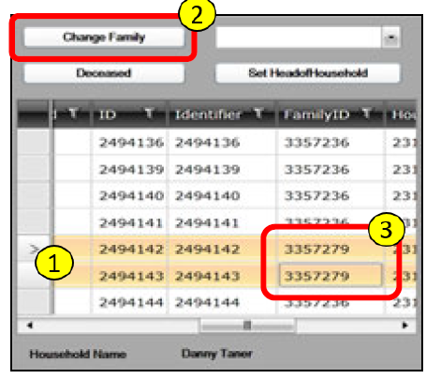

By changing the different Family IDs within a household, you will need to go back to the Demographics Tab of each member and update the HOUSING and FAMILY TYPE fields to reflect the status of each individual FAMILY ID.

Changing household members Family ID to an existing Family

If, by chance, you need to move someone else who is related to the Tanner family into the household (which we will discuss below), or you made a mistake and need to change the Family ID back, you can change their Family ID to match the Tanner by doing the following:

1. Select the client you need to change the Family ID

2. Use the dropdown box next to the CHANGE FAMILY button to select a family member in which you would like to add this new client to

3. Click CHANGE FAMILY

4. This will change the Family ID to match the Family ID of the person you selected from the Dropdown box.

For instance, if we selected Rebecca from the bottom grid and chose Danny Tanner from the dropdown and followed the steps above, Rebecca’s Family ID is now matches the Tanner Family ID once again.

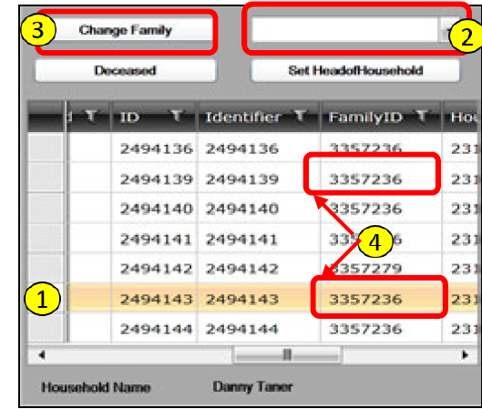

**To make a client Head of Household**

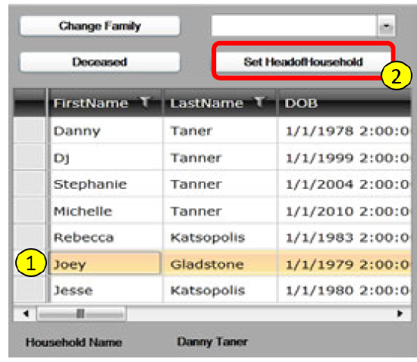

To make a client Head of Household

1. Select client in HOUSEHOLD MEMBER grid on left

2. Click **SET HEADOFHOUSEHOLD**

* Message will appear “You need to update the Relation to HOH for all household

3. Click OK, then select each household member in grid at top of page, open Demographics tab and update their Relation status (remember, this is the relationship of the client to the Head of Family – not HOH).

* Notice the Demographics tab label turns red if required information is missing.

For this instance, if we follow the steps above for changing Joey to the HOH it should now look like this:

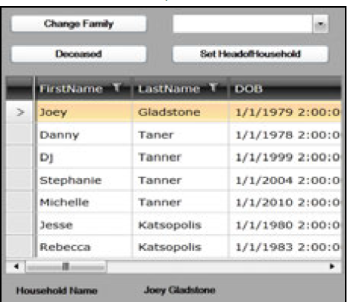

**To move Client(s) to NEW household**

1. Select NEW HOUSEHOLD button on the right grid to create a blank area.

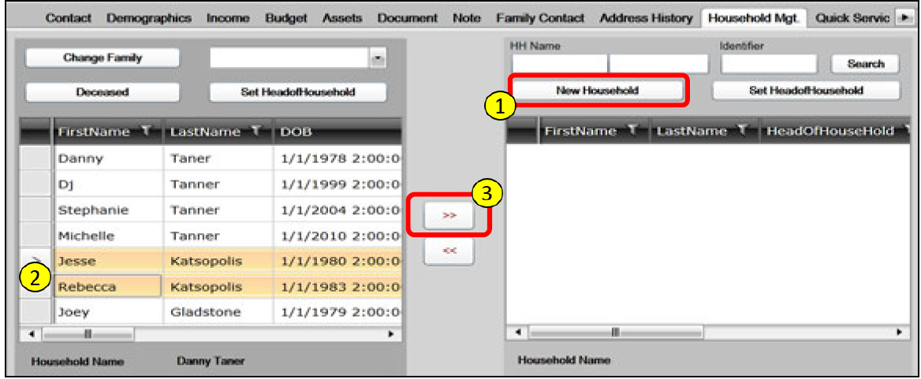

1. Select client(s) to move in grid on left
   * Select the member to be Head of Household first.
2. Click 
   * Selected household members will move to grid on right. The first person selected will be Head of Household.

Let’s say that Jesse & Rebecca move out and into their own home. By following the above steps, it would now look like this:

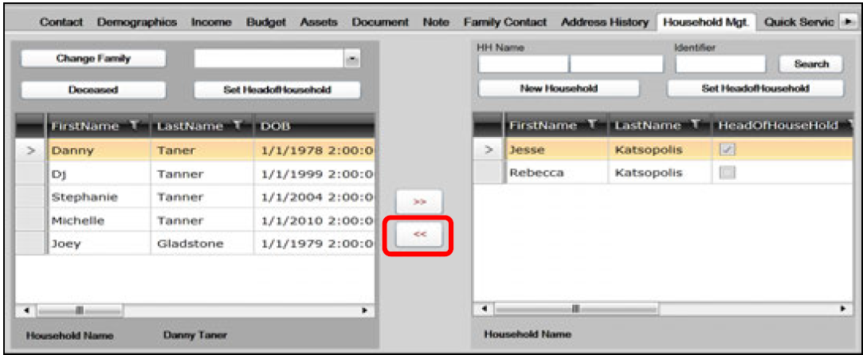

Let’s say you’ve made a mistake and only meant to move Jesse. You can click on Rebecca on the Right-Grid then click the  to move her back. If you wish to move them both back, you must move Rebecca first because MIS will not allow you to move the HOH until all other members of that Household have been moved first.

**To move client(s) to EXISTING household**

1. Select Customer(s) to move in grid on left

2. Enter First and Last name of Head of Household of existing household on right

3. Click SEARCH

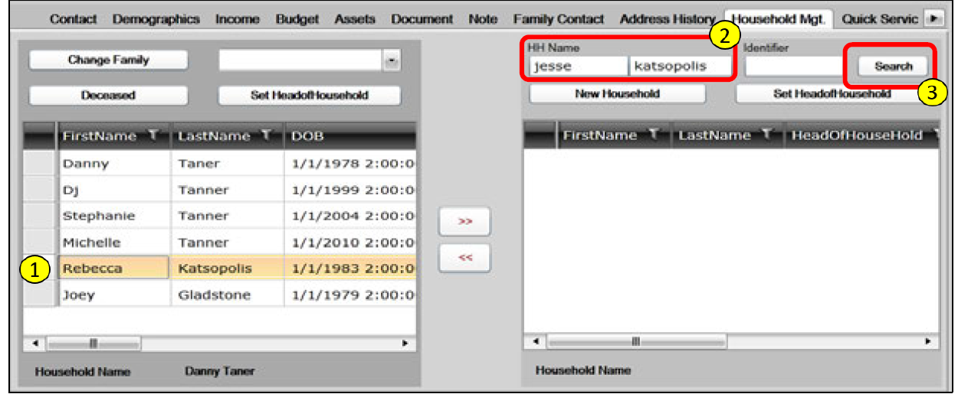

A select popup window will display matches

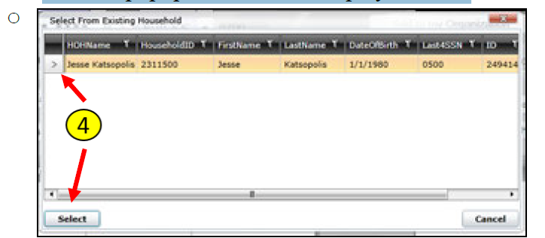

4. Select existing HOH in Household and click SELECT

5. Click 

* + Customer(s) will move to grid on right (and into the Household you selected)

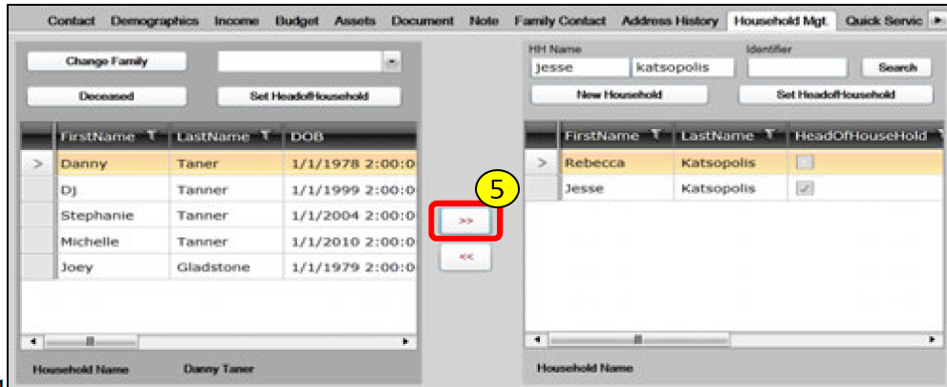

These steps can also be taken if you need to move someone into the household that you are currently working with by searching for the client you need to move on the Right-Grid and using the  button to move them from the Right-Grid to the Left-Grid (in which shows the family you are currently working with).