The process to search for clients and enter and/or update the client demographic information has not changed. It is included in this for documentation purposes. This process has not change – continue to follow your agency’s approved procedures.

- Search the MIS system, using the Client Listing Page before entering the information. You can search by SSN, First Name, Last Name or DOB.
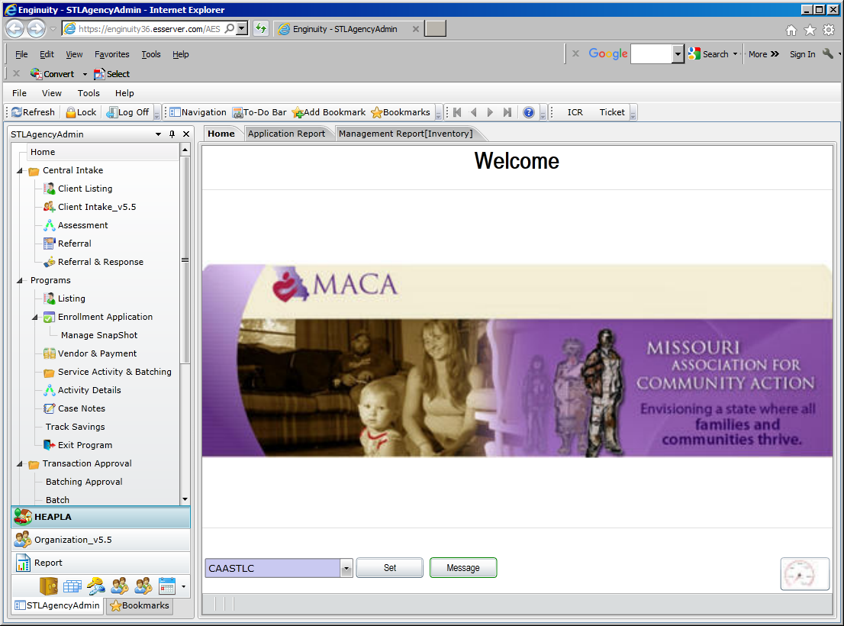

- If the client is found, highlight the client name and click on the Client Intake v5.5 to update information such as – family members, income, education levels (if known), insurance (if known). Click the SAVE button when finished.

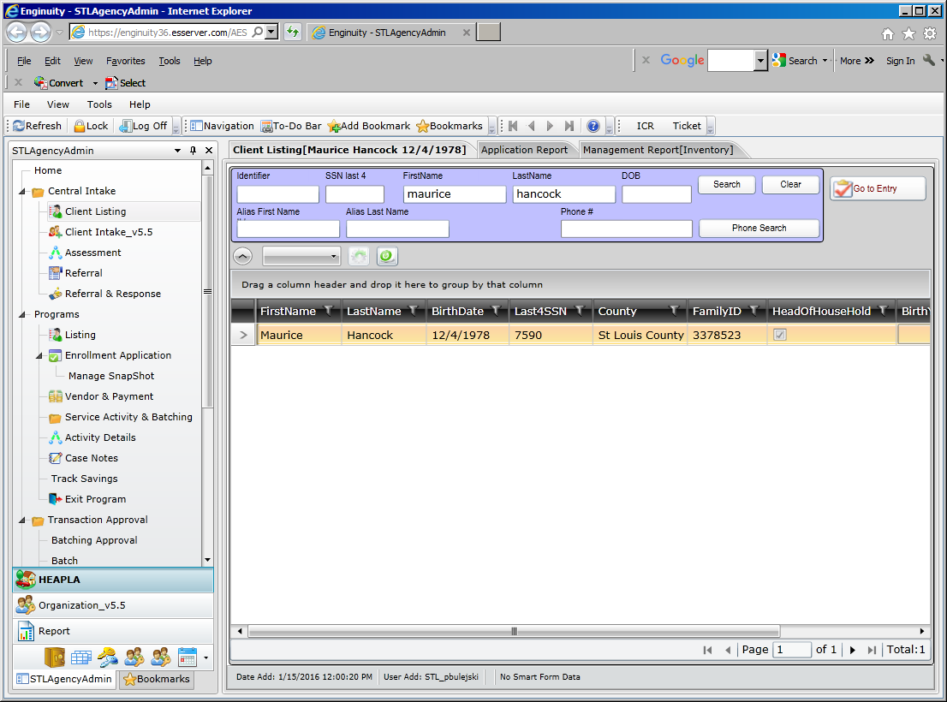

- If the client is not found, click on the New Household. Consent level is region Client Intake v5.5 page, which means the entire Missouri CAA network can view the client data. The following information is required on the Contact Tab:
SSN Street Name
SSN Code City
First Name County
Last Name State (always MO)
Date of Birth Zip
Street # Zip Data Quality
- If there is an apartment address, that information can also be entered
- Phone number can be entered
- Be sure to click the SAVE button when finished.

CSBG required fields are highlighted in the blue boxes. Enter information for each family member in the household.

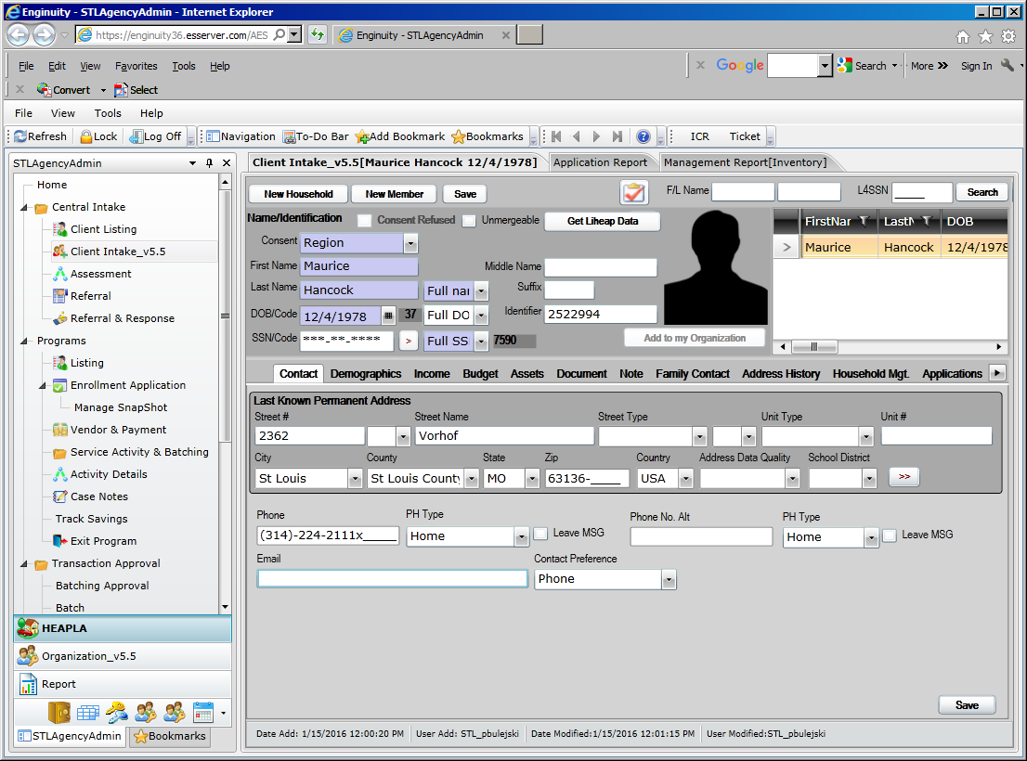
- After entering the Contact information, click on Demographics Tab to enter household member information.

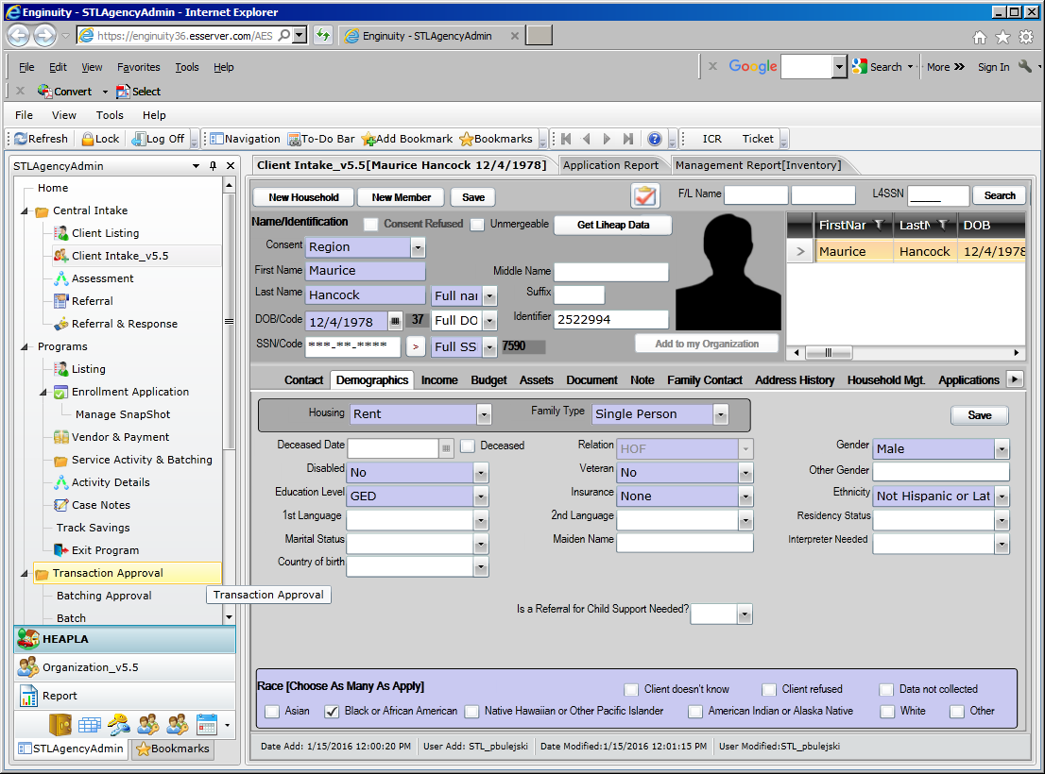

- Enter information for each family member in the household. Click the SAVE button when finished.

- Click on the Income tab to add income.

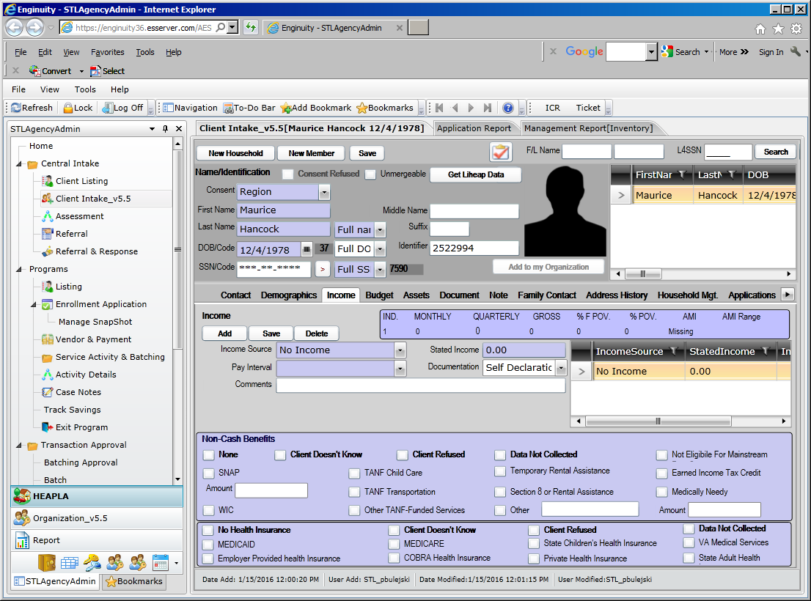

- Once the Client Intake information has been entered you are ready to enroll in the Emergency Assistance program. On the Client Intake Page there is a button which will take you to program entry (right above the person’s head). OR click on the Entry in the programs listing.

THIS IS THE NEW PROCESS
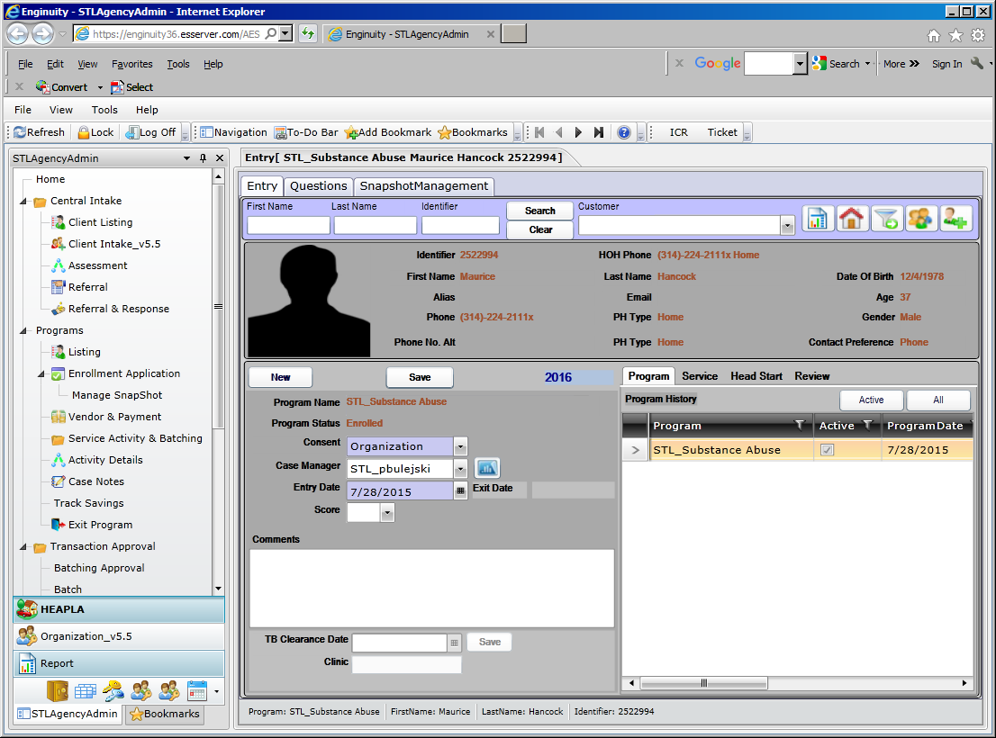
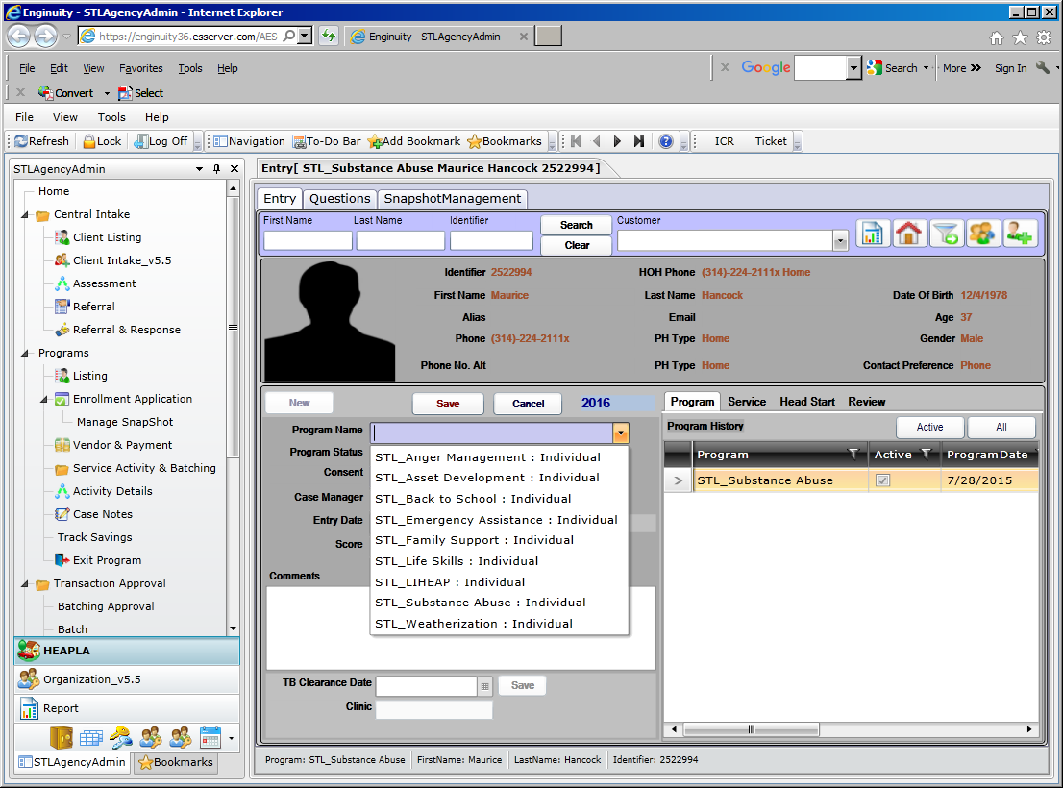

Click the new button to view the list of programs for enrollment - select the Weatherization Program
Program status is enrolled
Consent level is ORGANIZATION
Case Manager will be entered once you hit the save button
Enter the ‘entry date’
Click SAVE.
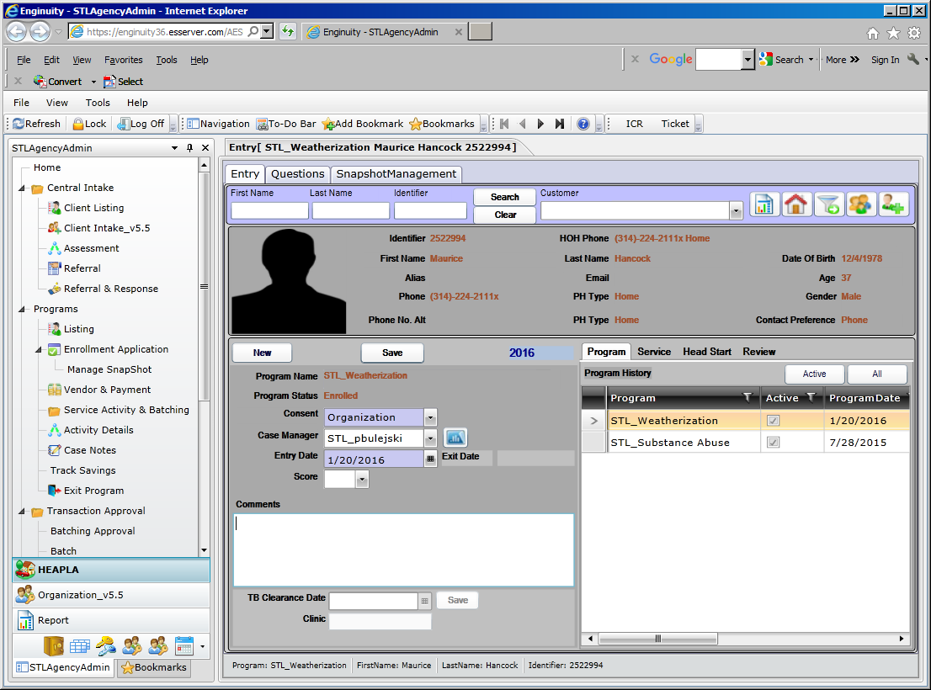

Client is now enrolled in Weatherization.

Click on the question tab to answer the questions. Answer the questions – click save answers
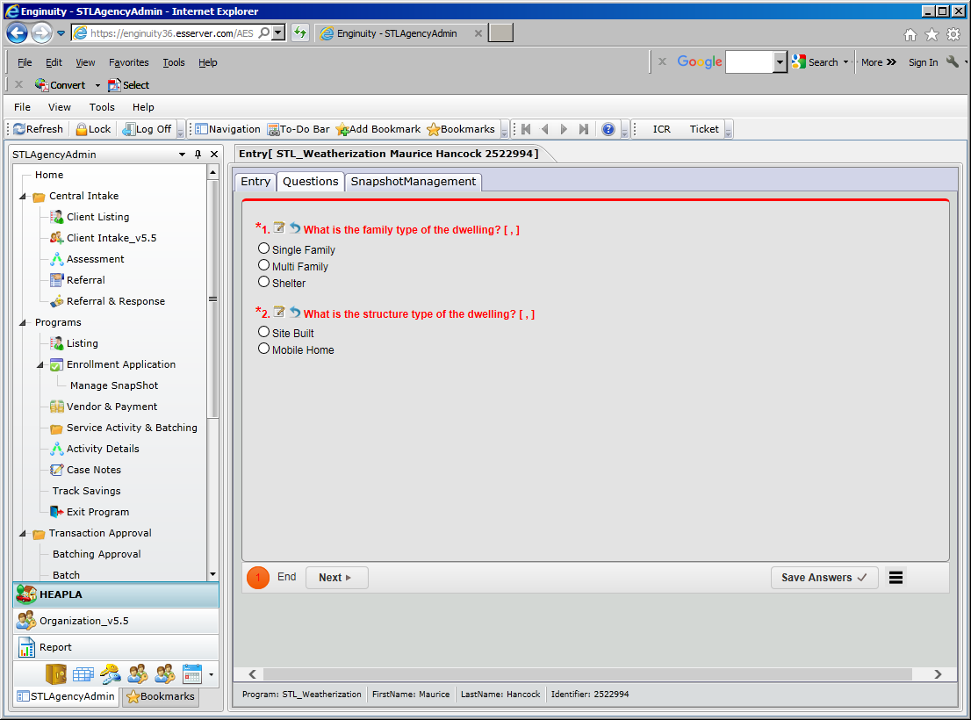

Click the submit button. If you want to view the summary of your answers, click the next button.
Go back to the Entry tab, click the send to state button to move the client demographic information from MIS to MoWAP.
*** currently the button is not active, not displayed on the new page – a ticket has been added to get this button to display on the page ***

