The process to search for clients and enter and/or update the client demographic information has not changed. It is included in this for documentation purposes. This process has not change – continue to follow your agency’s approved procedures.

- Search the MIS system, using the Client Listing Page before entering the information. You can search by SSN, First Name, Last Name or DOB.
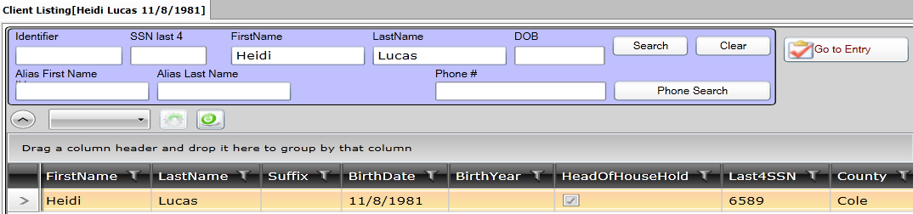
- If the client is found, highlight the client name and click on the Client Intake v5.5 to update information such as – family members, income, education levels (if known), insurance (if known). Click the SAVE button when finished.
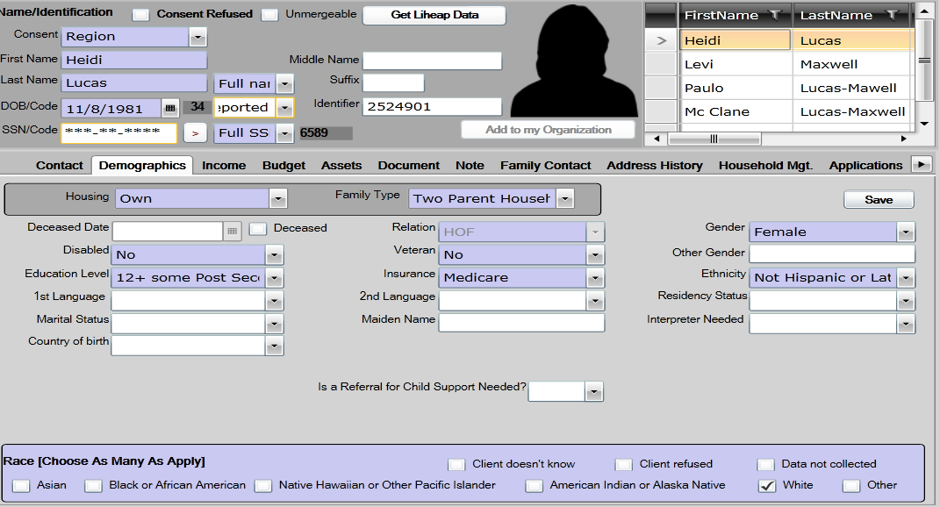

- If the client is not found, click on the New Household. Consent level is region Client Intake v5.5 page, which means the entire Missouri CAA network can view the client data. The following information is required on the Contact Tab:
SSN Street Name
SSN Code City
First Name County (always St Louis County)
Last Name State (always MO)
Date of Birth Zip
Street # Zip Data Quality
- If there is an apartment address, that information can also be entered
- Phone number can be entered
- Be sure to click the SAVE button when finished.
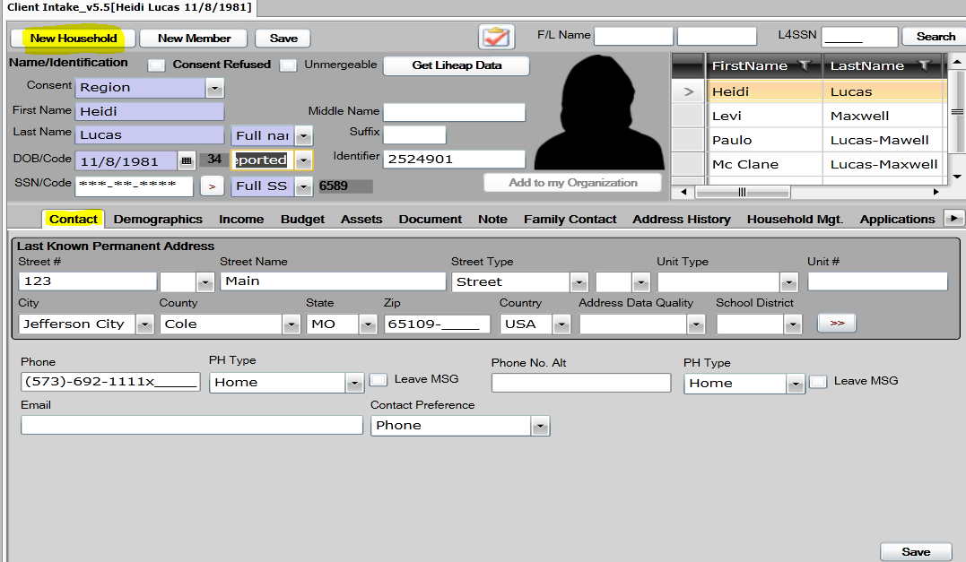

- After entering the Contact information, click on Demographics Tab to enter household member information.
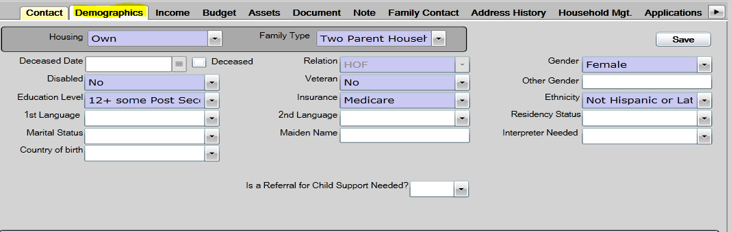
- The following information is required on the Demographics Tab for each family member that is entered on this page:
First Name Relation (HOH is always listed as HOF-head of family)
Last Name Disabled (if known)
Date of Birth Ethnicity (if known)
Gender Education level (if known)
Race Insurance (if known)
Housing Family Type
- Click the SAVE button when finished.

- Click on the Income tab to add income.
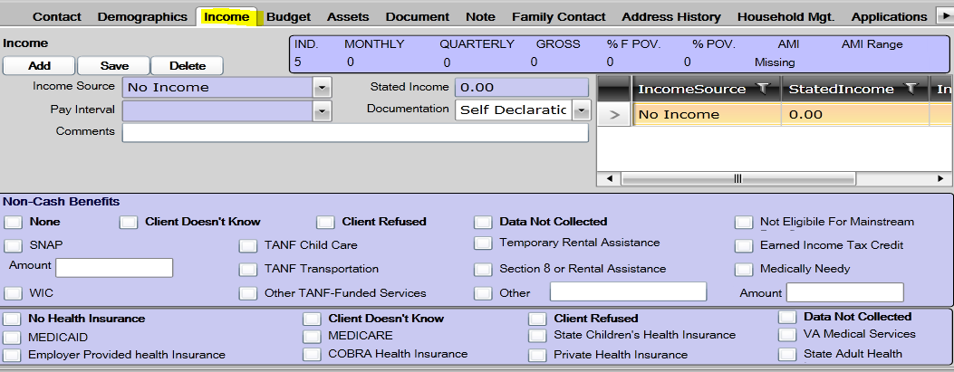

- Once the Client Intake information has been entered you are ready to enroll in the Tax Assistance program. On the Client Intake Page there is a button which will take you to program entry (right above the person’s head). OR click on the Entry in the programs listing.
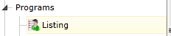

THIS IS THE NEW PROCESS
Click the new button to view the list of programs for enrollment - select the Tax Assistance
Program status is enrolled
Consent level is ORGANIZATION
Case Manager will be entered once you hit the save button
Enter the ‘entry date’
Click SAVE.
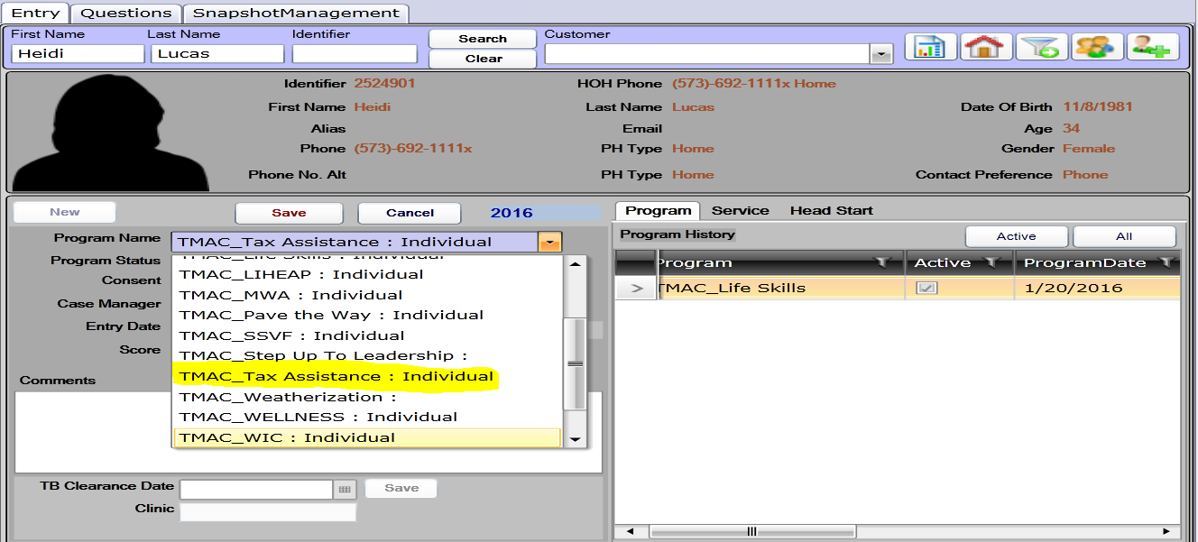

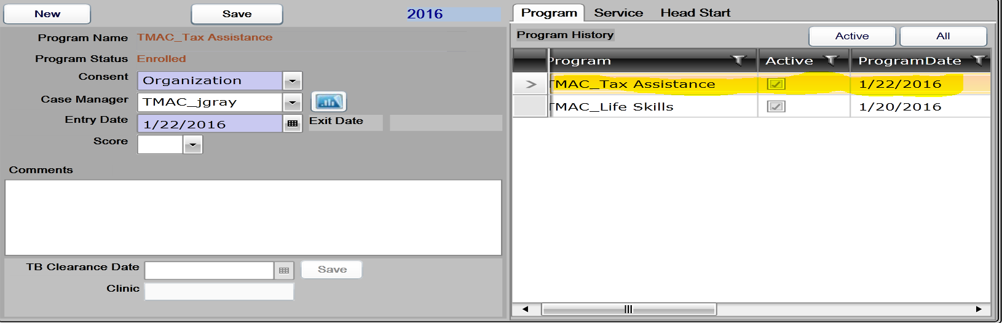
To complete Tax Assistance Assessment, click on Program Details
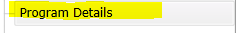
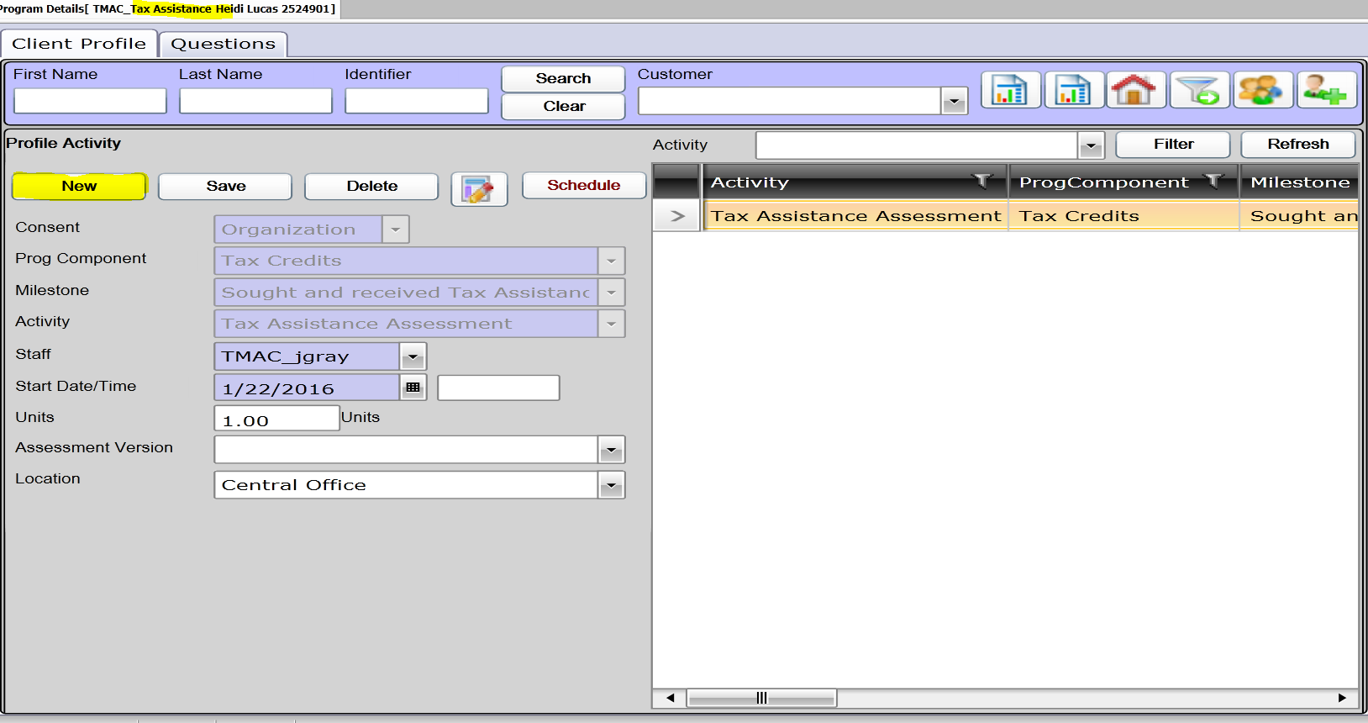
Click New
Consent-Organization
Prog Component-Tax Credits
Milestone-Select Milestone
Activity-Tax Assistance Assessment
Date-Auto populates for today’s date
Click Save
Click on Question tab
Answer Questions
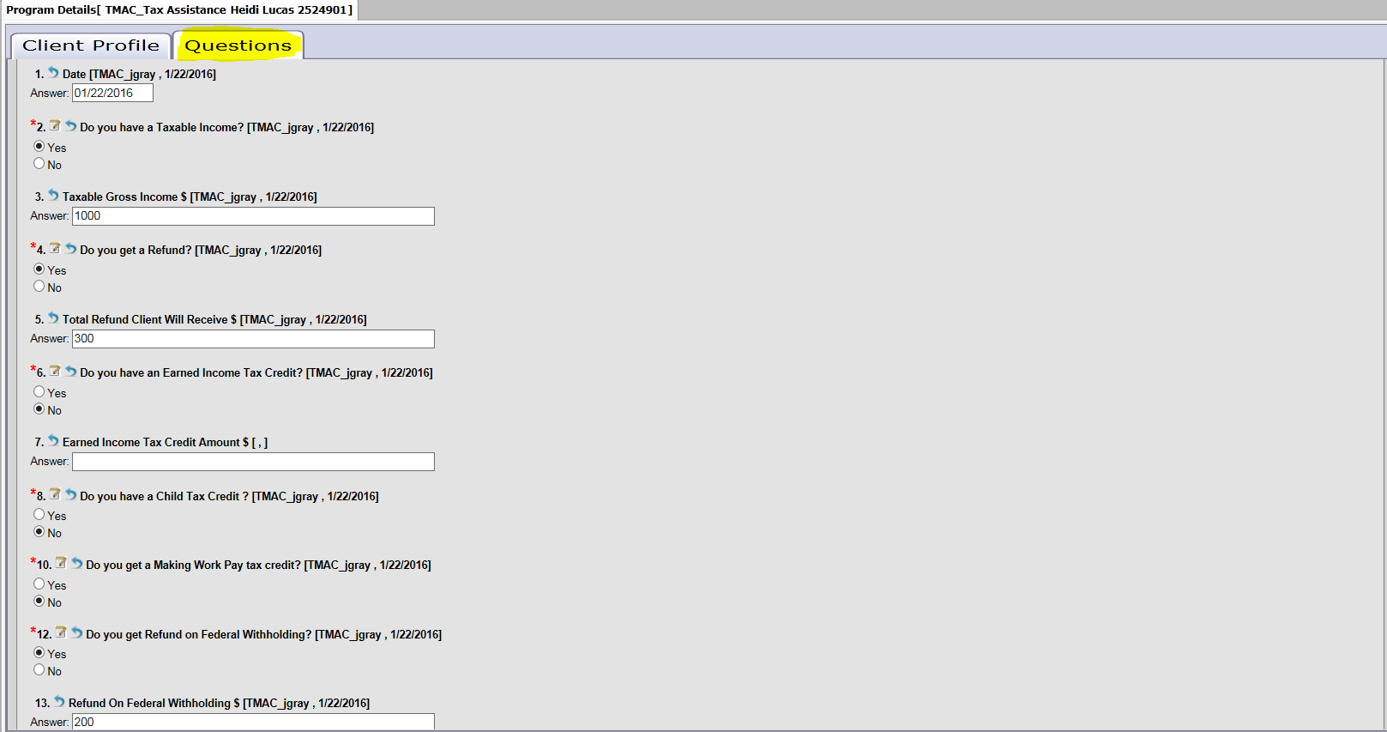
Answer all questions
When you click next it will bring up a summary page of the answers to the questions.
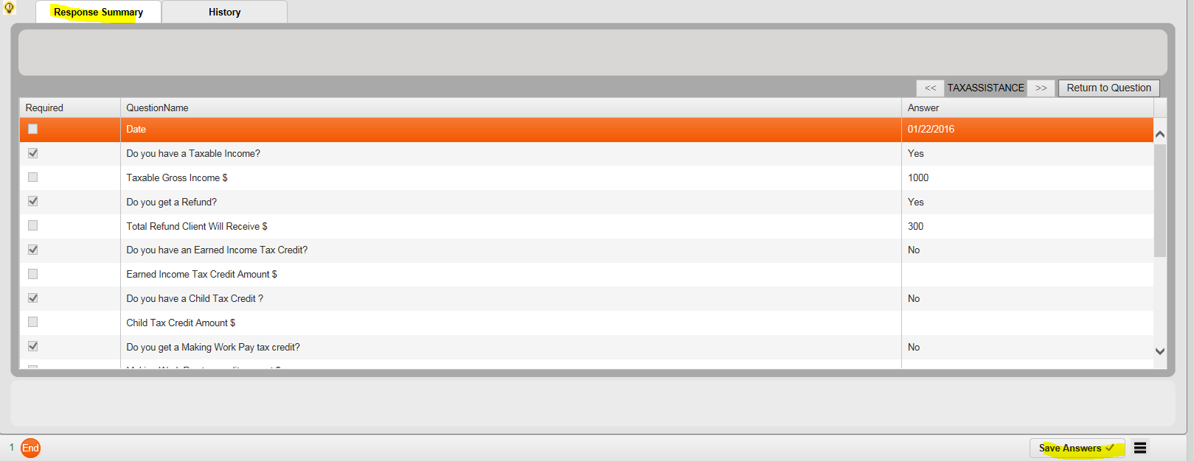
Review answers and click Save Answer. Click Submit
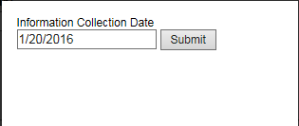
Service & Activities page –update the milestone status
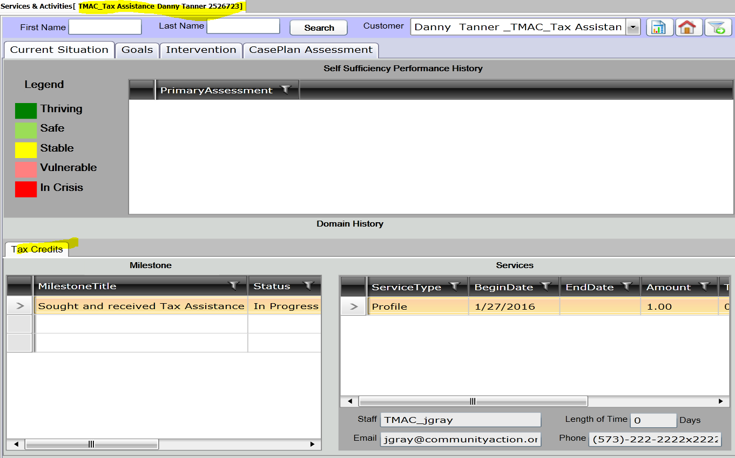
Click on the Intervention tab
Click on the Tax Credits tab
If the milestone was achieved you can update the status.
Click save
