The process to search for clients and enter and/or update the client demographic information has not changed. It is included in this for documentation purposes. This process has not change – continue to follow your agency’s approved procedures.

- Search the MIS system, using the Client Listing Page before entering the information. You can search by SSN, First Name, Last Name or DOB.
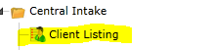
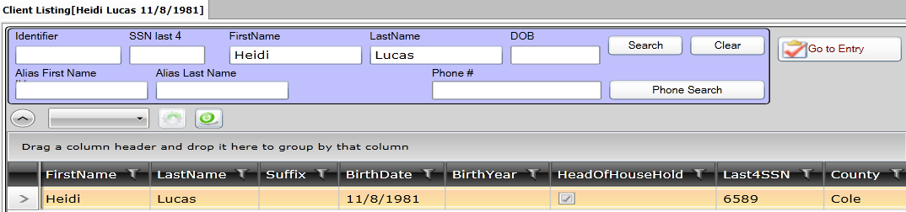
- If the client is found, highlight the client name and click on the Client Intake v5.5 to update information such as – family members, income, education levels (if known), insurance (if known). Click the SAVE button when finished.
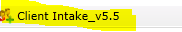
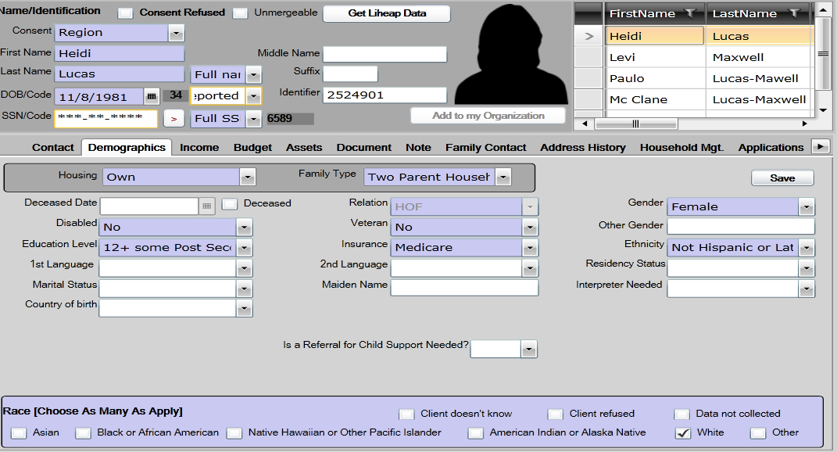

- If the client is not found, click on the New Household. Consent level is region Client Intake v5.5 page, which means the entire Missouri CAA network can view the client data. The following information is required on the Contact Tab:
SSN Street Name
SSN Code City
First Name County (always St Louis County)
Last Name State (always MO)
Date of Birth Zip
Street # Zip Data Quality
- If there is an apartment address, that information can also be entered
- Phone number can be entered
- Be sure to click the SAVE button when finished.
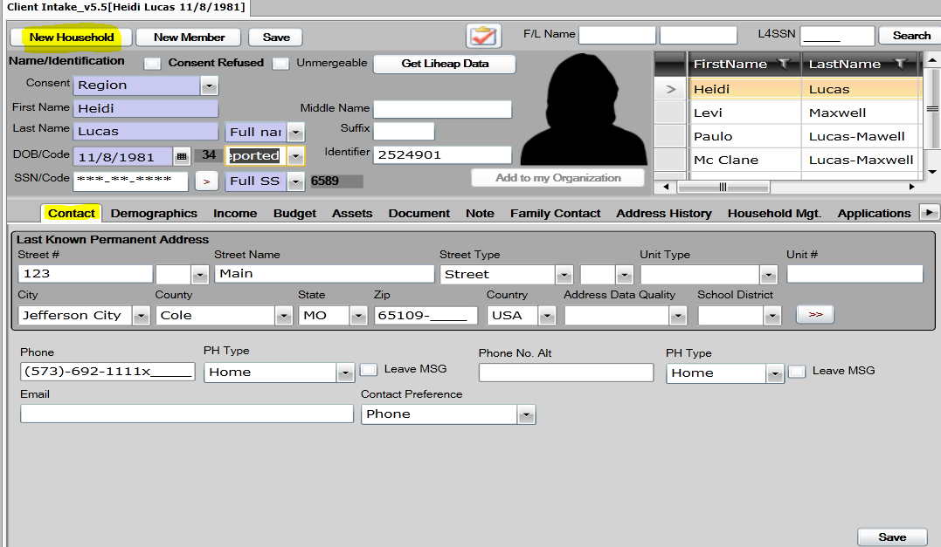

- After entering the Contact information, click on Demographics Tab to enter household member information.
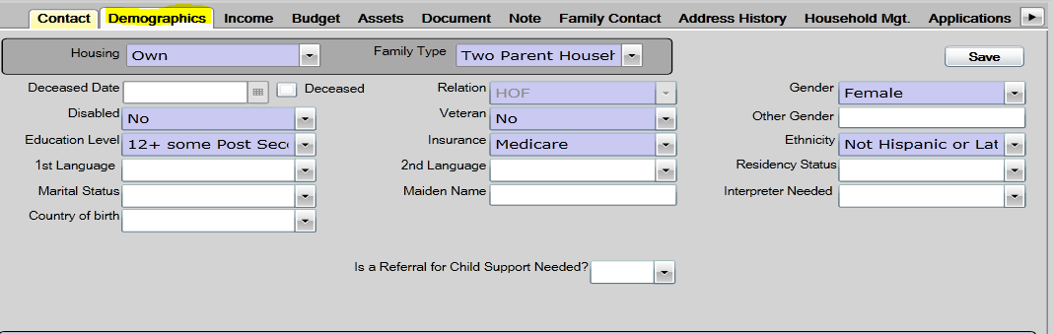
- The following information is required on the Demographics Tab for each family member that is entered on this page:
First Name Relation (HOH is always listed as HOF-head of family)
Last Name Disabled (if known)
Date of Birth Ethnicity (if known)
Gender Education level (if known)
Race Insurance (if known)
Housing Family Type
- Click the SAVE button when finished.

- Click on the Income tab to add income.
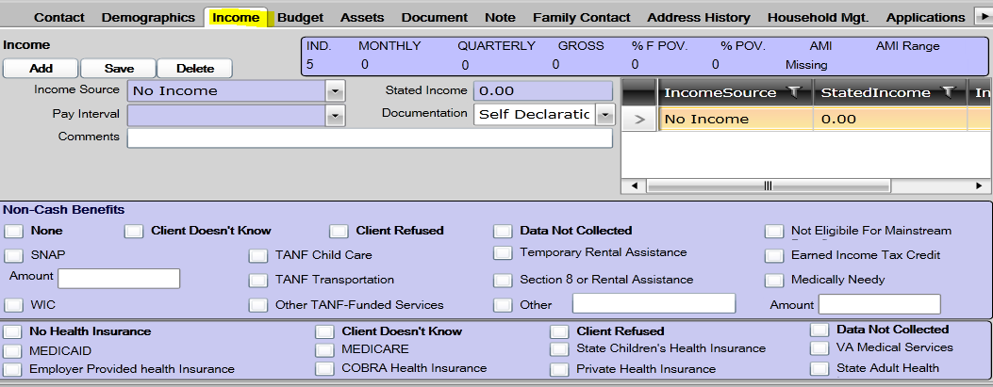

- Once the Client Intake information has been entered you are ready to enroll in the Life Skills program. On the Client Intake Page there is a button which will take you to program entry (right above the person’s head). 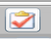 OR click on the Entry in the programs listing.
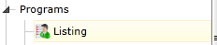
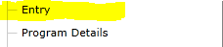
THIS IS THE NEW PROCESS
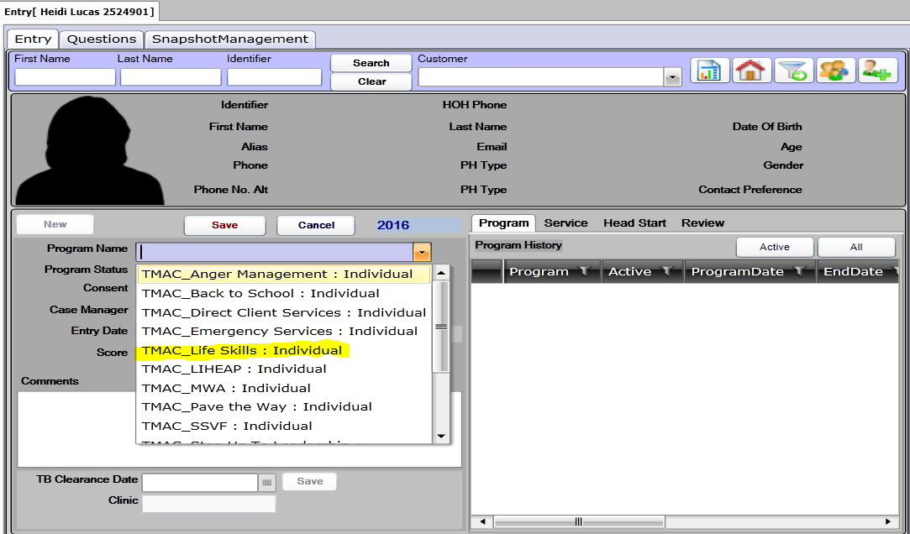
Click the new button to view the list of programs for enrollment - select the Life Skills program
Program status is enrolled
Consent level is ORGANIZATION
Case Manager will be entered once you hit the save button
Enter the ‘entry date’
Click SAVE.

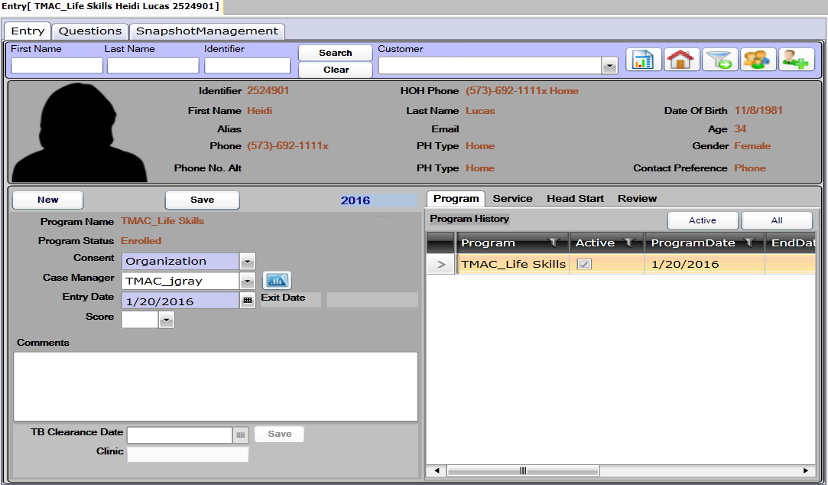
To add the Life Skills ‘classes’ service and/or activity, click on Services & Activities:
Programs the client has been enrolled in will display.
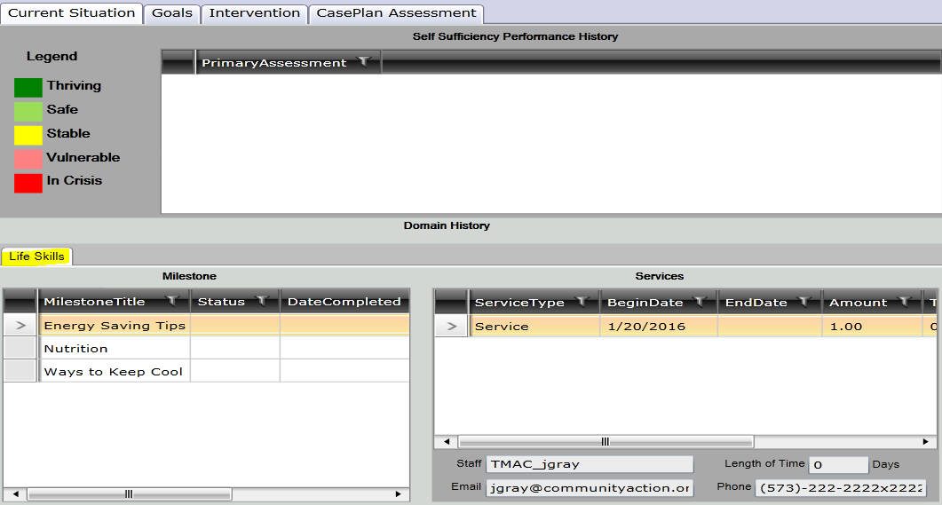

Click on Intervention Tab
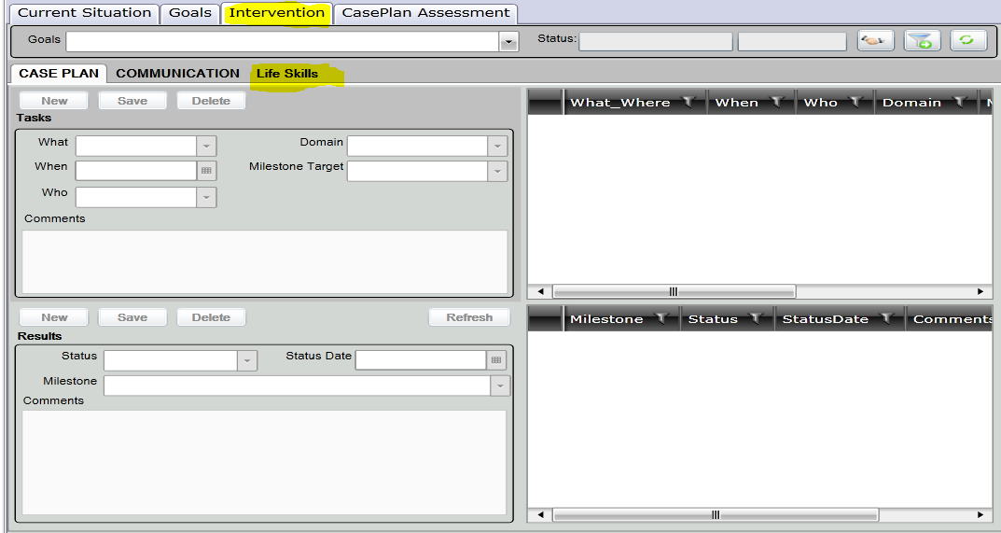
Click new to enter the service.
Enter the activity.
Enter the date service received.
Click Save
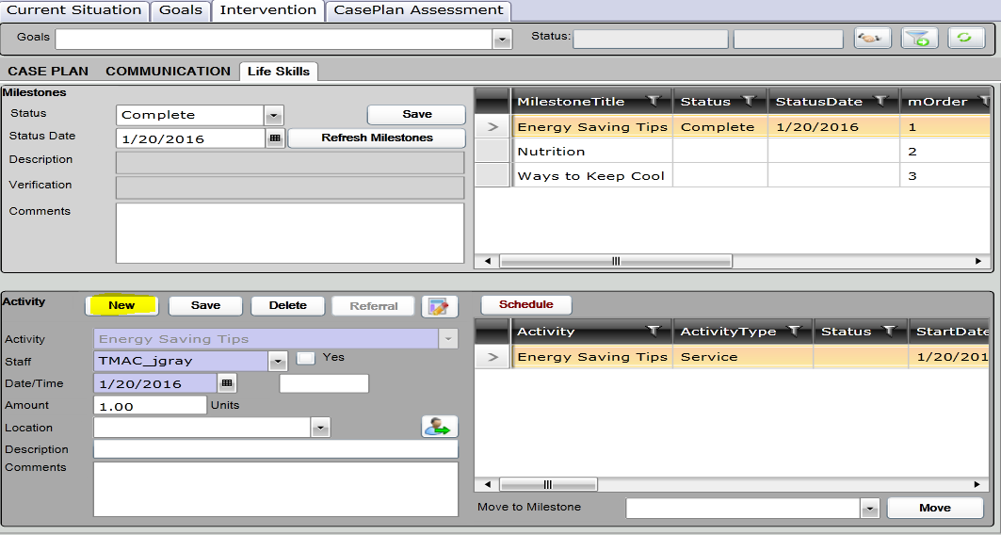

Pre & Post Test
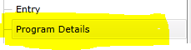
Click New
Consent-Organization
Prog Component-Life Skills
Milestone-Class/Milestone you are complete the pre and post test
Activity Pre-Post Test
Date-Auto populates for today’s date
Click Save
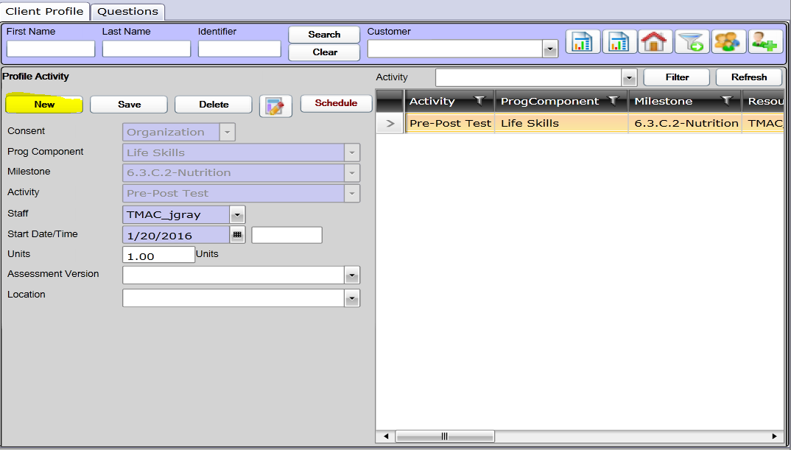

Click on Question tab
Answer Questions
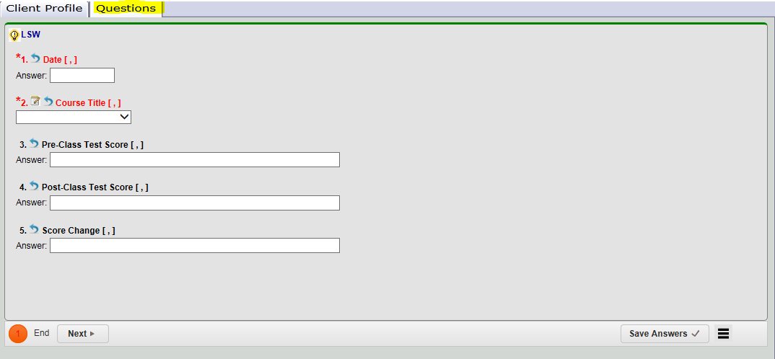
Save Answers
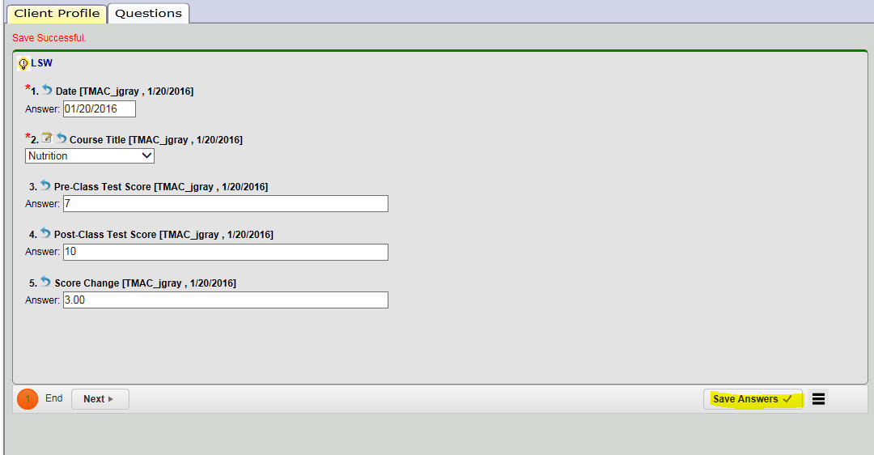
Click Submit
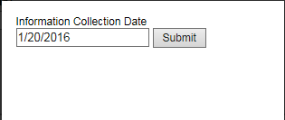

You have now successfully enrolled a client into Life skills, entered them into a Life skills class and completed a pre and posttest.

