The process to search for clients and enter and/or update the client demographic information has not changed. It is included in this for documentation purposes. This process has not changed – continue to follow your agency’s approved procedures.

- Search the MIS system, using the Client Listing Page before entering the information. You can search by SSN, First Name, Last Name or DOB.
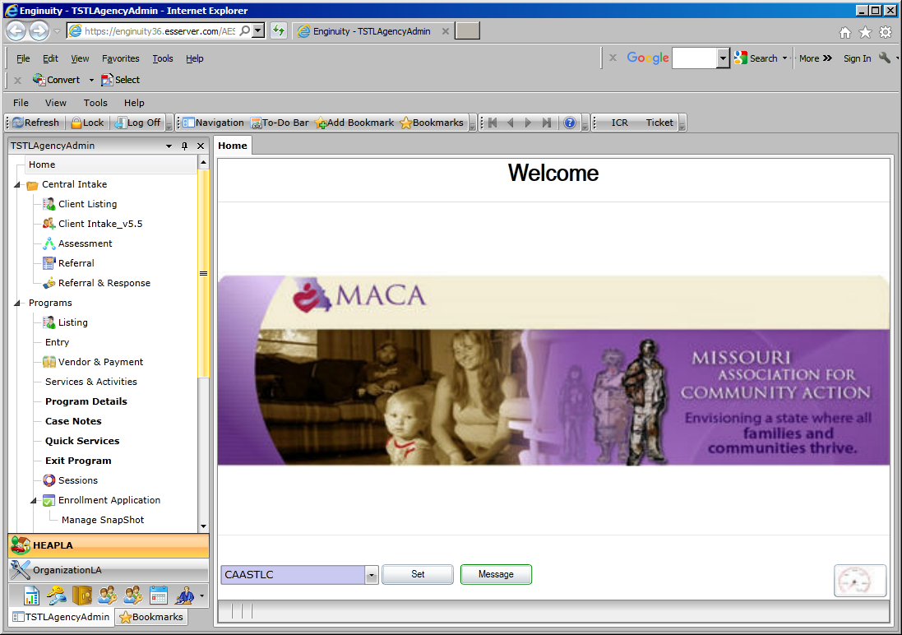

- If the client is found, highlight the client name and click on the Client Intake v5.5 to update information such as – family members, income, education levels (if known), insurance (if known). Click the SAVE button when finished.

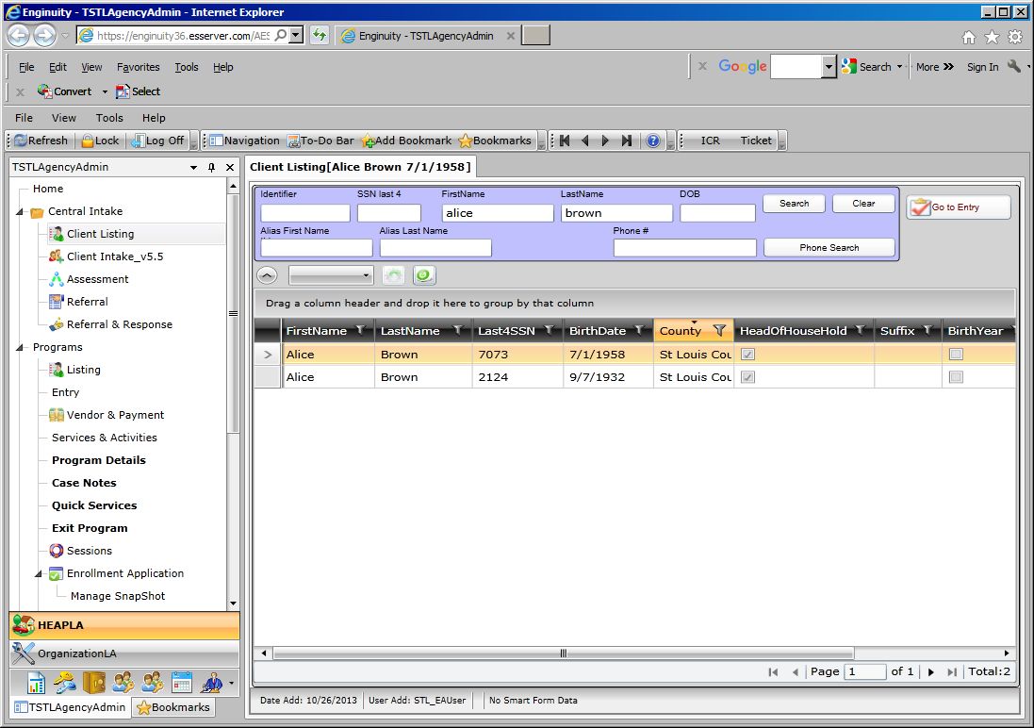

- If the client is not found, click on the New Household. Consent level is region Client Intake v5.5 page, which means the entire Missouri CAA network can view the client data. The following information is required on the Contact Tab:
SSN Street Name
SSN Code City
First Name County (always St Louis County)
Last Name State (always MO)
Date of Birth Zip
Street # Zip Data Quality
- If there is an apartment address, that information can also be entered
- Phone number can be entered
- Be sure to click the SAVE button when finished.

- Once the Client Intake information is entered - click on the Get LIHEAP Data to retrieve EA application information from the state. This button should:
- Add all family members from the EA application
- Create program enrollment
- Create vendor payment for EA transaction

- After entering the Contact information, click on Demographics Tab to enter household member information.

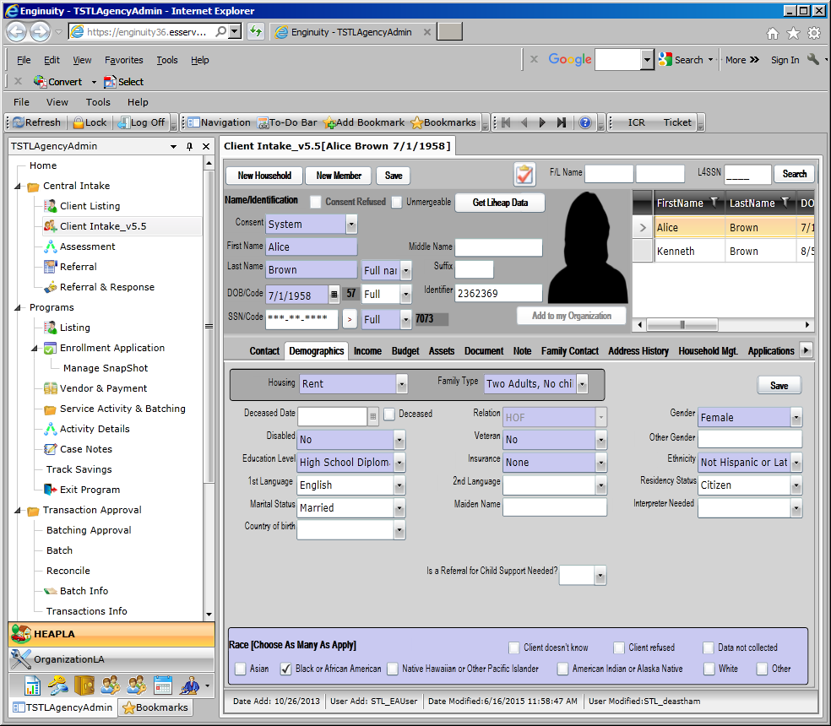

- The following information is required on the Demographics Tab for each family member that is entered on this page:
First Name Relation (HOH is always listed as HOF-head of family)
Last Name Disabled (if known)
Date of Birth Ethnicity (if known)
Gender Education level (if known)
Race Insurance (if known)
Housing Family Type
- Click the SAVE button when finished.

- Click on the Income tab to add income.

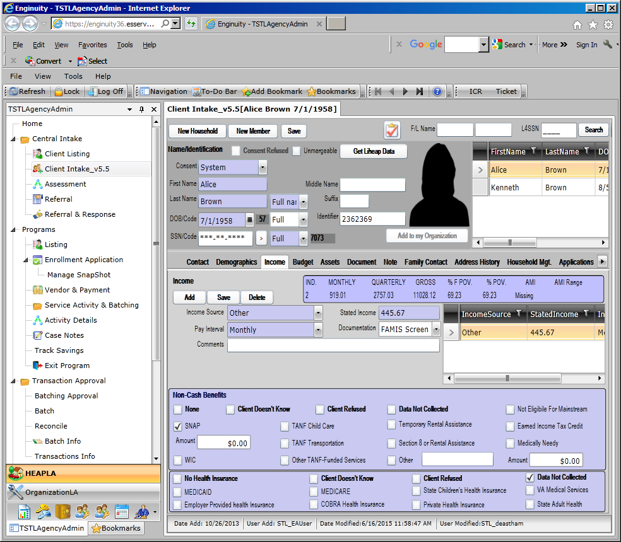

- Once the Client Intake information has been entered you are ready to enroll in the LIHEAP program. On the Client Intake Page there is a button which will take you to program entry (right above the person’s head). OR click on the Entry in the programs listing.

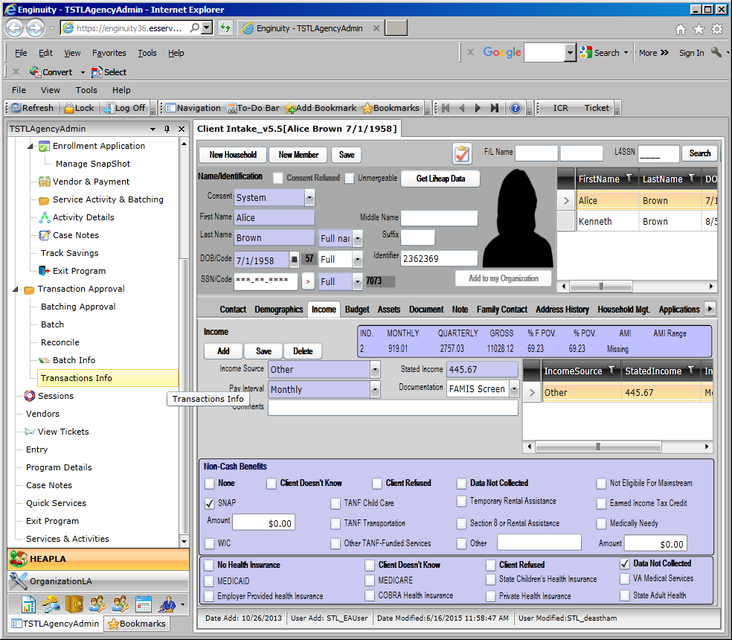

THIS IS THE NEW PROCESS

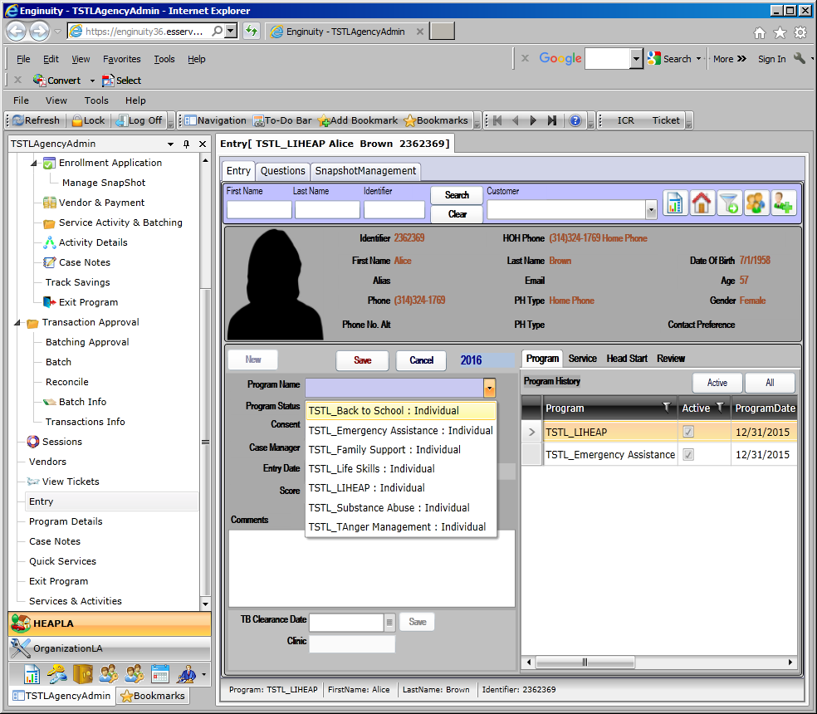

Click the new button to view the list of programs for enrollment - select the LIHEAP program
Program status is enrolled
Consent level is ORGANIZATION
Case Manager will be entered once you hit the save button
Enter the ‘entry date’
Click SAVE.

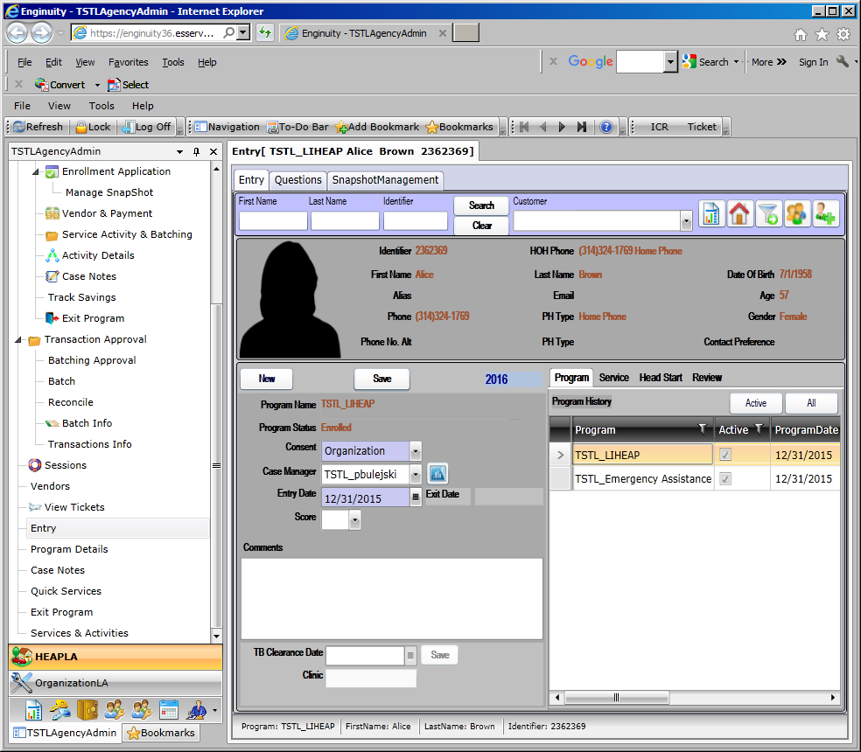

Client is now enrolled in LIHEAP.
Click on the question tab to enter and/or view the questions. If you used the GET LIHEAP button (and the data transferred over), you can view the questions answered.

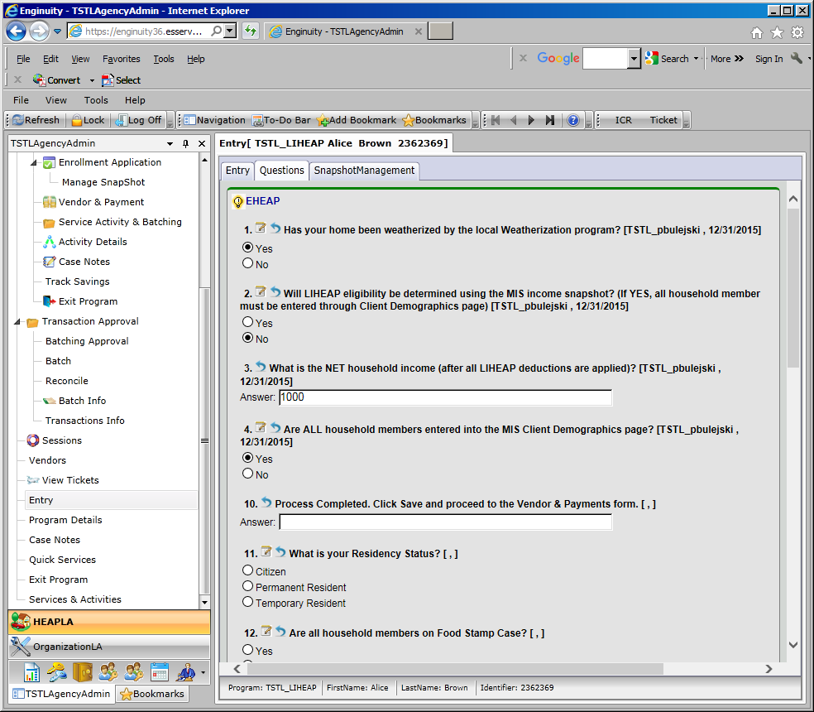

Notice only the first four questions were answered. This is because all members that were on the EA application are listed in MIS. If there is a discrepancy with the members listed on the EA application vs members listed in MIS then the LIHEAP Bridge will not pull over the data and you will have to answer the questions manually.

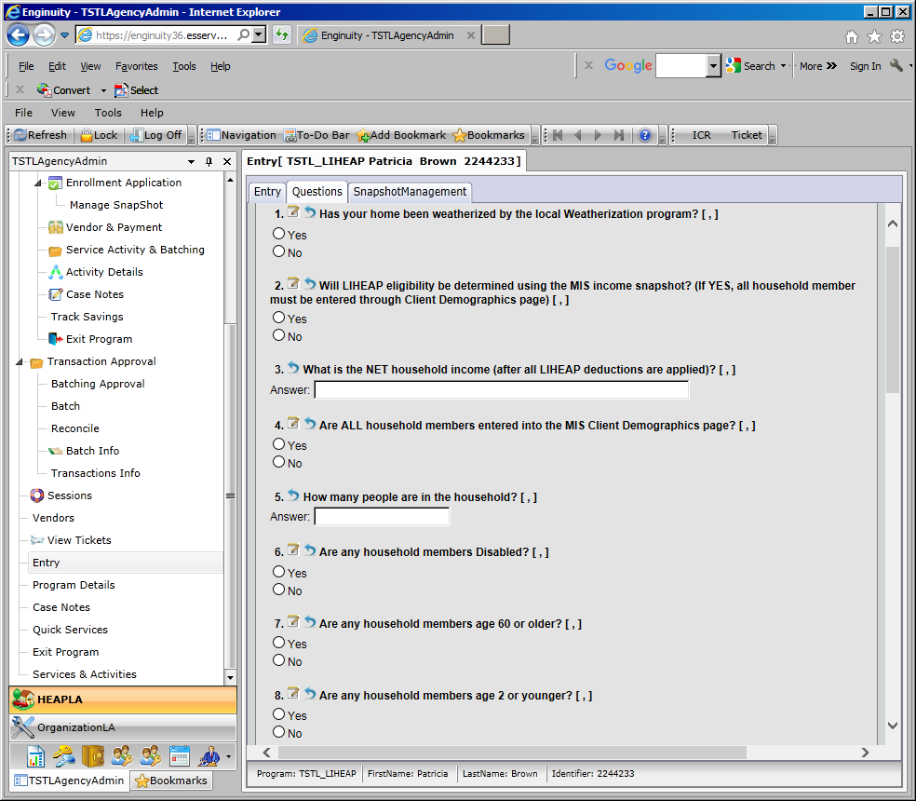

Answer the questions – then scroll down to the end, click save answers

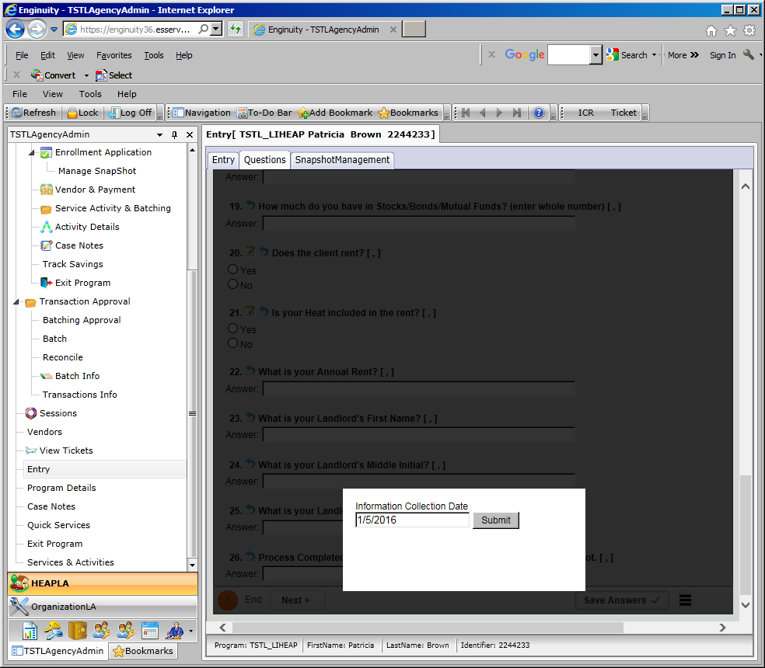

Click the submit button. If you want to view the summary of your answers, click the next button

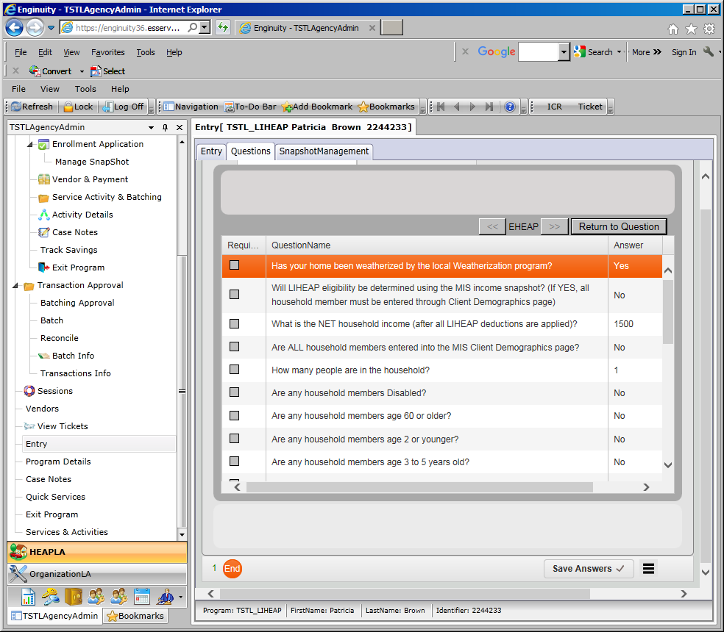

From this point, you can proceed to the Vendor & Payment page.
This process has not change – continue to follow your agency’s approved procedures.

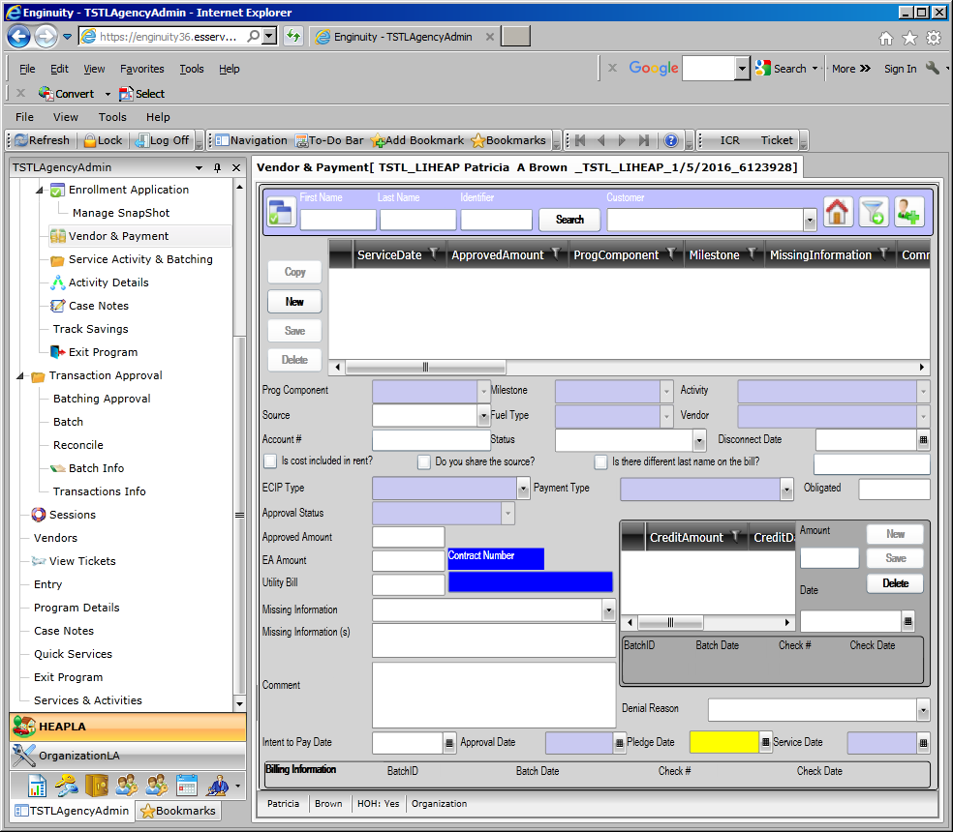

The data on this page is extremely critical for payments to the vendor and reports for fiscal and state.

Click on NEW button.

Several of the data fields are dependent on information entered in order to populate other fields. Many of the fields contain a drop down list and based on the contract, the entries vary.

The following fields outlined are major fields and control other data for fields based on entry.

Program Components: | ECIP Winter, ECIP Summer, EA Component, CSBG (controls the milestone/activity available for selection)
Fuel Type: | Electricity, Natural Gas, Propane, Wood, etc. (controls what vendors are associated with the fuel type)
Vendor: | Select appropriate vendor for the fuel type
ECIP Type: | ECIP Winter, ECIP Summer, NON-ECIP
Payment Type: | Select appropriate payment type
Obligated Amount: | $ amount pledged/obligated
Approved Amount: | $ amount approved for payment
EA Amount: | EA benefit amount
Approval Status: | Select appropriate approval status for the transaction type
Approval Date: | Date utility contacted and pledge made
Service Date: | Date from the application

- For the other fields, the information required has not changed.
Source: | Primary or Secondary
Account #: | Client utility account number
Status: | Service Terminated, Service Threatened
Disconnect Date: | Date from utility bill/disconnect notice

- Once all the information is entered for that payment, click on SAVE button.
- If the blue contract box does not contain contract information, bring the transaction to your agency admin to correct.

Transactions entered are ready to be batched, processed and reconciled/paid in MIS.
This process has not change – continue to follow your agency’s approved procedures.

