How to remove individuals out of sessions.

Program drop down select the program you….Program Component select Program Component
Hit Search
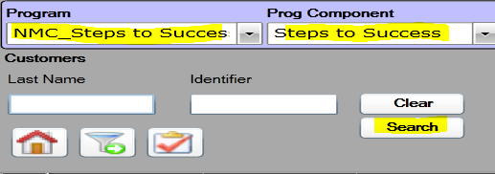

This will bring in all individuals you have enrolled into the program that you have selected from drop downs.
Use SHIFT + Click to select a range of records (ALL RECORDS)
Use CTRL + Click to select multiple records individually (Indivudal Names)

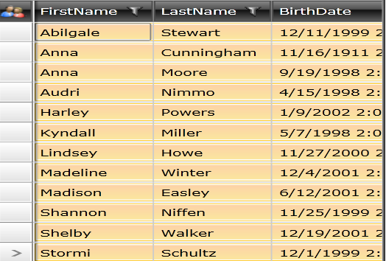

Screen shot of the Service Use by Particpate report to show duplicates from Come as You Are Activity
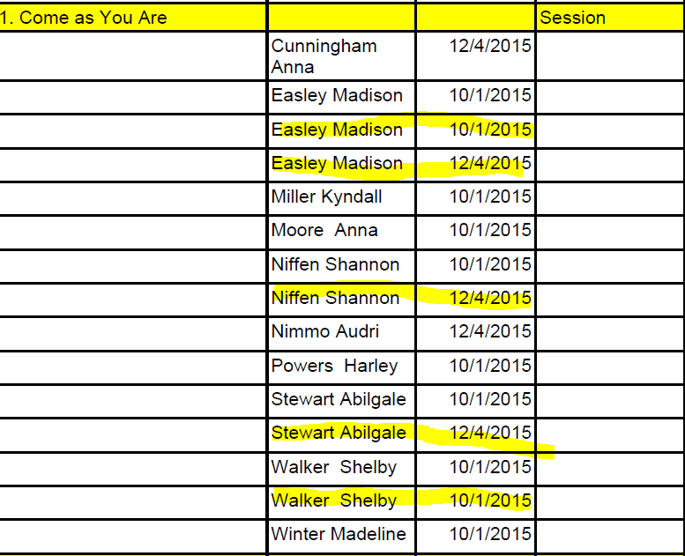

Select Activity (Class) you need to remove the client from.

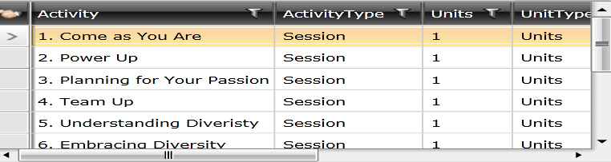

Search by date that of the class you want to remove clients from. (October 1st and December 4th both have duplicates)

Filter by Last Name-This will put the clients in alphbatic order by last name. Simply hit the LastName column.

Highlight the recrods that are duplicated. (KEEP THE FIRST ONE of THE DUPLICATE RECORDS). Then hit ‘REMOVE’. This will remove them from the session.

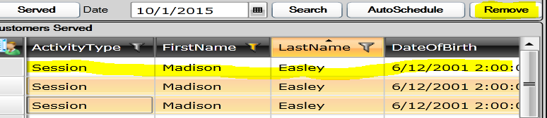

I have done Madison Easly for 10/01/15

To Search for a new date change date. Find Madison (She also had a December 4th Entry). Hit Remove.

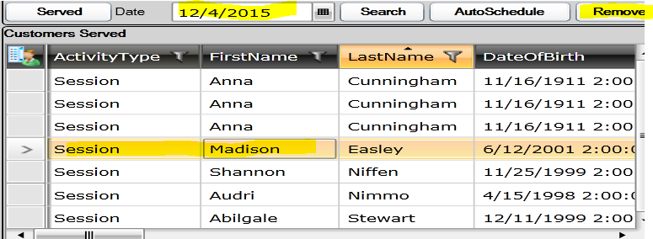

Go to the next one.

I would do all October 1st duplicates firth then go to December 4th.

