The process to search for clients and enter and/or update the client demographic information has not changed. It is included in this for documentation purposes. This process has not change – continue to follow your agency’s approved procedures.

- Search the MIS system, using the Client Listing Page before entering the information. You can search by SSN, First Name, Last Name or DOB.
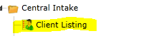
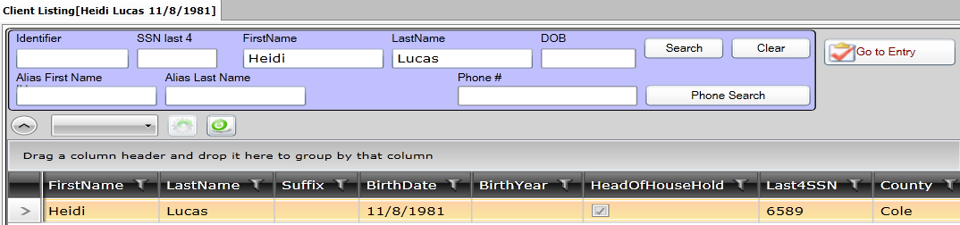
- If the client is found, highlight the client name and click on the Client Intake v5.5 to update information such as – family members, income, education levels (if known), insurance (if known). Click the SAVE button when finished.
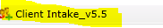
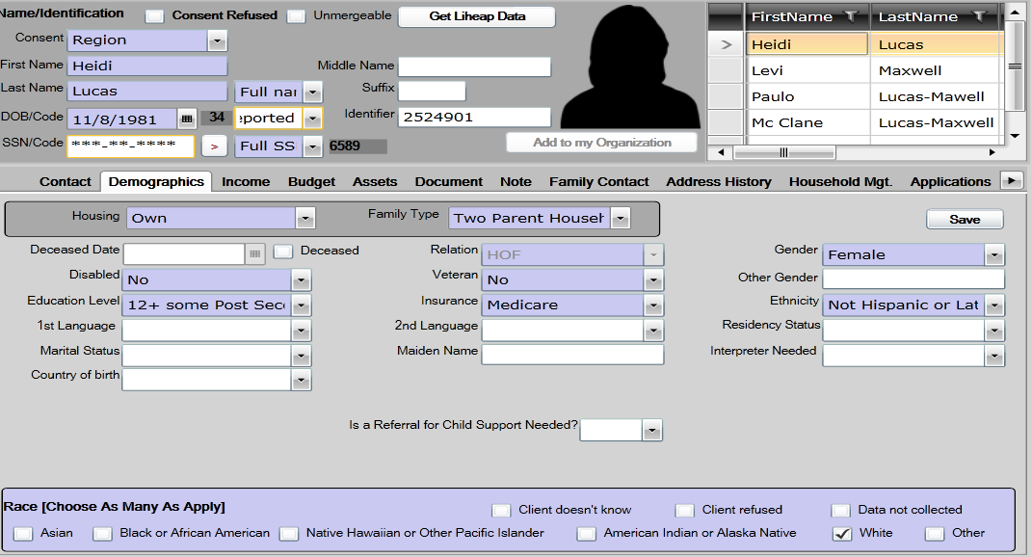

- If the client is not found, click on the New Household. Consent level is region Client Intake v5.5 page, which means the entire Missouri CAA network can view the client data. The following information is required on the Contact Tab:
SSN Street Name
SSN Code City
First Name County (always St Louis County)
Last Name State (always MO)
Date of Birth Zip
Street # Zip Data Quality
- If there is an apartment address, that information can also be entered
- Phone number can be entered
- Be sure to click the SAVE button when finished.
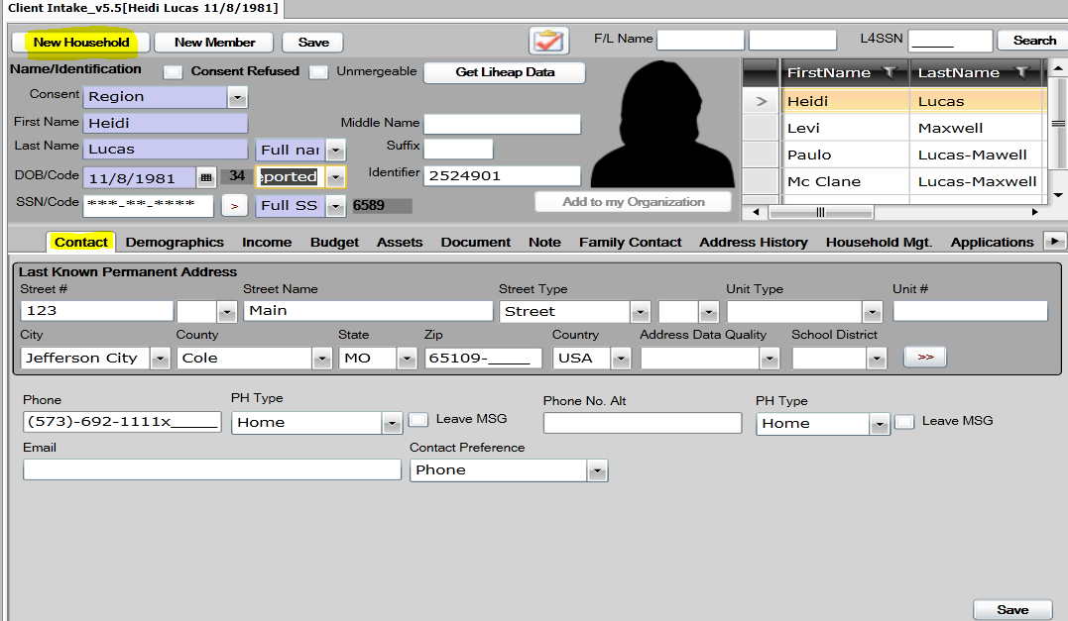

- After entering the Contact information, click on Demographics Tab to enter household member information.
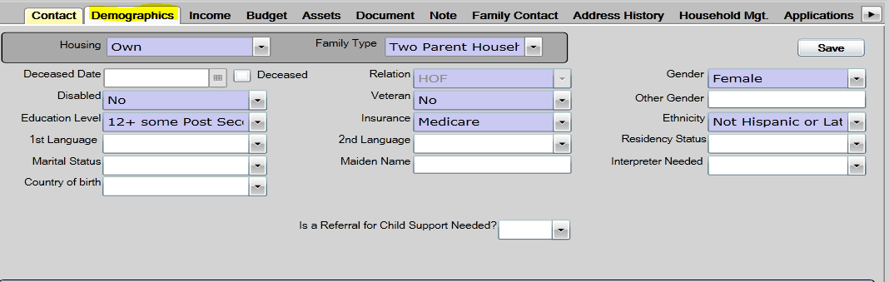
- The following information is required on the Demographics Tab for each family member that is entered on this page:
First Name Relation (HOH is always listed as HOF-head of family)
Last Name Disabled (if known)
Date of Birth Ethnicity (if known)
Gender Education level (if known)
Race Insurance (if known)
Housing Family Type
- Click the SAVE button when finished.

- Click on the Income tab to add income.
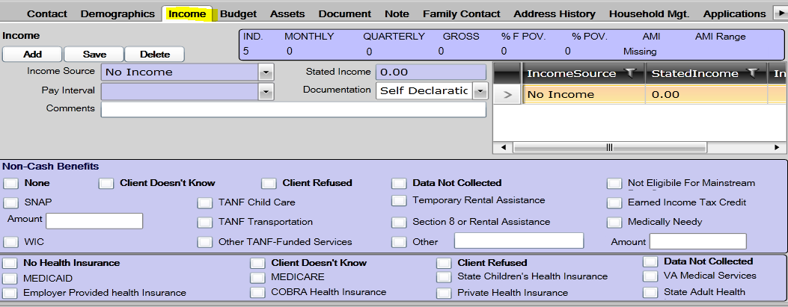

- Once the Client Intake information has been entered you are ready to enroll in the Tax Assistance program. On the Client Intake Page there is a button which will take you to program entry (right above the person’s head). 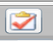 OR click on the Entry in the programs listing.
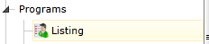
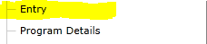

THIS IS THE NEW PROCESS
Click the new button to view the list of programs for enrollment - select the Family Support
Program status is enrolled
Consent level is ORGANIZATION
Case Manager will be entered once you hit the save button
Enter the ‘entry date’
Click SAVE.
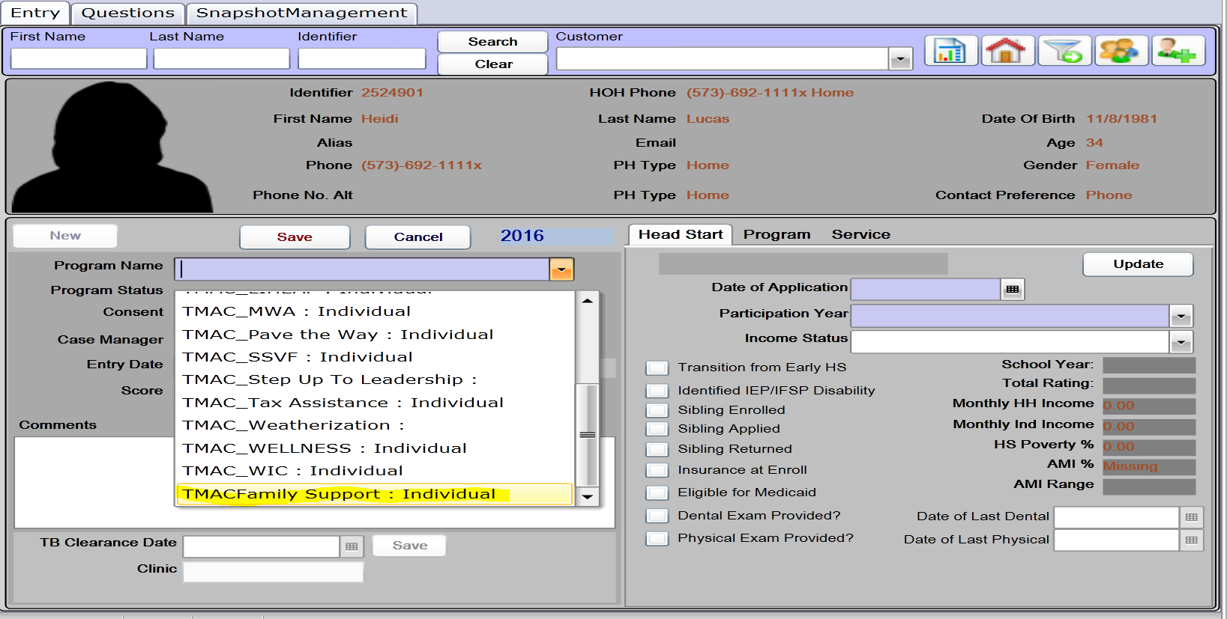

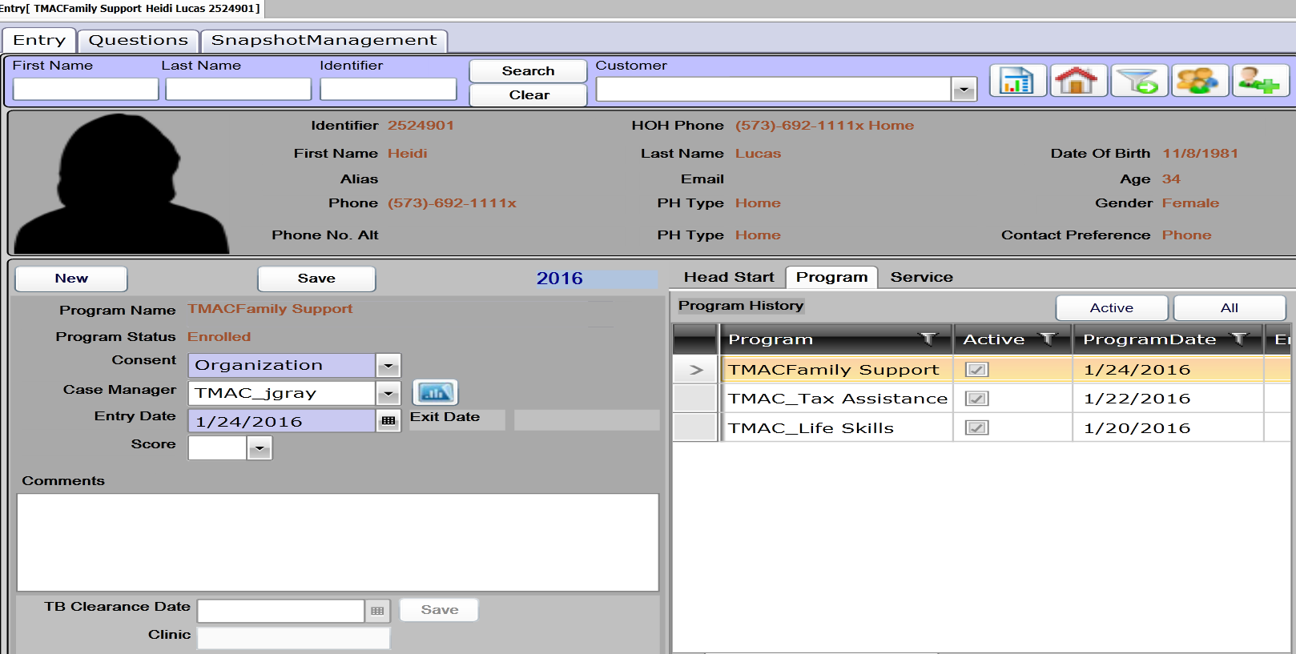

To add the FSS scale go to the Program Details Page.
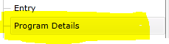
Consent-Populate Organization
Program Component-Family Support
Milestone-What is the milestone you are working on with your client. (you can pick multiple milestones on the Service & Activity Page.
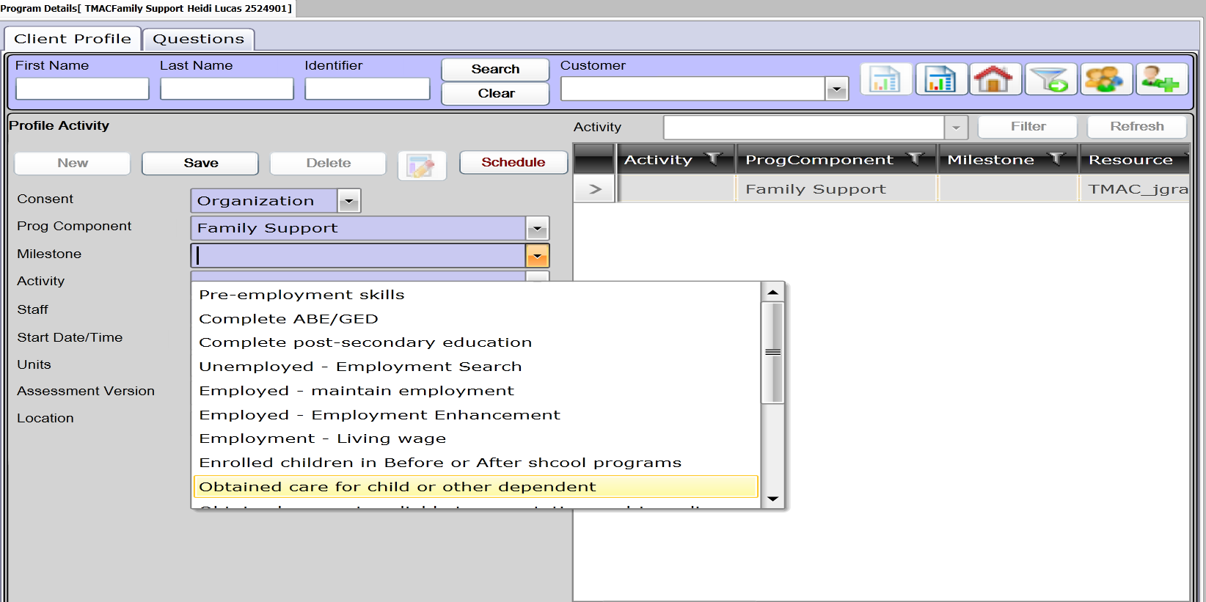

Acitivty FSS Scale
Staff defaults to user that is logged in
Date-date FSS completed
Click Save
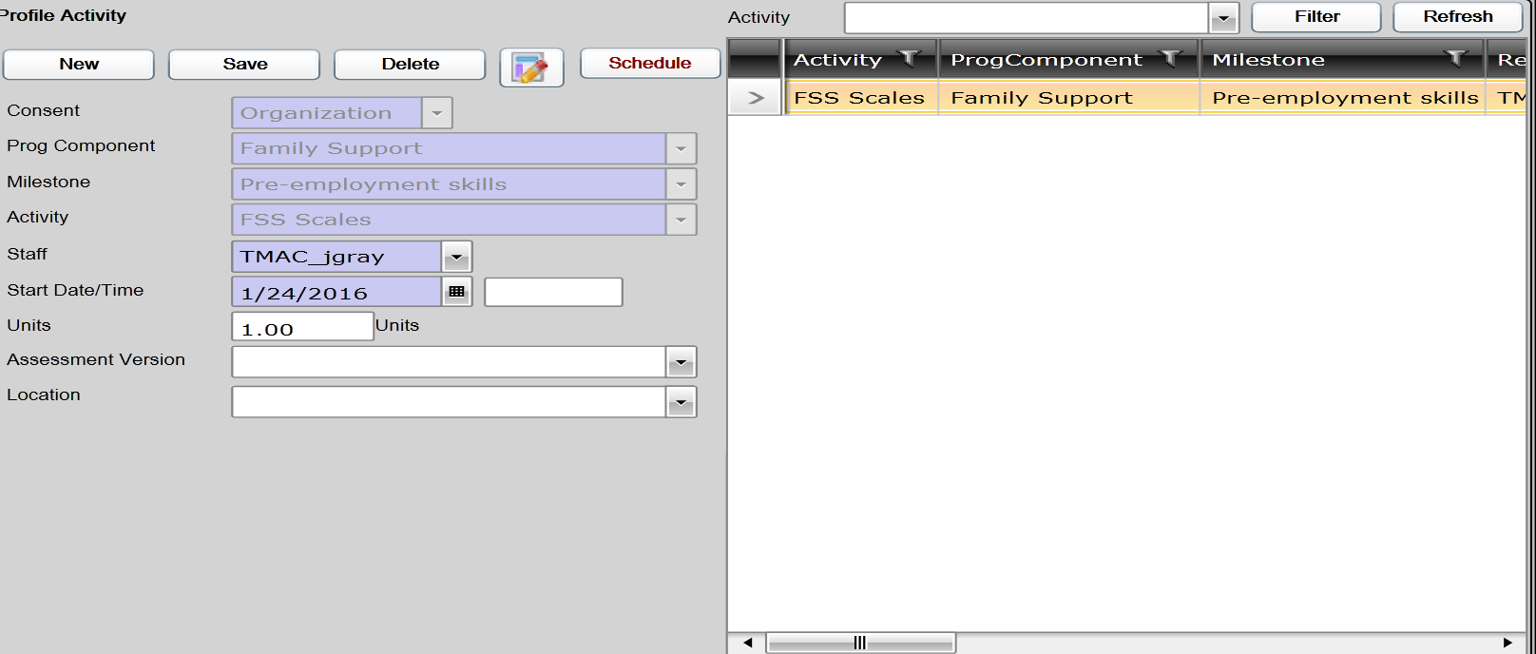
Click on Question tab
Answer ALL Questions (use scroll bar)
After you have answered all questions click
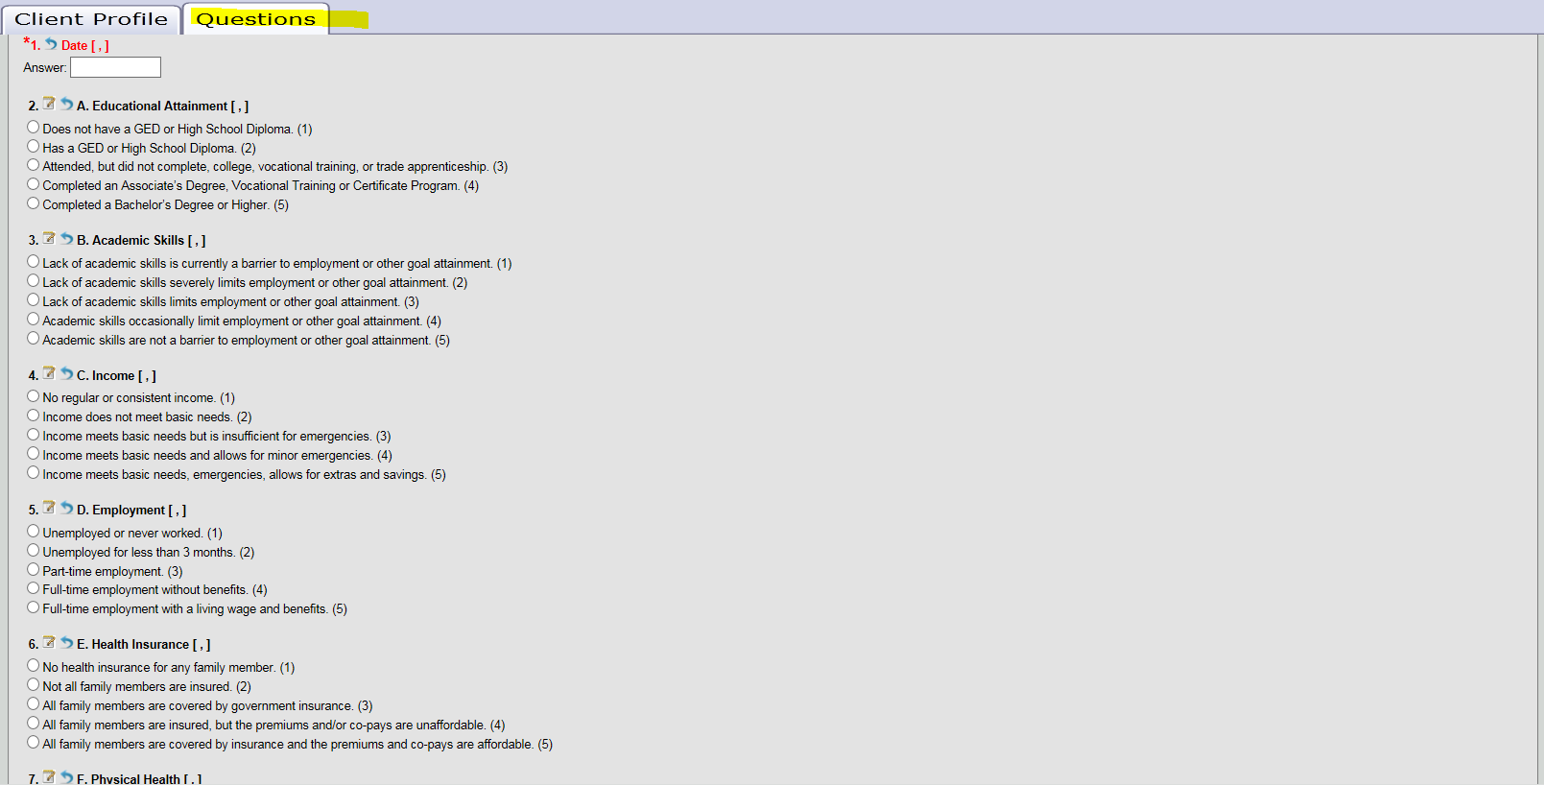

After you have answered all questions click Next.
This will bring you to the Response Summary tab. Review questions
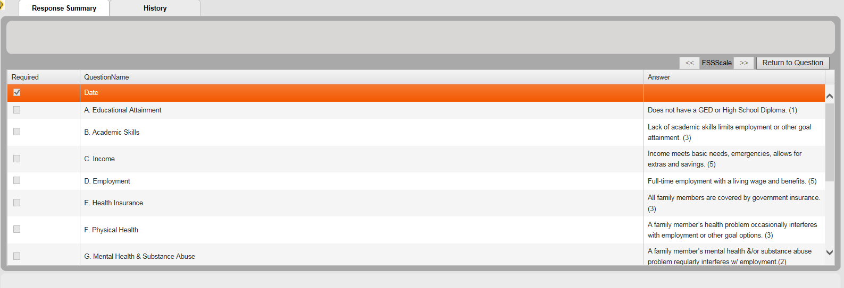
If you have answered a question incorrect you can click return to questions. You can scroll to the answer you would like to change then click next.
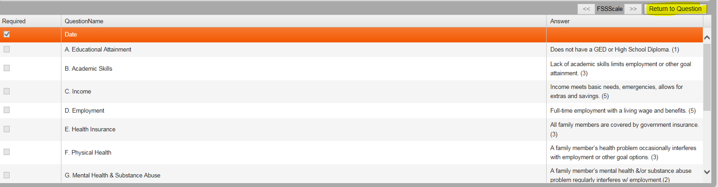
After you a verified questions are all answered you then will save answers.
Information collection date box pop will appear. Change date if different than today’s date. Click submit. If date does need to be changed click submit.
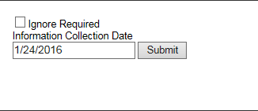
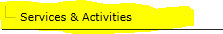
Choose Family Support tab. Current Situation tab will show the answers scaling from the FSS scale you have completed on the Program Details page. 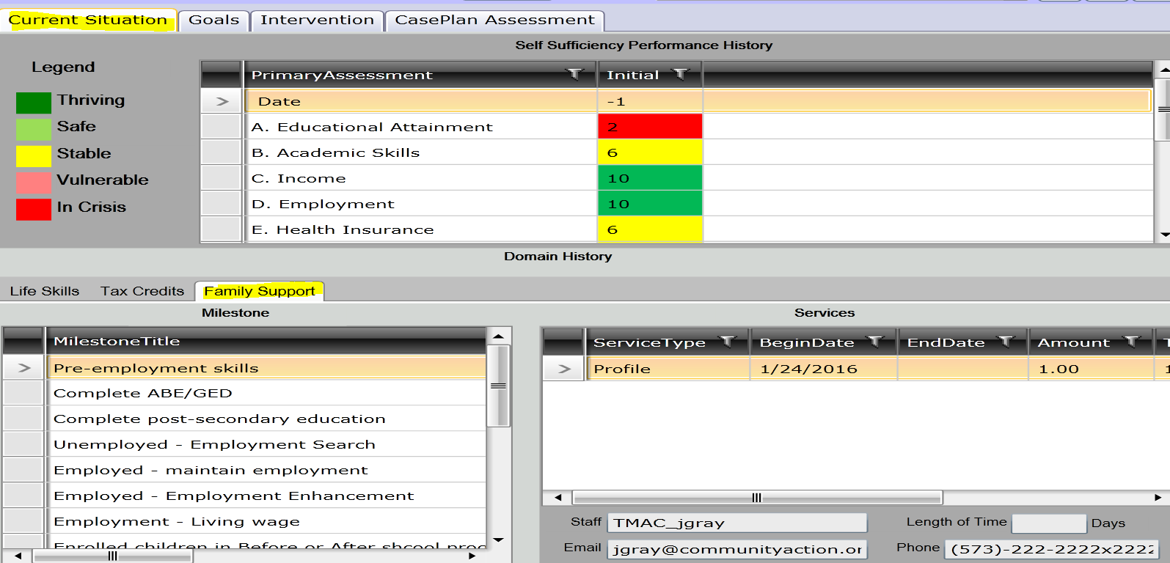
Colors/Scaling
= 5 on the FSS scale (shows 10 on current situation tab)
=4 on FSS scale (shows 8 on the current situation tab)
=3 on FSS scale (shows 6 on the current situation tab)
=2 on FSS scale (shows 4 on the current situation tab)
=1 on FSS scale (shows 2 on the current situation tab)

Goals tab
Consent-Defaults to Organization
Current Situation- What is the current situation of the client?
Goal-What goal will the client be working toward to help their current situation?
Staff-defaults to user logged in
Statues defined-
Incomplete didn’t not achieve the goal
In Progress currently working toward the goal
Complete the goals has been achieved
N/A-not applicable

Click Save
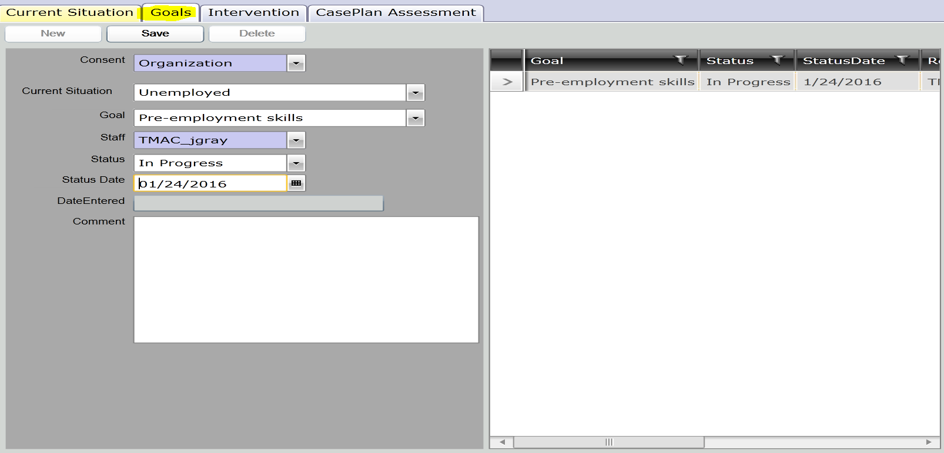

Intervention tab
Case Plan
Click New
Tasks-
What task does the client need to complete for the current goal the client is working on.
When is this task going to be completed or when does this task need to be completed by?
Who is responsible for this task-Client or Case Worker?
Domain-Family Support
Milestone Target-What milestone target this task being completed for?
Add comments
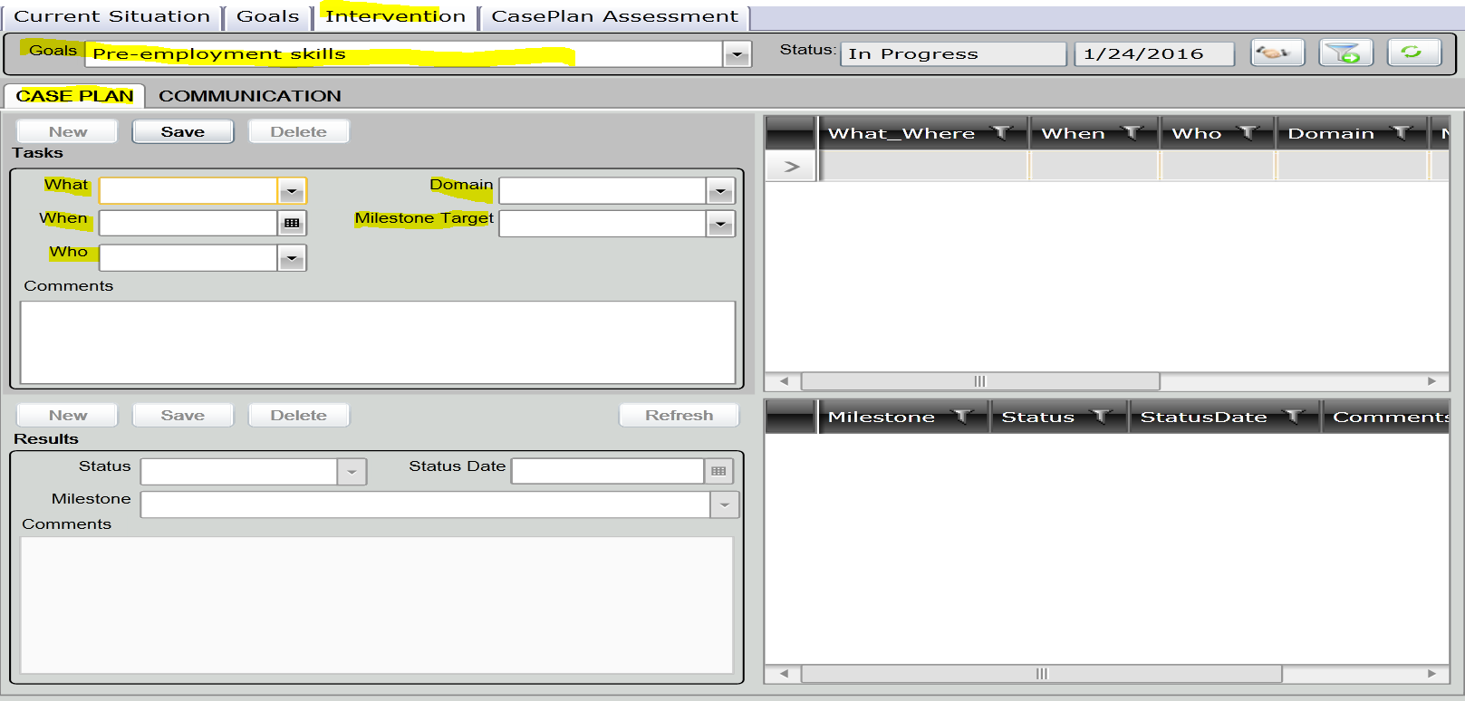
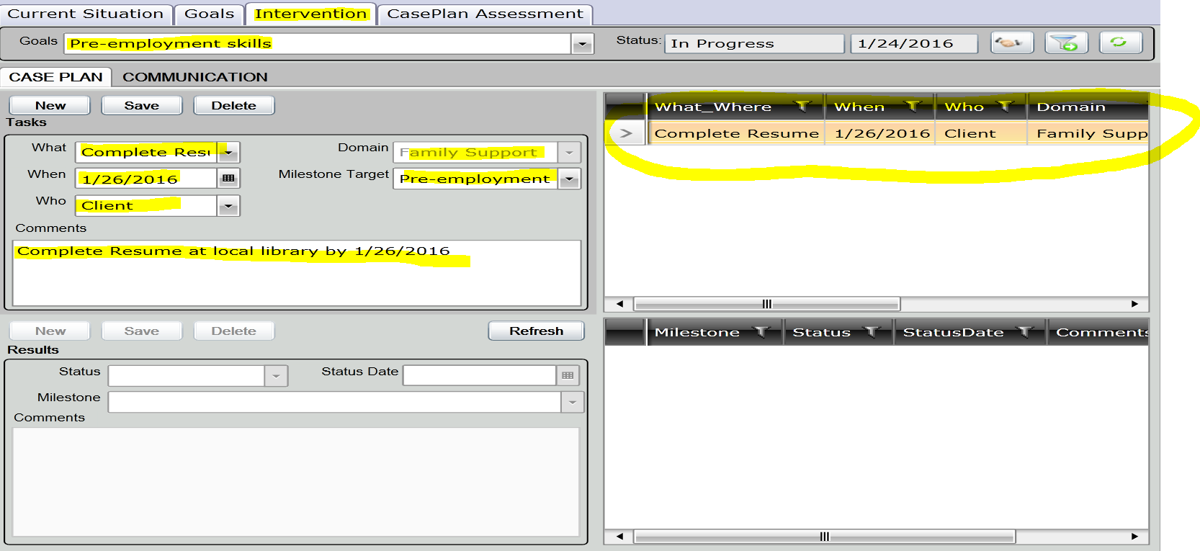
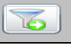- Will filter to goal domains/components
-show all services client is program activities are currently enrolled.
Click
Family support tab will appear.
This tab you will link your milestones/identify status/and tie activity to each milestone.
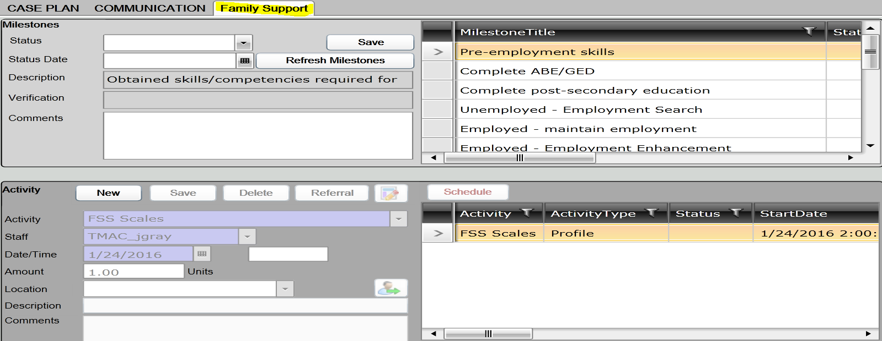
By clicking on milestone on the right this identifies what milestone you are updating. Enter status, date and click save.
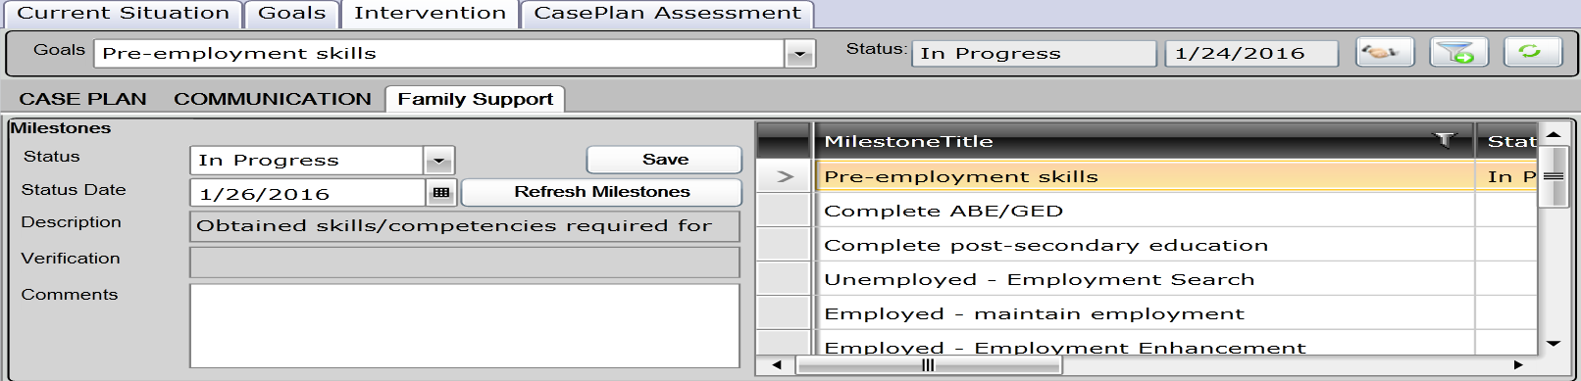

Each milestone must have an activity tied to it to count on the NPI reprots. FSS scale shows on this client because the FSS scale was completed for this milstone. If you want to add an additional milestone click new, choose milestone from drop down and click save.
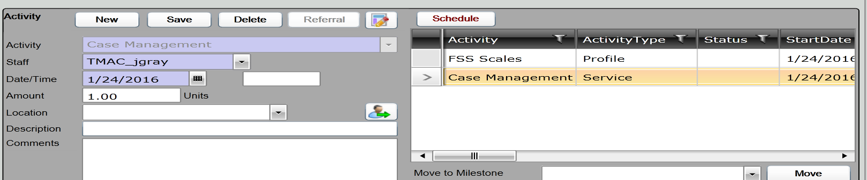

That milestone will now appear on the Case Plan Tab under results. 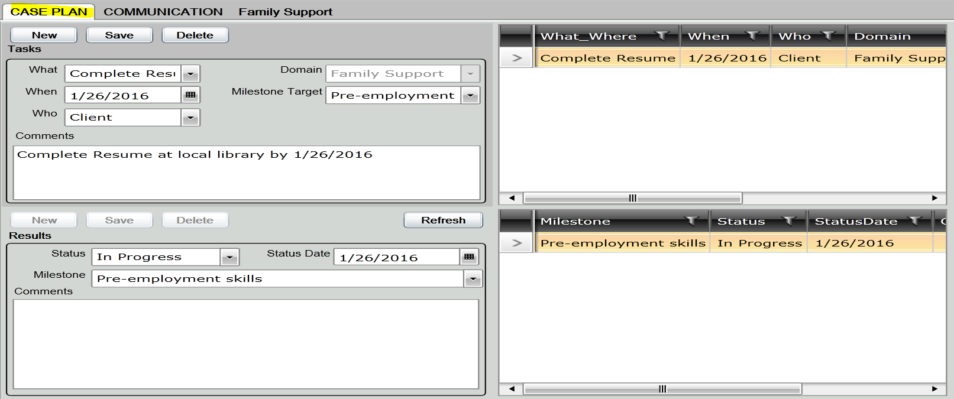
On the CasePlan Assessment tab you can additional FSS scales. Your initial FSS will need to be completed on the Program Details Page.
Answer questions and the Save Answers on the bottom of the page. 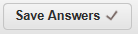
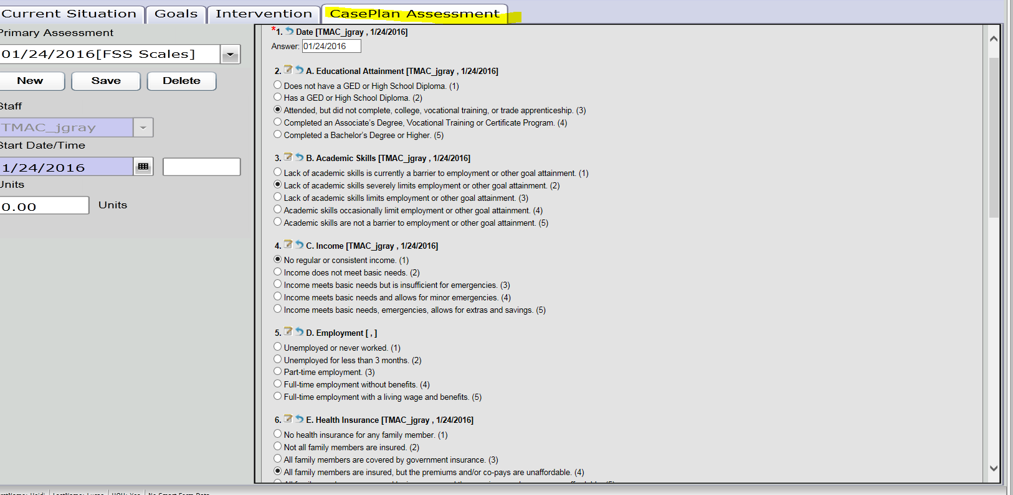
Now when I click on the current situation tab it will show my initial FSS and the new one that I have completed.
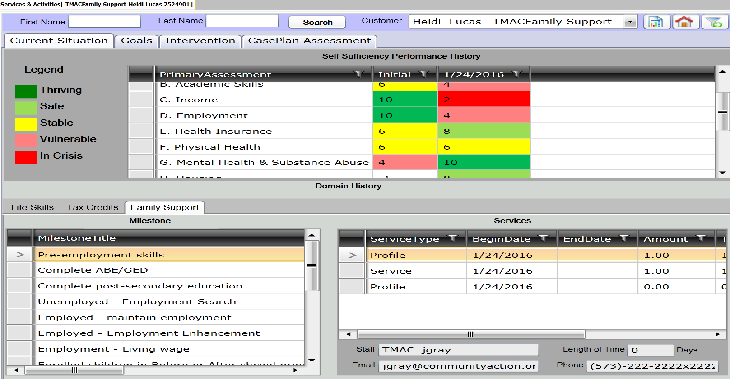

Click New
Consent-Defaults to Organization.
Component-Defaults to Family Support
Activity-Defaults to Case Note
Date-Defaults to date of entry. You can change the date.
Complete-Subject and Note information
Click Save.
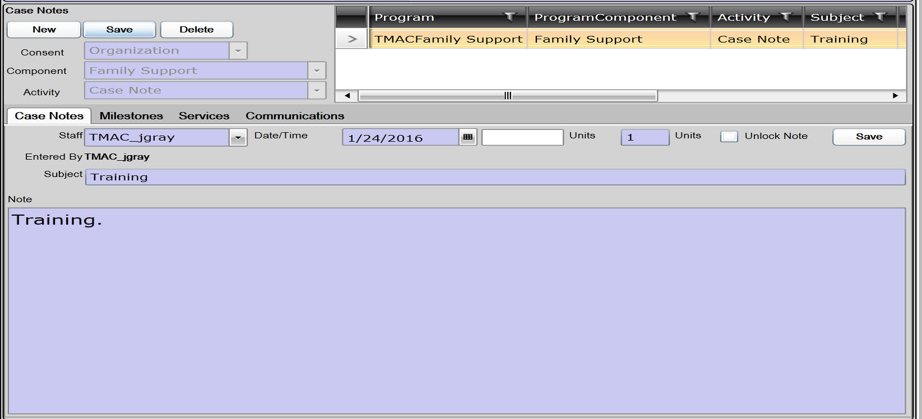
Milestone tab.
Check the box next to the milestone the case note is associated to. (You can select multiple milestones)
Click Save
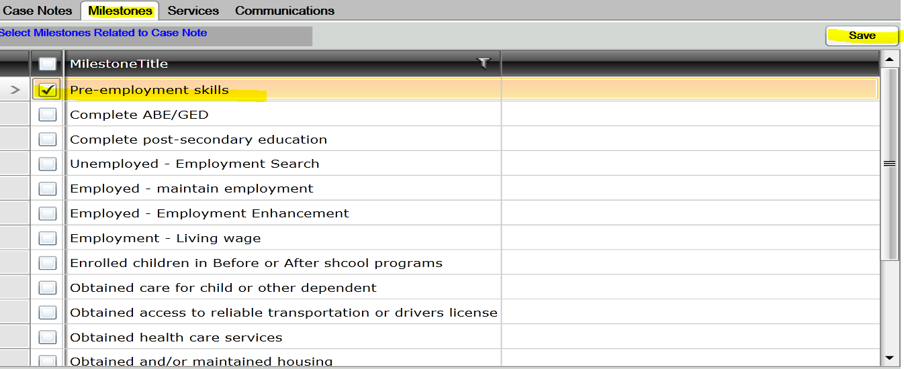
Services Tab
Check Case Management as the service you are providing to the client. The milestone will appear in the dropbox.
Click Save

