Summary:
Use Exit Clients from Program page to provide an end date of your Client’s Case File
Start: on Exit Program tab:  - Click Begin Exiting Client Out of Program  - Enter Destination and Reason for Leaving as necessary  - Click SAVE  If Family/Household Program, the Select HH Member popup window will be displayed  - Select Household Members who will exit | 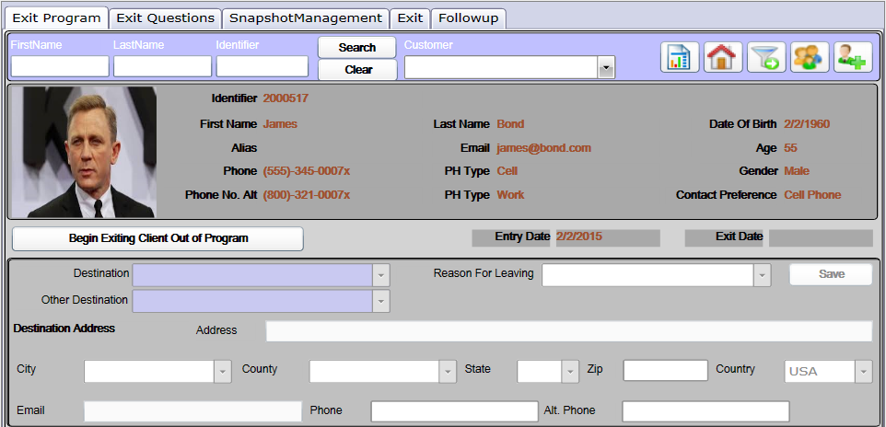
Next: on Exit Questions tab:  - Answer required questions  - Click NEXT or Page Number to answer additional questions  - Some questions may require a comment or may jump to another question based on your answer  - Click END, then click SAVE ANSWERS  Remember to answer questions for  each Household Member | 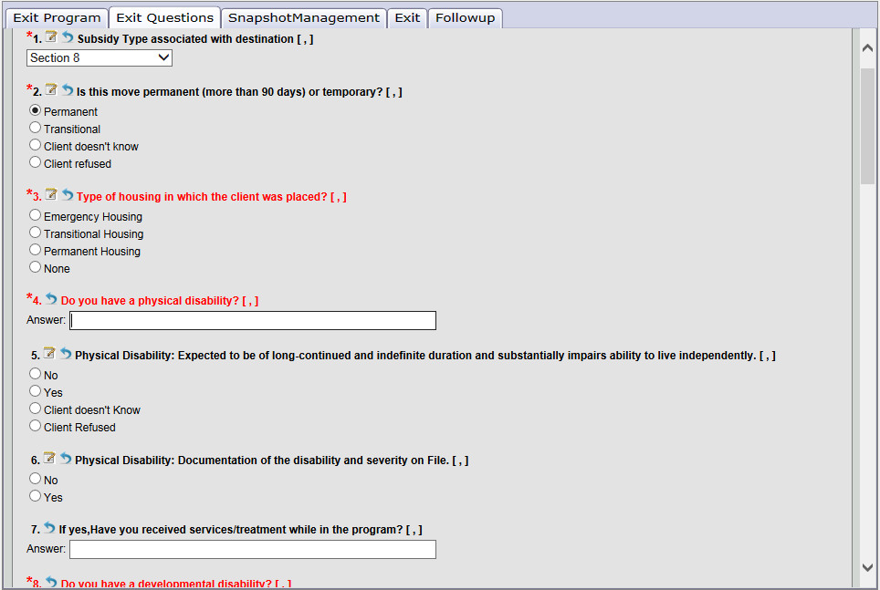
Next: on Snapshot Management tab:  - Update Income Information for all HH Members  - Add, Edit or delete income record as needed  - Add or edit Non-Cash and Insurance  Make sure you are editing the LAST Snapshot  (2 of 2, 3 of 3, etc.) | 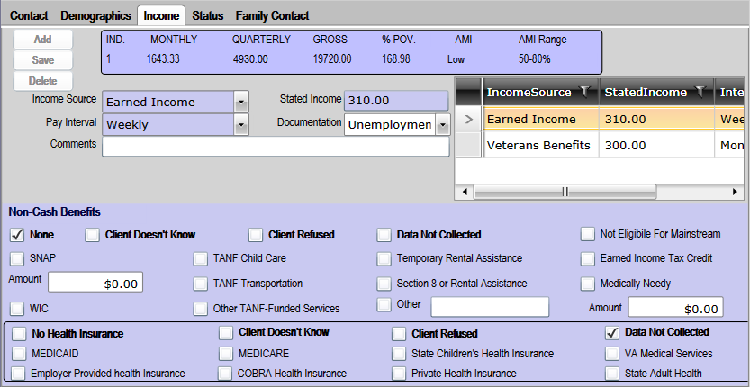
Last: on Exit tab  - Enter the Date of your Client’s Program Termination Date  - Click EXIT CUSTOMER(S)  Make sure Client’s Exit Income has been updated  in the Snapshot and all Services are up to date  before finalizing Exit  Optional: Case Managers have the option to use  the Follow-Up tab to collect additional information about the Client after exit while keeping  their original case file closed | 