Summary:
Use Enroll Clients into Program page to create and manage your Client’s Case File
- The Client Dashboard puts key client information at your fingertips  - You can search by Client, Household or your entire Case Load | 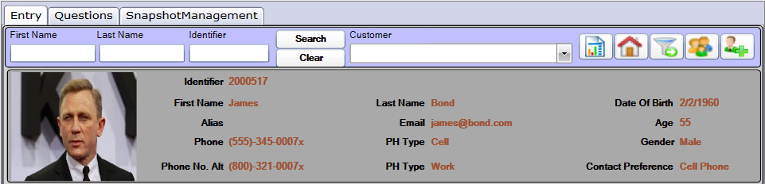
Start: Begin Entry Process on ENTRY tab:  - Click NEW  - Select Program and Entry Date  - Answer any additional information as required  - Click SAVE  If Family/Household program, the Select Household Member Popup window will be displayed  Case Manager and Consent may be changed if needed after Save | 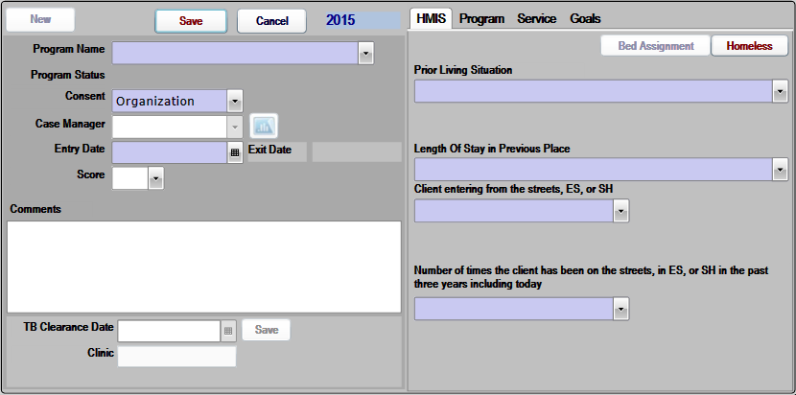
Next: Answer Entry Questions on QUESTIONS tab:  - Answer required Questions  - Click NEXT or Page Number to answer additional questions  - Some questions may require a comment or may jump to another question based on your answer | 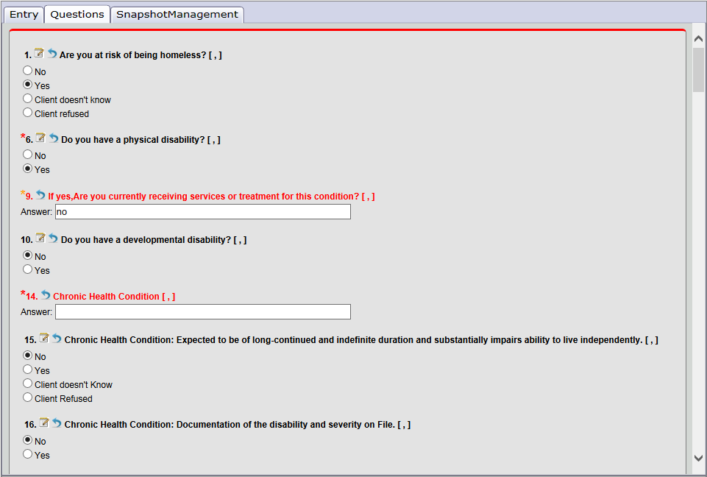
Last: Save Answers on Response Summary tab  - Click END to view Response Summary  - Review your answers  - to make corrections, select the Group and click RETURN TO QUESTION  - Click SAVE ANSWERS when complete  - You may need to enter date after saving  History tab may display any answer edits | 