**The process to search for clients and enter and/or update the client demographic information has not changed. It is included in this for documentation purposes. This process has not change – continue to follow your agency’s approved procedures.**

1. Search the MIS system, using the **Client Listing Page** before entering the information. You can search by SSN, First Name, Last Name or DOB.

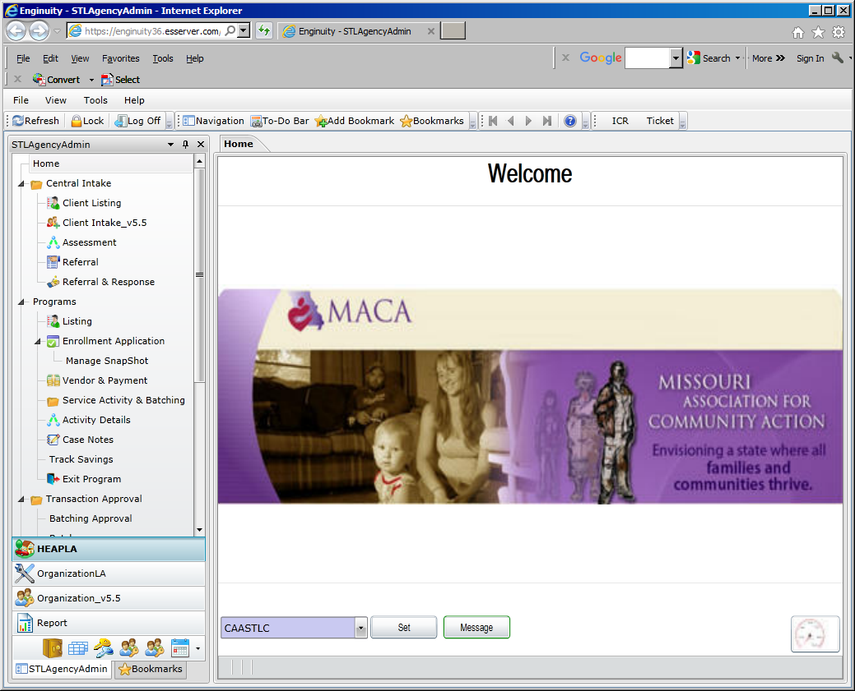

1. If the client is found, highlight the client name and click on the **Client Intake v5.5** to update information such as – family members, income, education levels (if known), and insurance (if known). Click the SAVE button when finished.

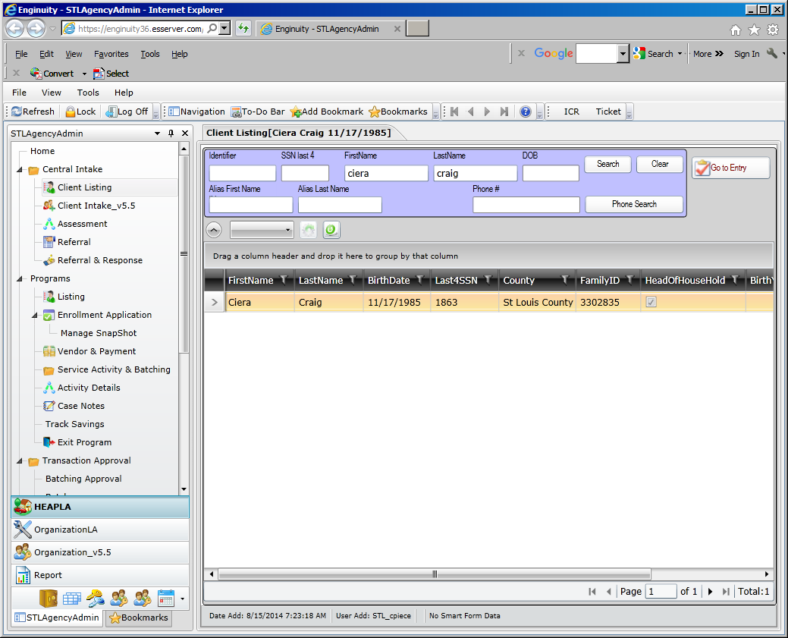

1. If the client is **not** found, click on the New Household. Consent level is region Client Intake v5.5 page, which means the entire Missouri CAA network can view the client data. The following information is required on the Contact Tab:

SSN Street Name

SSN Code City

First Name County

Last Name State (always MO)

Date of Birth Zip

Street # Zip Data Quality

* If there is an apartment address, that information can also be entered
* Phone number can be entered
* Be sure to click the SAVE button when finished.

**CSBG required fields are highlighted in the blue boxes. Enter information for each family member in the household.**

1. Enter Contact information

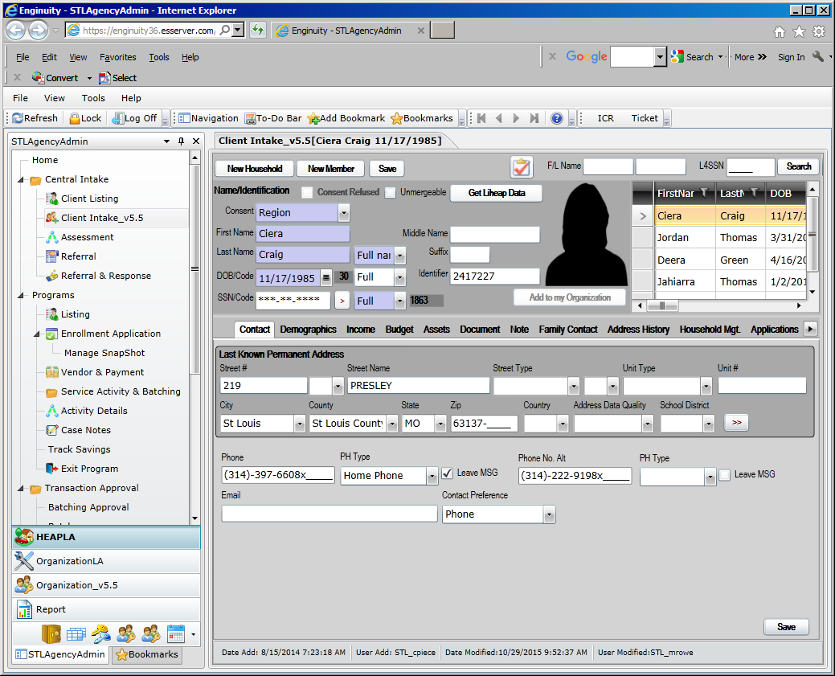

1. Click on Demographics Tab to enter household member information.

Enter information for each family member in the household. Click the SAVE button when finished.

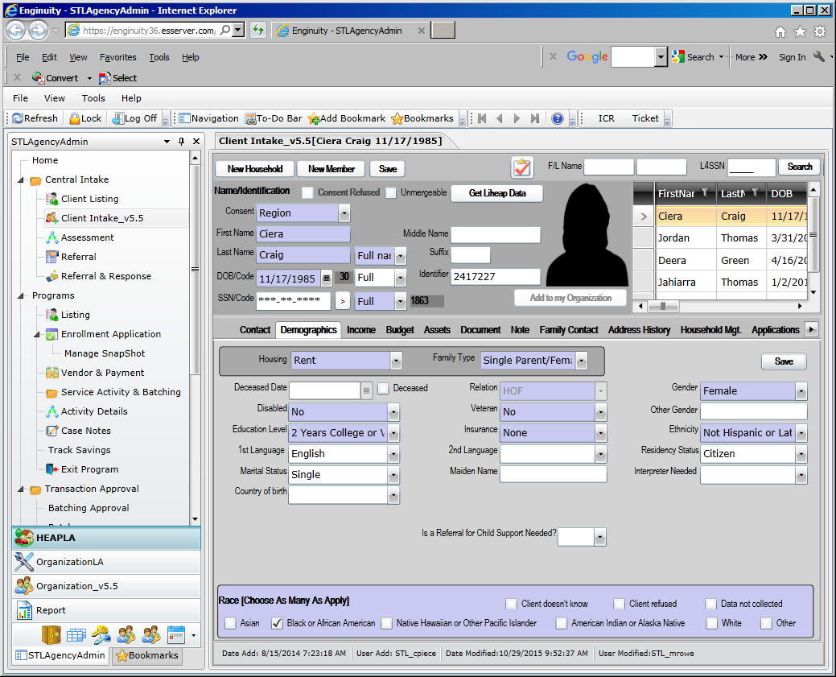

1. Click on the Income tab to add income.

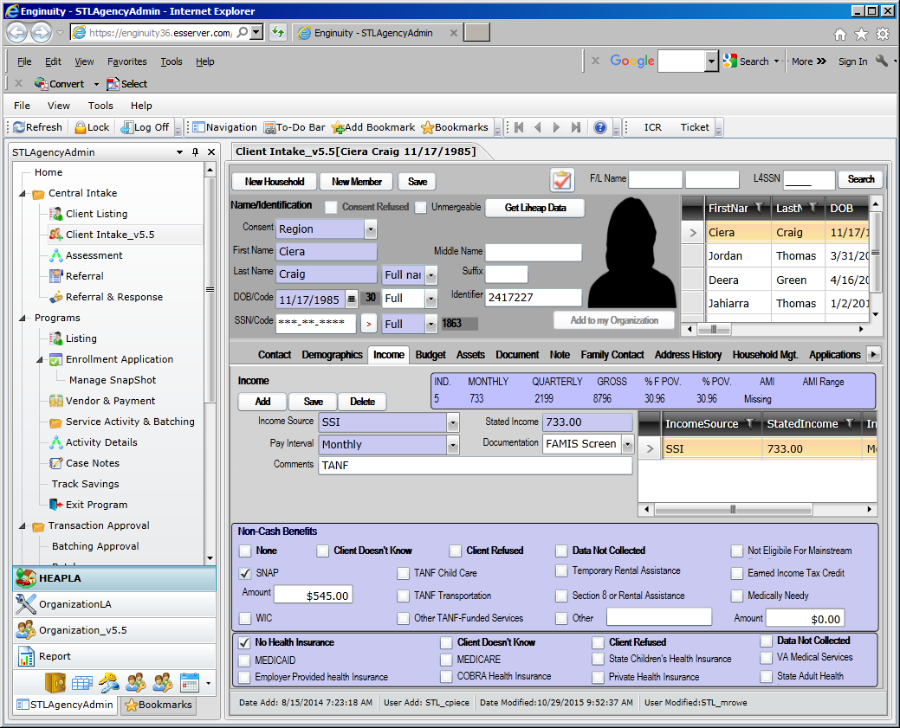

1. Once the Client Intake information has been entered you are ready to enroll in the Emergency Assistance program. On the Client Intake Page there is a button which will take you to program entry (right above the person’s head). OR click on the **Entry** in the programs listing.

**THIS IS THE NEW PROCESS**

***To determine if the client is enrolled in Emergency Assistance for the current year:***

Click on listing to search for the client

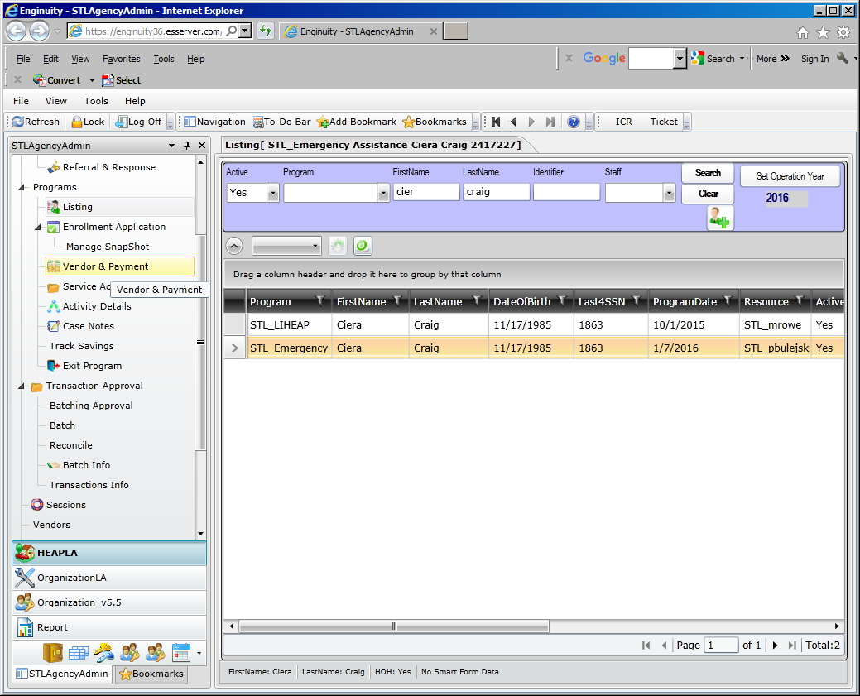

**OR**

On the Entry page: all program enrollments will display for the client. If you want to view only active programs, click on the active button and only active programs will be displayed.

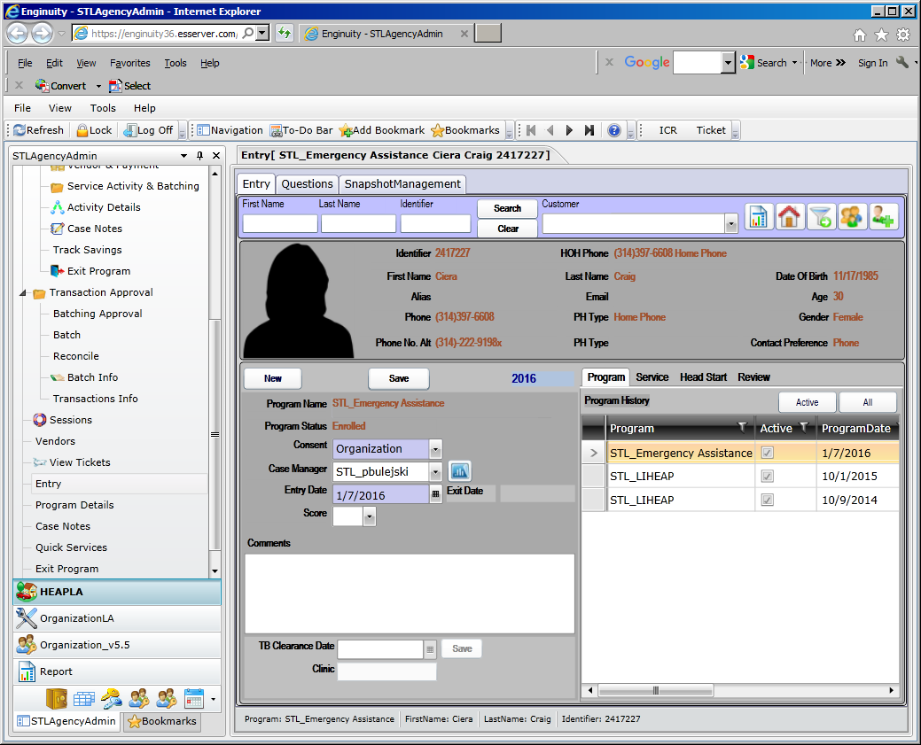

Highlight the Emergency Assistance program.

To add the emergency assistance service and/or activity, click on Services & Activities:

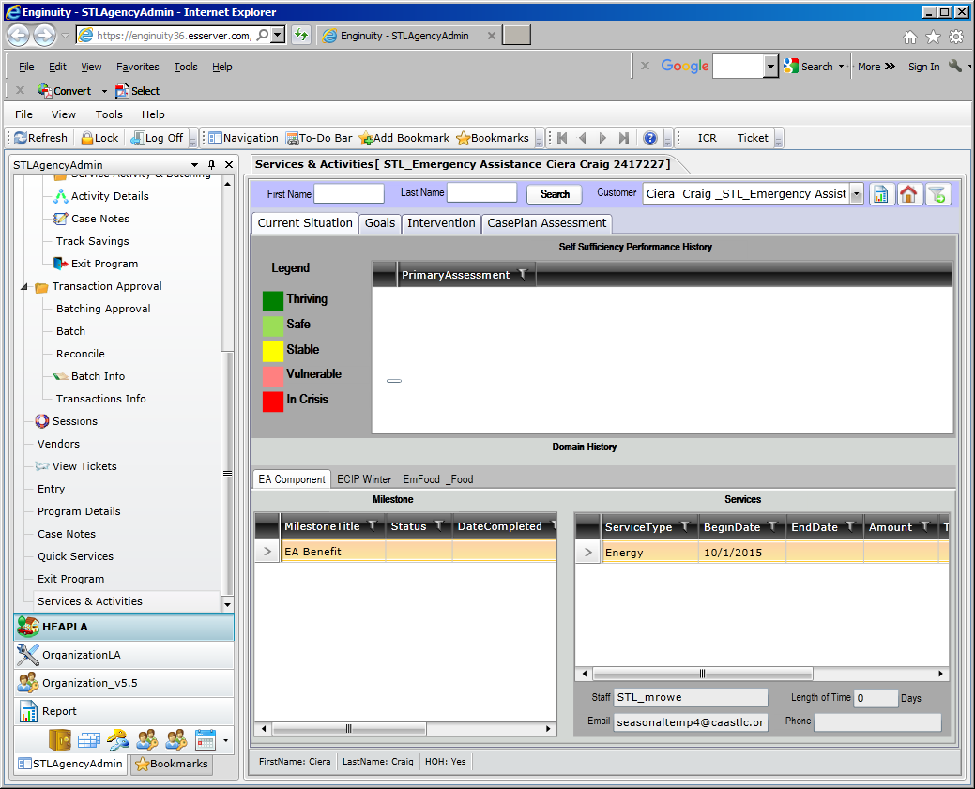

Click on the Intervention Tab to add services.

**\*\* if the program component/activity is set to auto create, the program component/activity will be created once you enroll in emergency assistance \*\***

**See the example of EMFood_Food activity – the Auto Create is checked.**

**This information is found on the Organization/Program Targets page.**

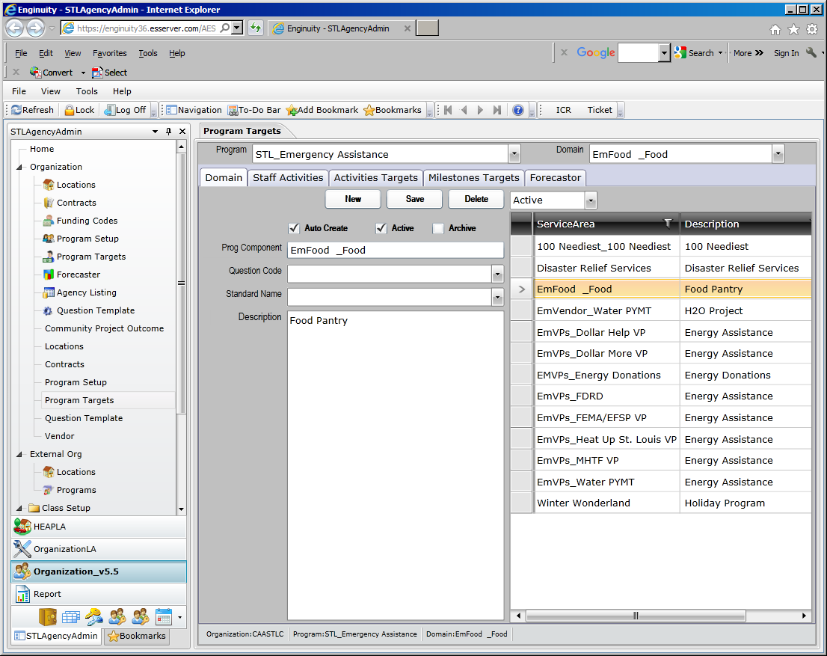

Programs the client has been enrolled in will display.

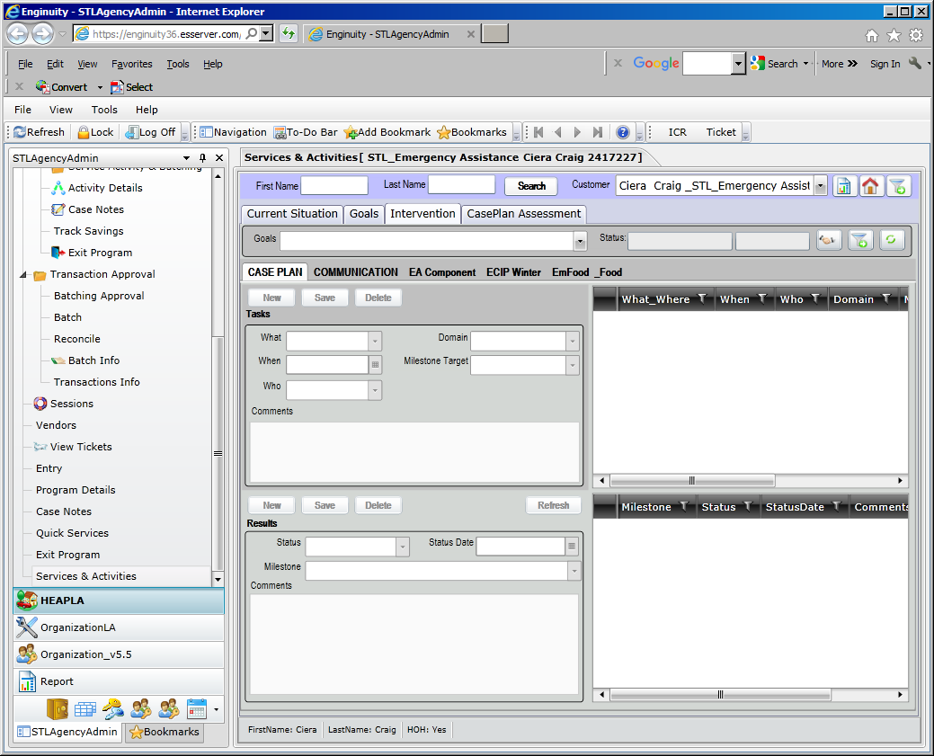

Select the appropriate emergency assistance component.

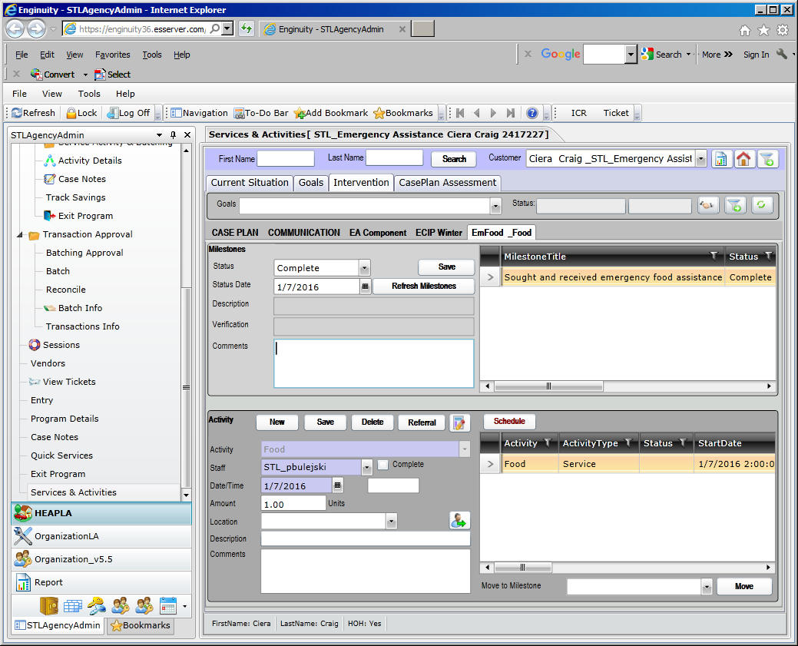

Click new to enter the service.

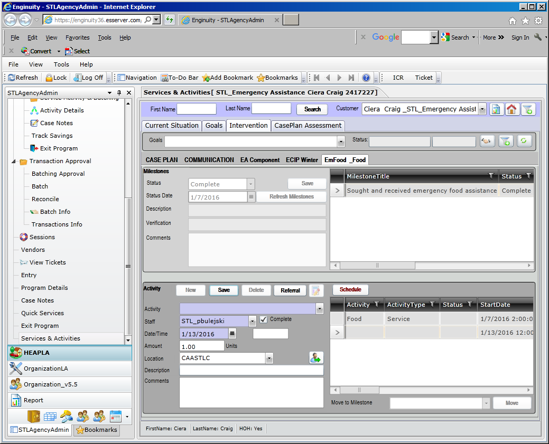

Enter the activity.

Enter the date service received.

Enter the amount, if required.

Click save.

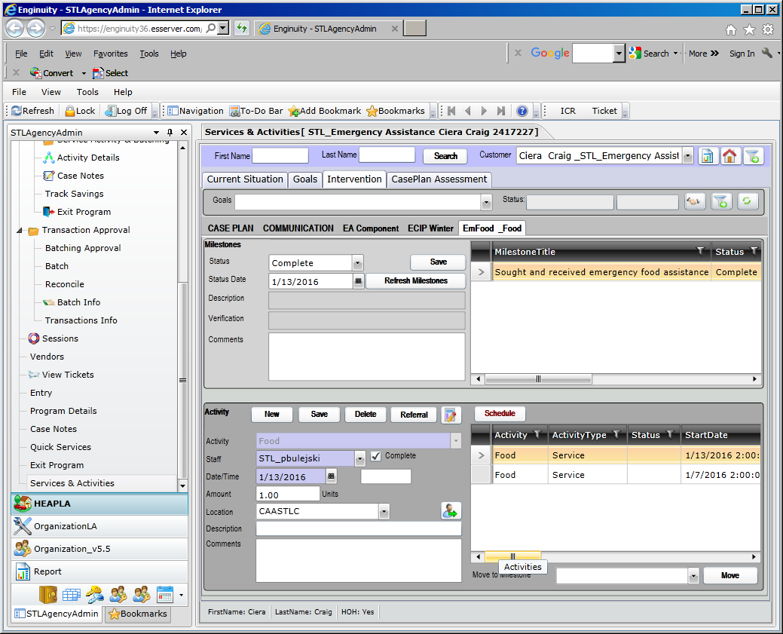

Service for food pantry has been recorded for this client on 1/13/16.

Batching Approval, Batch and Reconciliation of Emergency Assistance Services:

**This process has not change – continue to follow your agency’s approved procedures.**

***If Client is not enrolled*** in Emergency Assistance program for the current program year:

Search for client under the listing

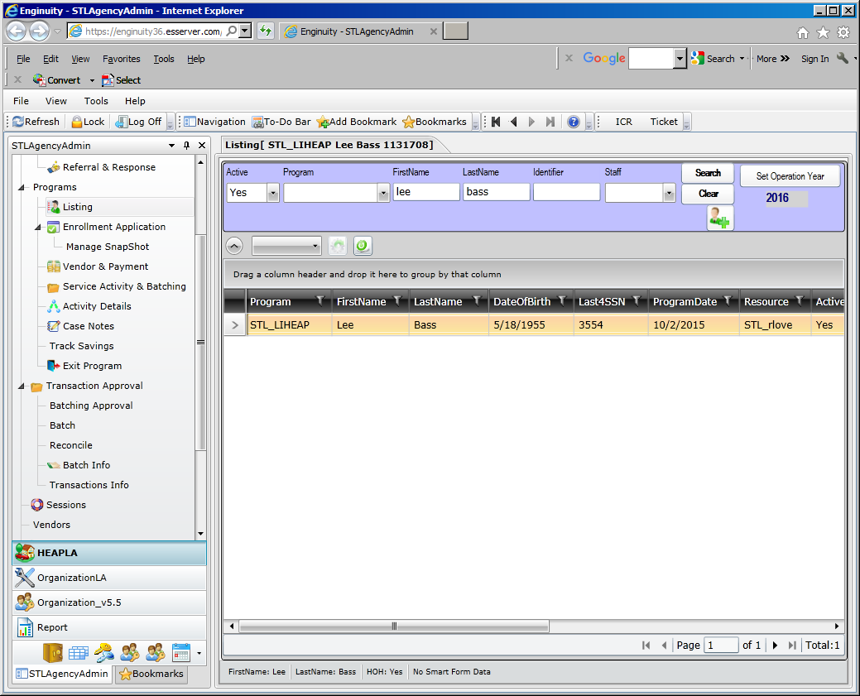

Client is not enrolled in Emergency Assistance.

Click on Entry to add program enrollment.

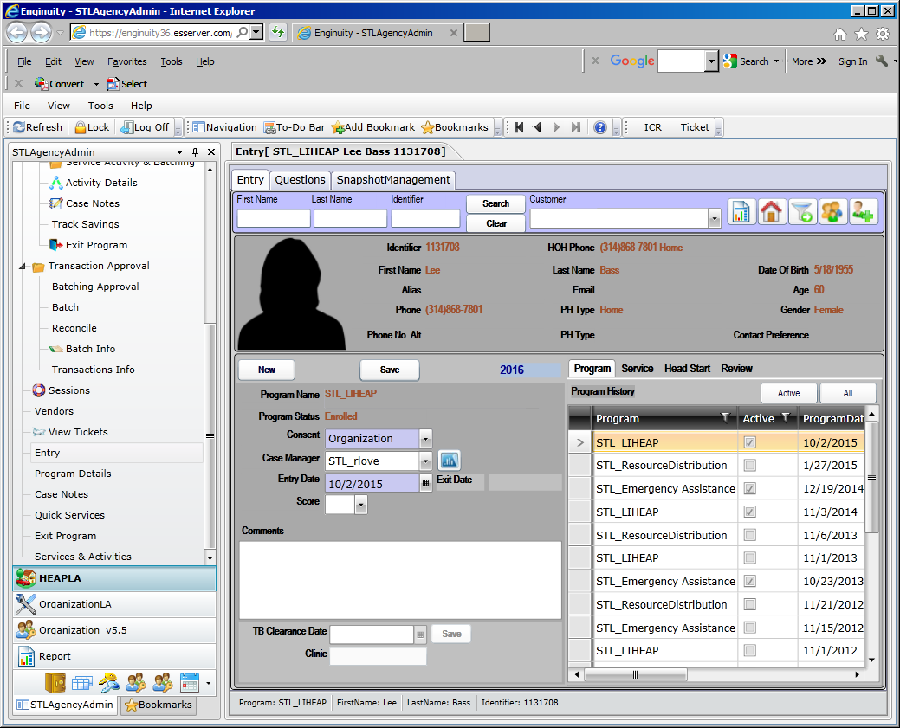

Click new to enroll in program for current program year.

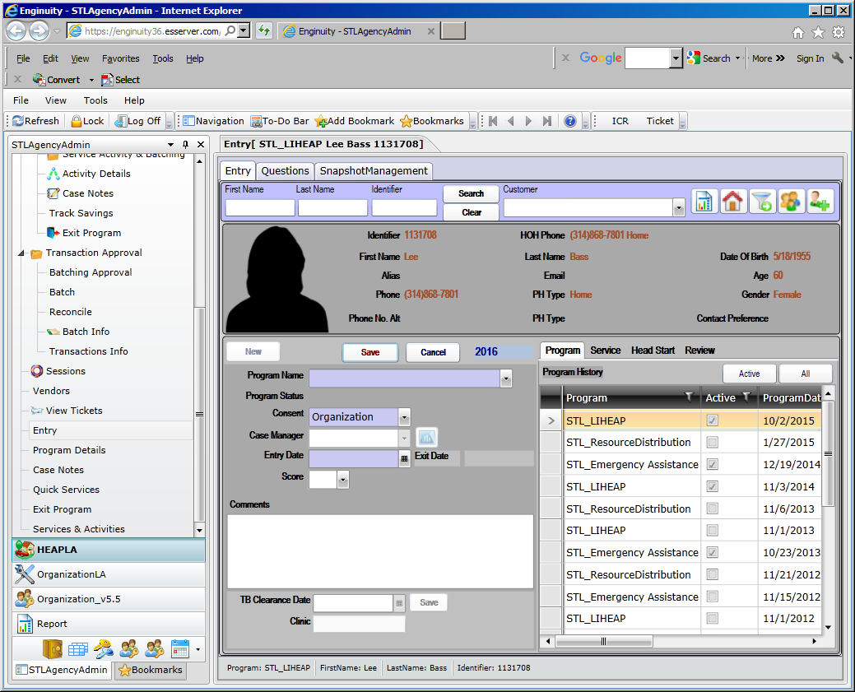

Click on the drop down for program name, select Emergency Assistance.

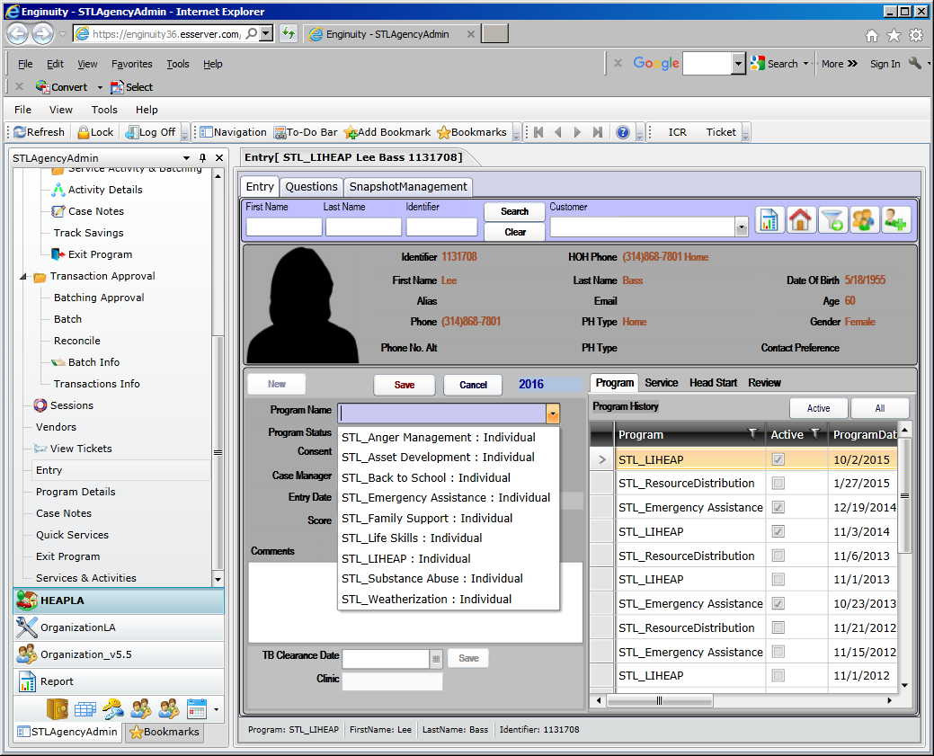

Key in entry date

Click save

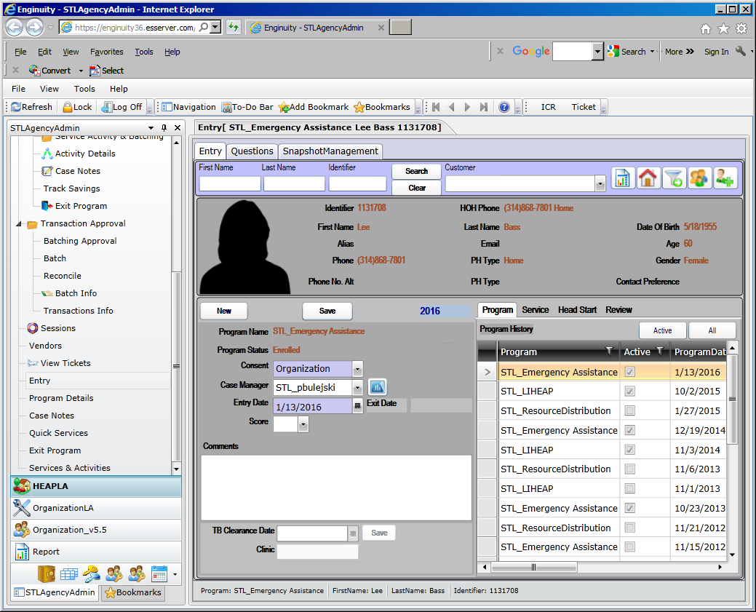

Client is now enrolled in Emergency Assistance. If your agency answers questions regarding emergency assistance, click on the question tab.

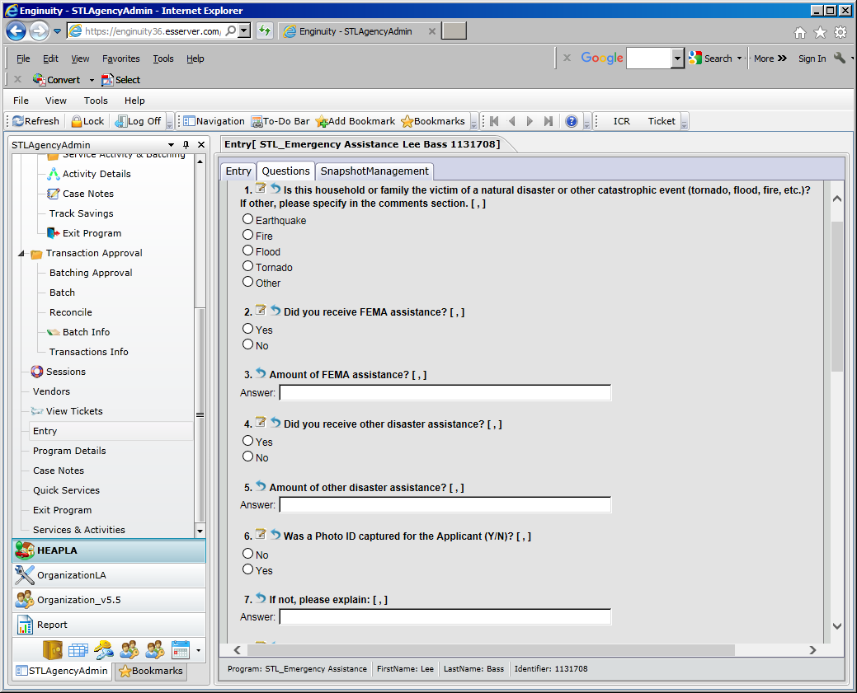

Answer the questions, scroll down to save.

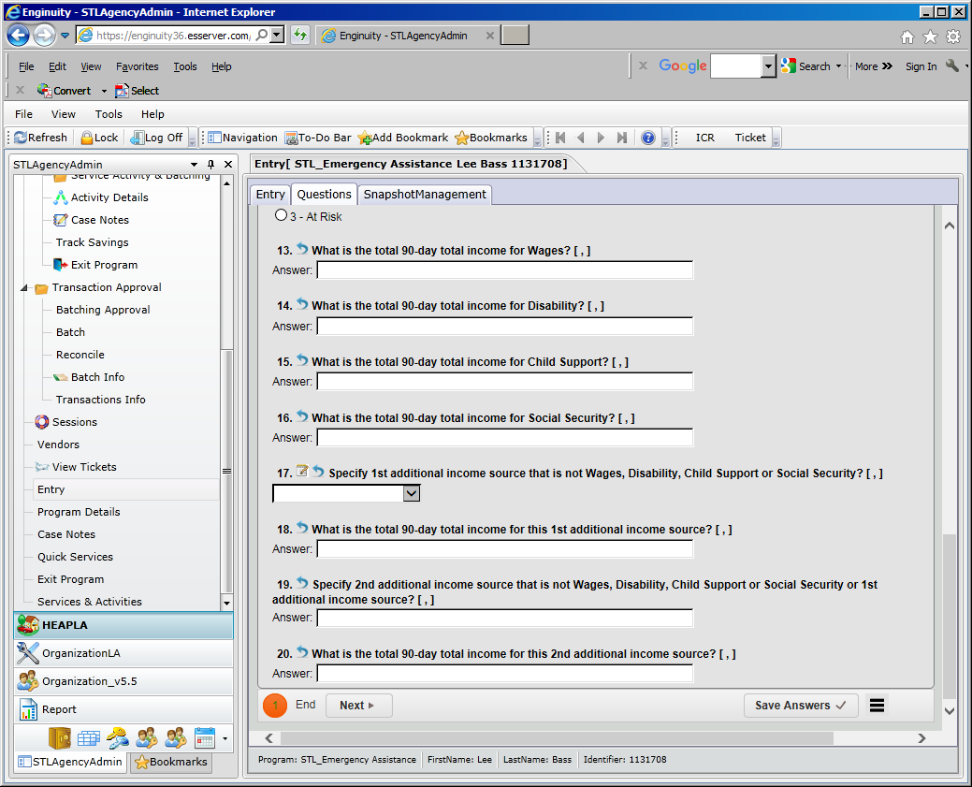

To add the service & activity, click on Services & Activities

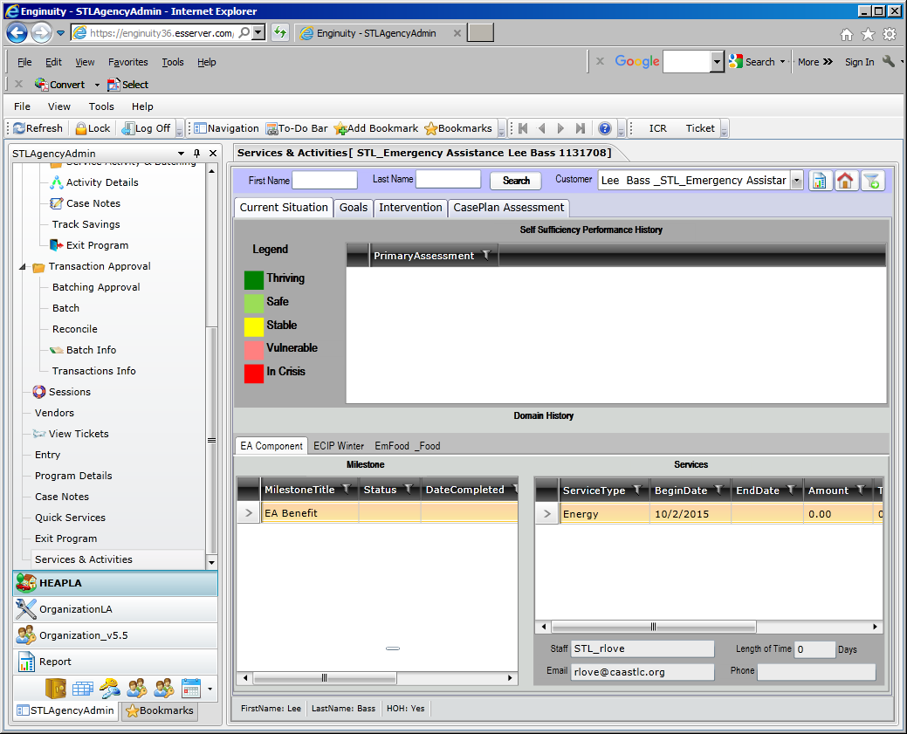

Click on the Intervention Tab to add services.

**\*\* if the program component/activity is set to auto create, the program component/activity will be created once you enroll in emergency assistance \*\***

**See the example of EMFood_Food activity – the Auto Create is checked.**

**This information is found on the Organization/Program Targets page.**



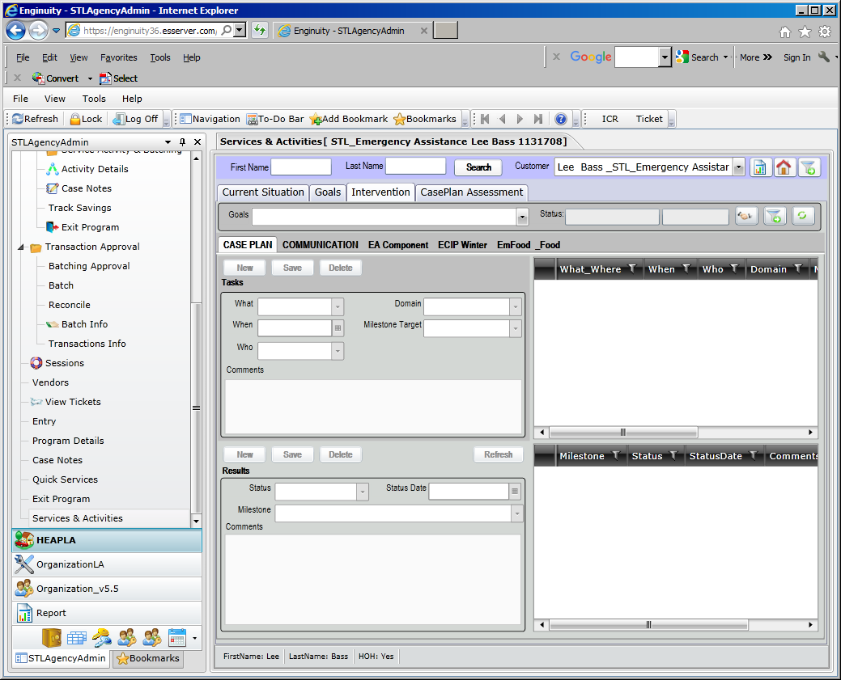

Click on the appropriate emergency service client is receiving

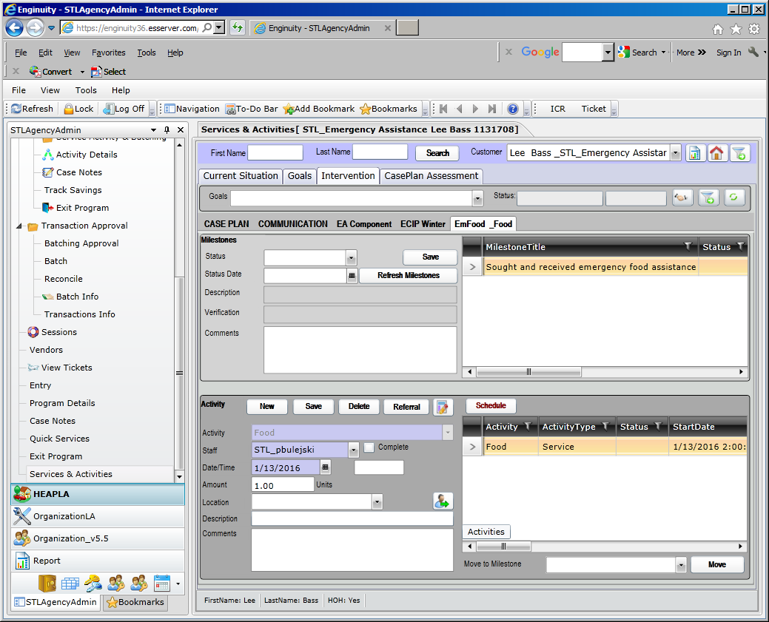

In the activities container the information is auto populated – verify the information. You can change the date of the service, if necessary. You might receive this message if you accepted the default date for program enrollment.

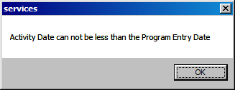

You can go back to entry and change the program enrollment date to the date the service was received. Then go back to Services & Activities and change date to the date service was received. Click Save.

Service for food pantry has been recorded for this client on 1/13/16.

Batching Approval, Batch and Reconciliation of Emergency Assistance Services:

**This process has not change – continue to follow your agency’s approved procedures.**

**Report – Service Use by Participant** – this report will display the emergency assistance services recorded for the program component/activity.

Click on Reports, select Services Use by Participant.

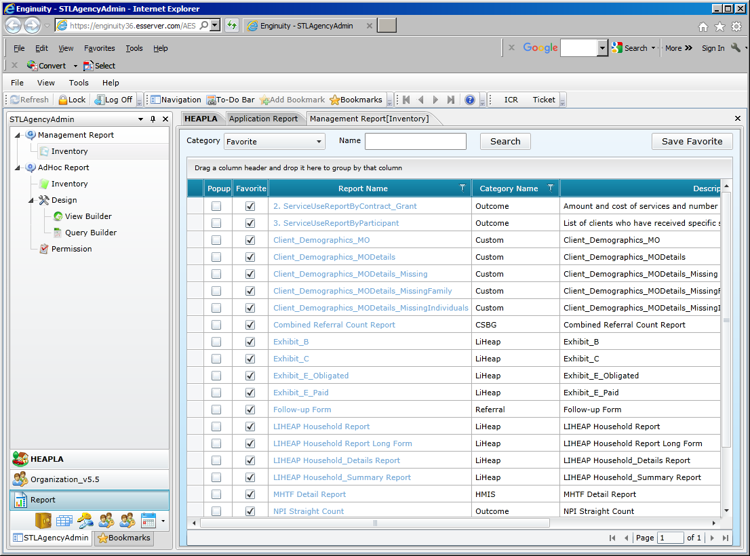

Enter the parameters for the report.

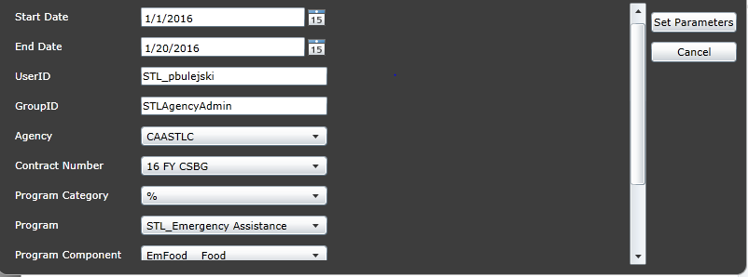

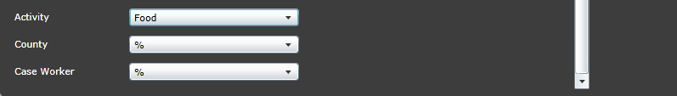

Click Set Parameters.

Report is displayed.

