MIS Community/Project Outcomes page
Description of use: Entry form to record projects, the number of participants (individuals or partners) and the outcomes achieved. The idea is to allow data entry for community projects that will then be counted on the MIS Outcomes reports for all six goals, when they are not linked to individual client records through enrollment in a program.
Example: An agency operates an employment & training program, with a target of 50 individuals obtaining employment. 100 individual clients are enrolled, and 50 achieve the target. This would be recorded through the individual client records (typically through Case Management activities under the Family Support program), and counted on the existing report processes, with no changes required.
The same agency also collaborates with community partners on an employment & training initiative with a target of 500 additional people obtaining employment but the agency may not know who these individuals are, and may not have any demographic data for these participants, and they were not enrolled in any agency program measuring this outcome.
This form/page allows the agency to record the project in the system, link to the contract that is funding the partnership efforts and to select the appropriate NPIs. The data entered through this page must be available on all management outcomes reports (i.e., NPI Goal reports, NPI Straight Count Report, Quarterly Outcomes reports, etc.). This data does not need to be available for reports that look at individual client records, such as the NPI Straight Count Detail report. Each new record on this page constitutes separate targets and outcomes. For example, if a project is tracking three different outcomes, that project will have three separate records (with outcomes recorded quarterly or annually as needed). Another project that tracks only one outcome will have only one record.
A screenshot of the page is included below, with an example record entered. .
Field names and descriptions:
- Project Name: data entry – select existing project or type in new project name
- Program Year: dropdown from list of valid years; default to current Operation Year
- Contract: dropdown – user select from valid agency contracts. If the project is not technically part of an existing contract, a placeholder contract can be created for the purpose, assigning it the NPI/s that apply.
- Outcome: dropdown – user select from valid NPIs linked to the selected contract; once the NPI is selected, the NPI Category, Description, and Unit of Measure for that NPI are displayed automatically. (If the NPI to be measured is not in the list, go to the Contracts page and add the NPI to those included for the contract.)
- Annual Target: Number of the things being measured, (participants, opportunities, referrals, etc.), you expect to achieve during the year/reporting period.
- Achieved #: Number of participants/partners achieving the goal for each quarter/entry
- Dollar Amount: Aggregate dollar amount of credit/payments/savings for each quarter/entry (used only for a small number of NPI targets)

MIS Community/Project Outcomes page :
Project Name: Type in as needed. Once added, project names appear in the dropdown after the screen is refreshed. This should help group project outcomes and minimize typing errors.
Program Year: Select from dropdown
Contract: Select from dropdown of currently active contracts
Outcome (NPI): Select from current NPIs linked to the selected Contract (NPI number and language is displayed in the dropdown list values, making the selection easy for users)
NPI Category, Description, and Unit of Measure: Displayed for the selected Outcome (NPI)
Annual Target: Number you expect to achieve during the program year of the NPI units being measured.
Outcome entries by quarter: Date, Number achieving the target during the reported time frame (i.e., during each quarter), and aggregate Dollar Amount (if required, such as for Tax Credits received). (NOTE: Date quarterly entries the last day of the quarter, regardless of when number is entered, so the result will appear on an NPI report for that quarter.)
Comment: Brief comments about the Project/NPI and outcome numbers (optional)
Documents Button – you can now import documents and attach them to the project name for project documentation/verification.

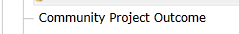

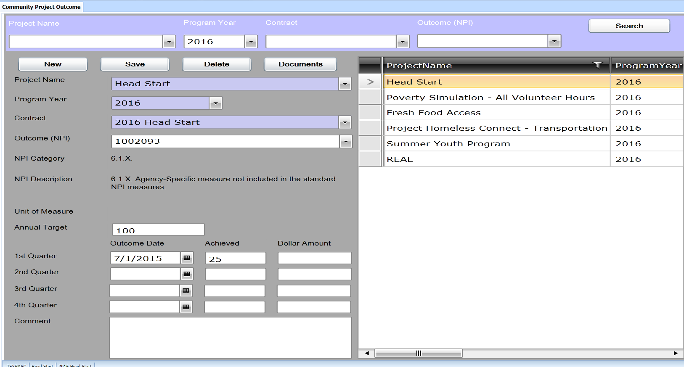
Community Projects Outcomes Page
I application role has been development XXX_Outcomes. This group only has access to the Community Projects Outcomes Page.
To set up this group in your agency follow these steps-
-
Go to User Group Page- To set up the new group.
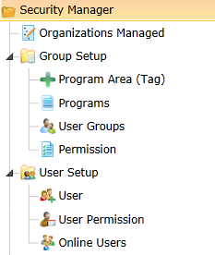
Click on the New Button
Enter in UserGroup box _Outcomes in the
Description- Only has access to Community Projects Page
Check the Active Box
Hit Save
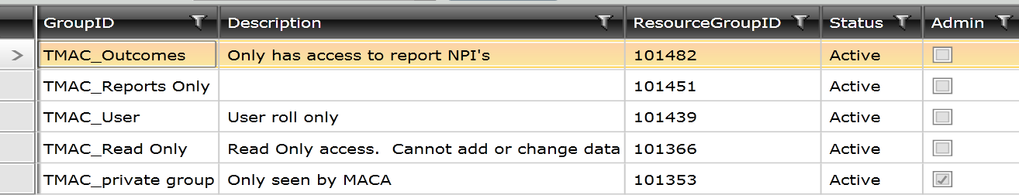

Go to the User Permissions Page
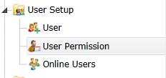

Enter the user id that you want to have access to the new group
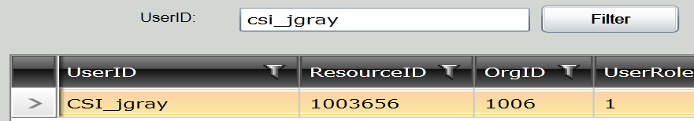

Click dropdown to select a group-Select the user group xxx_Outcomes
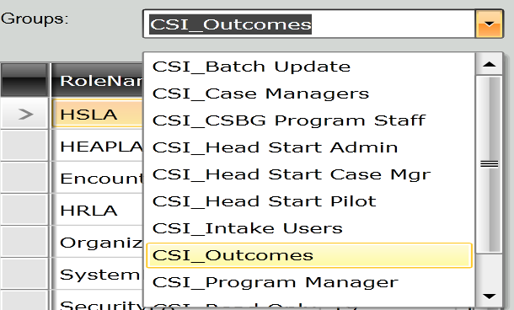
Select the Role Name-Organization Outcomes

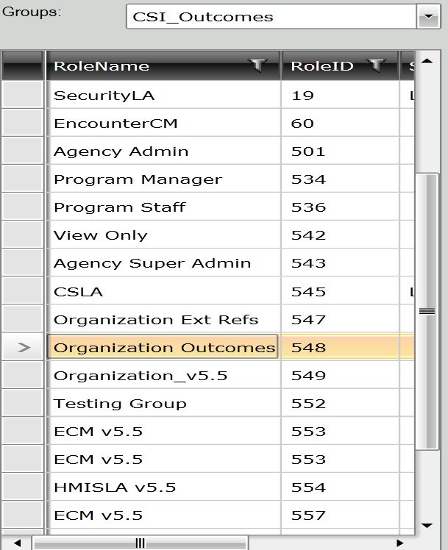

When new Role is highliged click on right arrow to grant rights

When the user logs in they should have this user group to select-xxx_Outcomes
