Report Parameters
A new drop down has been added that report parameters for Section G reports (and other widely used reports). This allows you to run a report for inactive contracts. By selecting ‘Yes’ is the dropdown. You no longer have to make inactive contracts active when this dropdown appears on the report parameters.
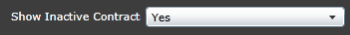
Demographics_MO(Section G)
State CSBG Section G report; run by contract, program, location, or agency-wide
Agency client demographics (summary data, in the format requested for state/federal reporting)
These parameters are when pull for the CSBG contract only. The Section G report should match when you pull the report with these parameters.
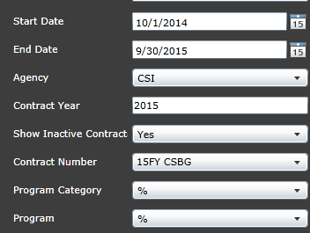
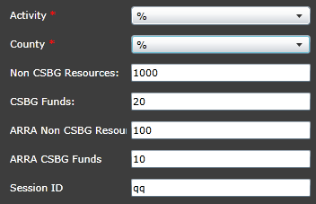
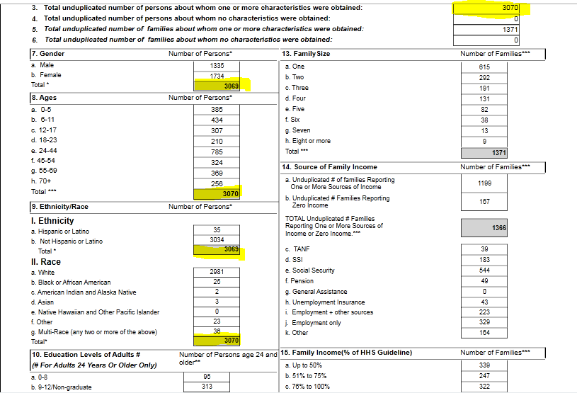
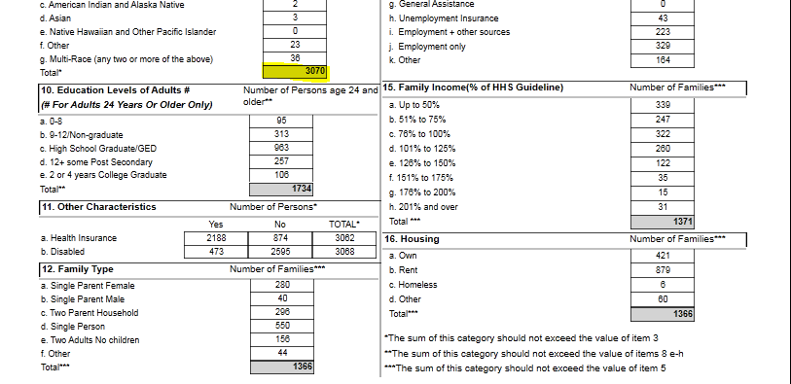

Client Demographics_ MO Detail (Section G records)
Lists all individual clients that make up the aggregate data in the Section G report; run by contract or agency-wide
Detail listing of all clients and demographic info captured; helps identify missing information from client demographics page
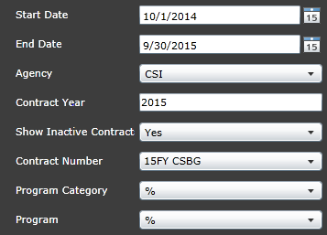
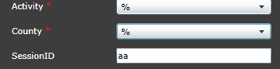

Missing Family Type (12)/Missing Housing (16), Family Size (13)

Source of Family Income (14)
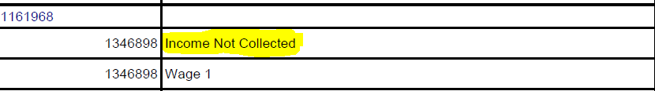

Client Demographics_MO Details Missing Individual (Section G records)
Lists only individual clients that have missing demographic data needed for the Section G report
Detail listing of blank client data needed for Section G report – use as guide for maintenance of records

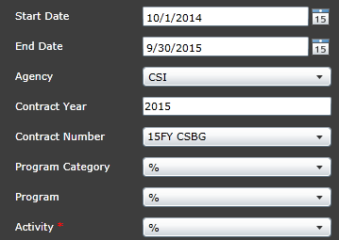
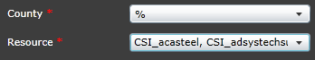

Missing-Gender (7), Age (8), Ethnicity/Race (9), Education Levels of Adults (10), Other Characteristics (11)
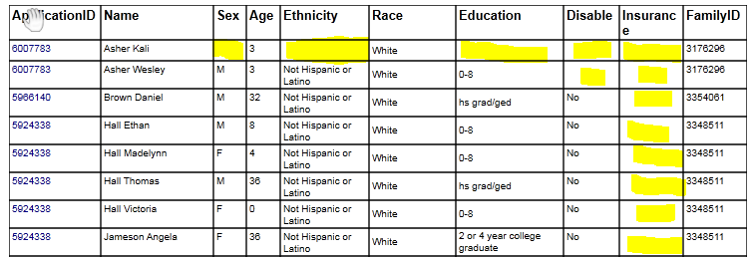

Client Demographics_MO DetailsMissing Fam (Section G records)
Lists only individual clients that have missing family demographic data needed for the Section G report (Housing, Family Type, etc.)
Detail listing of blank or invalid client data needed for Section G report – use as guide for maintenance of records
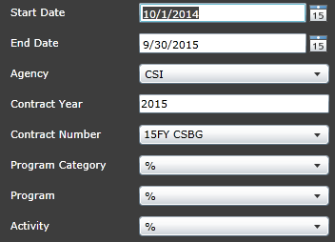
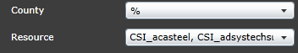

Missing Family Type (12), Family Income (15), Housing (16)
