Summary:
Use Sessions page to record services for multiple clients; Services linked to Milestones will display on Case Plan page
Start: Select Program & Component:  - Open Sessions page  - Select Program and Component | 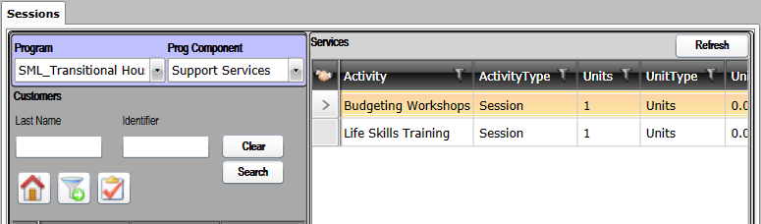
Next: Select Client(s):  - Click SEARCH  Available Clients will be displayed in  Client Listing grid  - In Client listing grid, select Client(s)  Use CTRL + Click to select multiple records individually  Use SHIFT + Click to select a range of records | 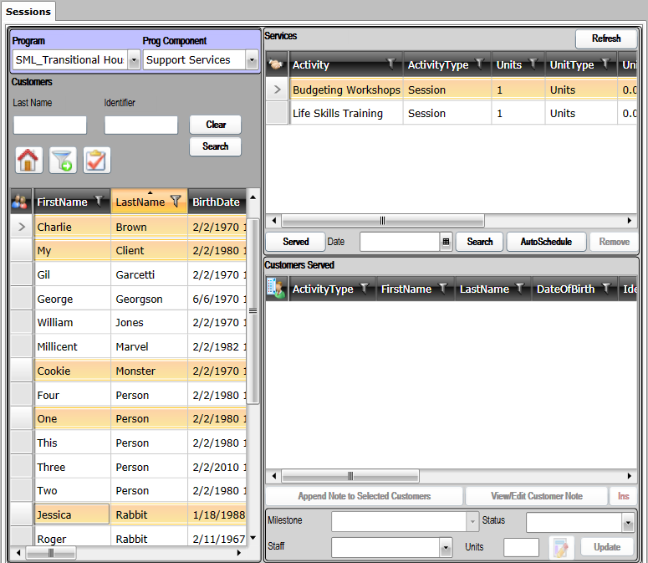
Next: Select Service(s):
- In Service Listing grid, Select Service(s)
Use CTRL + Click to select multiple records
Use SHIFT + Click to select range of records

Next: Record Services:  - Select Date  - Click SERVED  Records will be displayed in Client Served Listing grid | 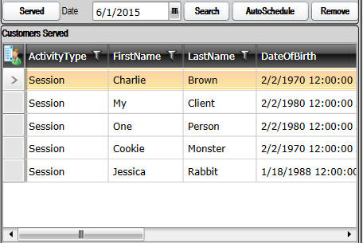
Optional: Link to Milestone:  - Select record(s) in Client Served Listing grid  - Select Milestone in dropdown  - Status, Staff, Units are optional  - Click UPDATE  Use Append Note to Selected Customers to attach  a note to the selected records if desired | 