Summary:
Use the Services page to add and view services for your client; all services will be displayed here no matter what page was used to record them.
Start: View or create Program Components in top container:  - Click NEW to create new Component  - Select Component and Staff  - Click SAVE  If Program Component is auto created, it will be displayed automatically  Statuses may be created with popup up Status page | 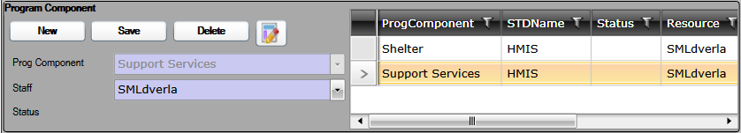
Next: Record Services:  - Select appropriate Milestone in Milestone Container first  - Click NEW in Activity Container at bottom  - Enter or select Activity data as required  - Click SAVE  Service is displayed in grid; Activity Type indicates on which page it was recorded  Move to Milestone allows you to link the selected Activity to a different Milestone | 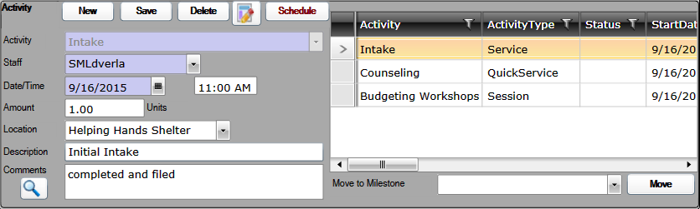
Next: Record Milestone Status Updates in Milestones Container:  - Select the appropriate Milestone  - Select Status and Date, Comments are optional  - Click SAVE  Refresh Milestones brings in new Milestones for active client | 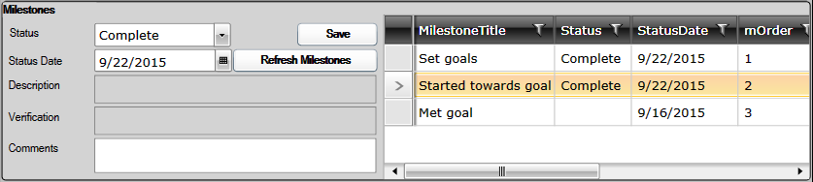
Services Options:  - Some Services may have different fields available, such as End Date or Time  - If Complete checkbox is displayed and checked, selected Milestone status will be changed to “Complete” automatically  - Amount, Location, Description, Comments are all optional  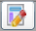  - SCHEDULE opens popup to schedule recurring activity  - STATUS opens popup to record current  Status and displays in Status column  - Magnifying Glass Opens Comments field  in larger window | 