Summary:
Use the Case Plan v5.5 page to add and view services for your client; all services will be displayed here no matter what page was used to record them.
Start: Record Services on Intervention tab: Component sub-tab:  - Open Component tab  - Select appropriate Milestone  - Click NEW in Activity section at bottom  - Enter or select Activity data as required  - Click SAVE  If Component is not displayed, click SHOW ALL button on right side of page | 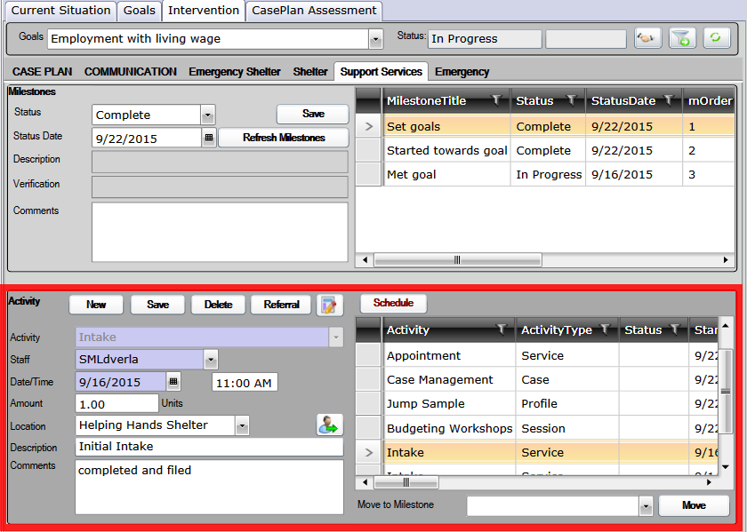
Next: Record Milestone Status Updates on Intervention tab: Component sub- tab:  - Open Component tab  - Select the appropriate Milestone  - Select Status and Date, Comments are optional  - Click SAVE  Refresh Milestones brings in new Milestones for active client | 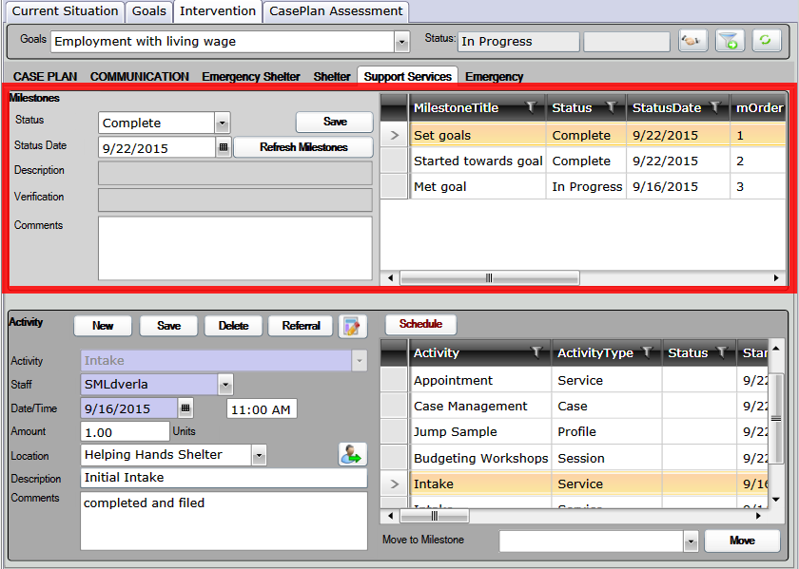
Switch between viewing Only Linked Components and viewing All Components  Use FILTER TO GOAL DOMAINS /COMPONENTS to show components linked to a task  Use SHOW ALL to show all components  When viewing Components of other Programs,  you will be able to only view the services,  not add or edit them | 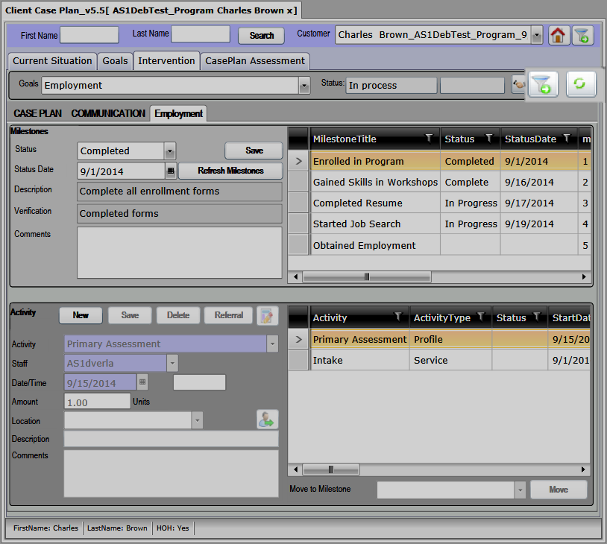
Services Options:  - Some Services may have different fields available, such as End Date or Time  - If Complete checkbox is displayed and checked, selected Milestone status will be changed to “Complete” automatically  - Amount, Location, Description, Comments are all optional  - SCHEDULE opens popup to schedule recurring activity  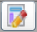  - STATUS opens popup to record current  Status and displays in Status column  - Activity Type column indicates on which page the service was recorded | 