Summary:
Use Client Intake page to add new or edit an existing Client intake record; search for client in fields at top right on page
Start: on Client Intake page:  - Click NEW HOUSEHOLD  - Enter Name, Date of Birth and Social Security Number, each item also has a Data Quality Code field  - Click SAVE  Blue fields are required  System will search after Name/DOB  and after SSN to find any existing matches | 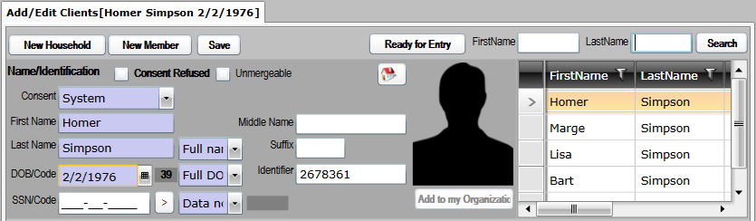
Next: on Contact tab:  - Enter Address and contact information  - Click SAVE  Address data is shared among household members, each member can have their own phone and  email address data | 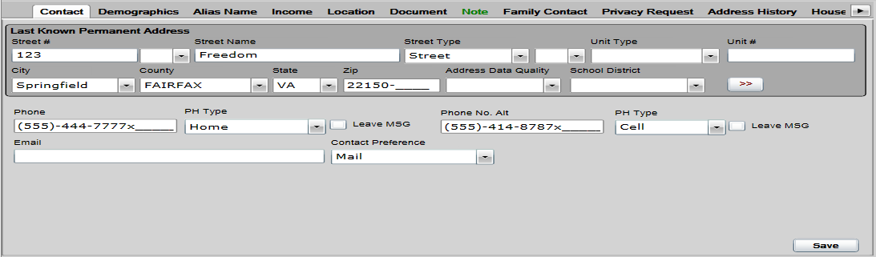
Next: on Demographics tab:  - Select answer for all required fields in dropdowns  - Select appropriate Race(s)  - Click SAVE  Some items may fill automatically | 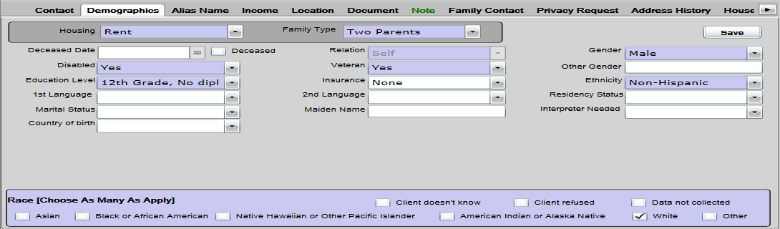
Next: on Income tab:  - If no income, leave ‘No Financial Resources’  - If there is income, Select appropriate Income Source and Pay Interval, enter Stated Income  - Select Non-Cash Benefits and Insurance information  - Click SAVE  Click ADD to create additional income records as necessary and repeat process | 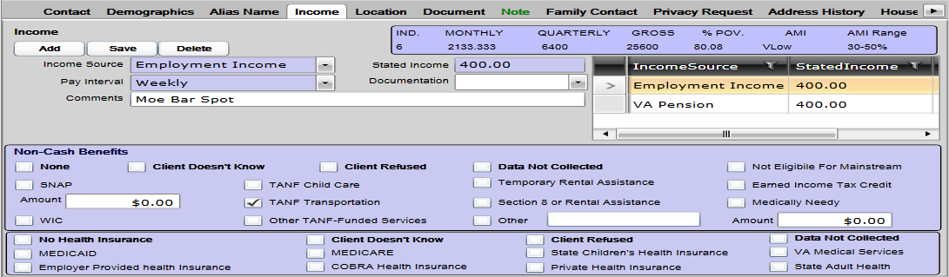
Next: Add additional Household Members:  - Click NEW MEMBER  - enter Name, DOB, SSN data and SAVE  - Repeat Contact, Demographic and Income steps | 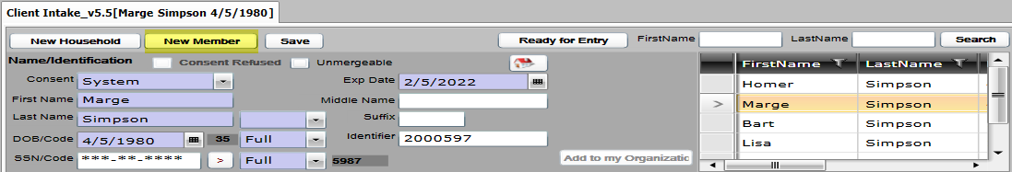
Make sure you check and verify all client data before enrolling a returning client into a new Program

