Summary:
Use Add/Edit Services or Quick Services page to quickly record Activities and Services for your Client
Start: Create Services record:  - Click New  - Select Date and Staff; Location and Comments are optional  - Click SAVE  - Select the Program component tab in the bottom section  The first time you create a record for the client,  you will need to check the Program Component to use and click SAVE; afterward, the Component  will be displayed on its own tab | 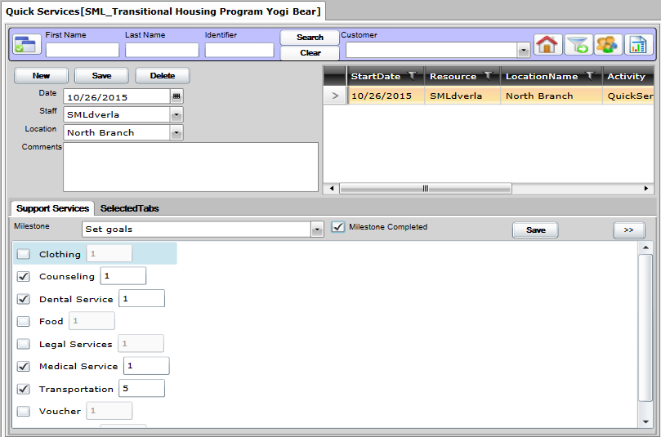
Next: on the Component tab:
- Check all Services to be logged for the client
- Update Number of Units if needed
- Select the Milestone in the dropdown
- Check Milestone Completed if true
- Click SAVE

Optional: Set the Component tabs:  - Click Selected Tabs tab  - Check or uncheck to indicate which Components will be used  - Click SAVE  Unchecked tabs will not be displayed  This can be changed as needed | 