Summary:
Use Add Case Notes page to record narratives of your client meetings
Start: Create Case Notes record:  - Click New  - Select Consent, Component and Activity  - Click SAVE | 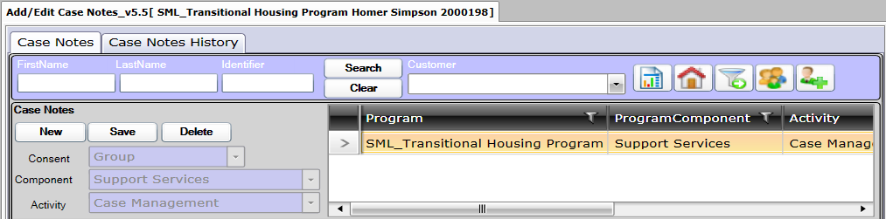
Next: Create Case Note on Case Notes tab:  - Select Staff, Date, Units; Time is optional  - Enter Subject and Note text  - Click SAVE | 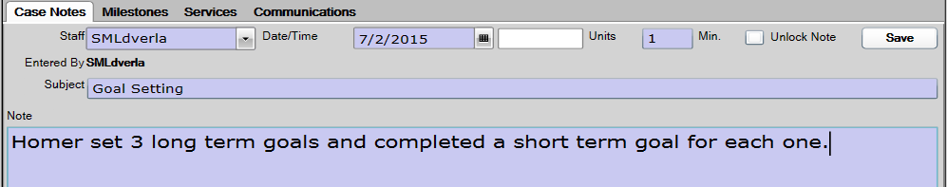
Optional: Link to Milestone on Milestones tab:  - Open Milestones tab  - Check which Milestones will be linked to case note  - Click SAVE  Multiple Milestones may be linked | 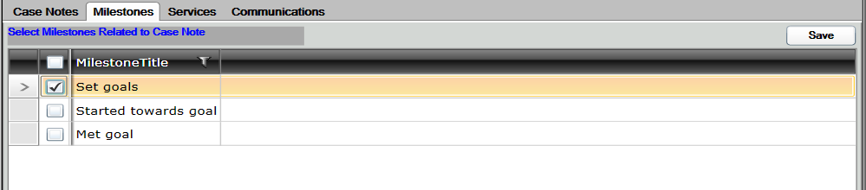
Optional: Record additional Services on Services tab:
- Open Services tab
- Check each Service received
- Select Milestone to link to Service in dropdown
- Click SAVE
Optional: Send Communication to Client on Communications tab:  - Open Communications tab  - Click NEW  - Select Type of Message and enter message text  - Click SEND | 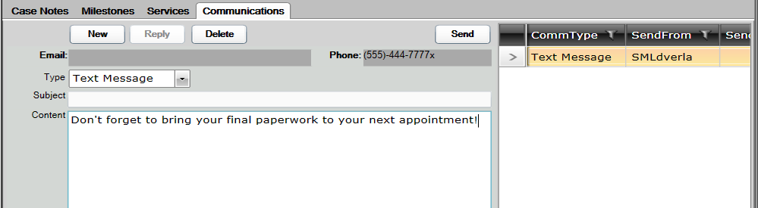
Optional: View History on Case Notes History tab:  - Open Case Notes History tab  - Select Program in dropdown  Matching Case Notes will be displayed in grid  Information of selected Note will be displayed beneath grid. | 